Name: Date:

**Student Exploration:** **Isosceles and Equilateral Triangles**

**Vocabulary:** base (of an isosceles triangle), base angles, equiangular, equilateral, isosceles, legs (of an isosceles triangle), vertex angle

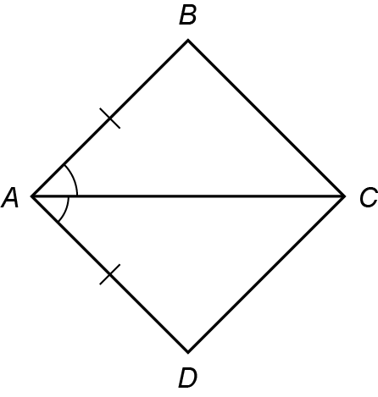

**Prior Knowledge Questions** (Do these BEFORE using the Gizmo.)

1. Consider the triangles in the diagram to the right.
2. Complete the congruence statement: Δ*ABC* ≅
3. What theorem proves the congruence?
4. Can you prove that  ≅ ? Explain.

**Gizmo Warm-up**

In the *Isosceles and Equilateral Triangles* Gizmo, you can create and manipulate triangles. You can also measure sides and angles of your triangles to explore their properties.

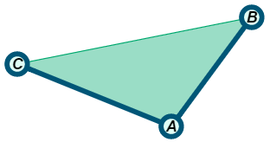

1. Be sure the **Condition** selected is **None**. Drag the vertices to create an obtuse triangle. Select **Show angle measure tool** to open the Gizmo protractor. To measure an angle, attach the protractor’s “donuts” to three points as shown to the right.

What does the triangle’s largest angle measure?

1. Change the **Condition** to **Two sides congruent**. A triangle with at least two sides congruent is an **isosceles** triangle.
2. Can you create an obtuse isosceles triangle?
3. Record the largest angle measure to verify your answer.
4. Change the **Condition** to **Three sides congruent**. A triangle with all three sides congruent is an **equilateral** triangle.
5. Can you create an obtuse equilateral triangle?
6. Explain.

|  |  |  |
| --- | --- | --- |
| **Activity A:**  **Exploring isosceles triangles** | Get the Gizmo ready:   * Be sure **Show bisector options** is not selected. | 186SE2 |

1. Set the **Condition** selected is **Two sides congruent** to create an isosceles triangle.
   1. The congruent sides of an isosceles triangle are called **legs**. The other side is called the **base**. Drag the vertices to change the triangle.

Which sides are the legs of Δ*ABC*? Which is the base?

* 1. The two angles that are adjacent to the base are the **base angles**. Select **Show angle measure tool** to turn on the Gizmo protractors.

What are the measures of the base angles of Δ*ABC*?

* 1. With both protractors still set on base angles, drag the vertices of the triangle to create different isosceles triangles. What do you notice about the base angles?

* 1. Complete the statement: If two sides of a triangle are , then

This is the called the *Isosceles Triangle Theorem*.

1. Turn off both protractors and set **Condition** to **Two angles congruent**.
2. Which two sides are opposite the congruent angles?
3. Select **Show ruler** to turn on the Gizmo rulers. Then measure these sides. What do you notice about the lengths?

1. Drag the vertices. Does your finding above seem to always be true?
2. Use those observations to complete the following statement:

If two angles of a triangle are , then

The statement you wrote is the *Converse of the Isosceles Triangle Theorem*.

**(Activity A continued on next page)**

**Activity A (continued from previous page)**

1. Set **Condition** to **None**, and select **Show bisector options**. Then choose **Show perpendicular bisector of **.
2. Drag all three vertices to see many different triangles. Pay attention to when the perpendicular bisector passes through point *B*.

What type of triangle does this appear to be?

Set the triangle in the Gizmo to that type, and verify your finding.

1. Use the Gizmo protractors on your triangle to measure ∠*ABD* and ∠*CBD.* Drag the vertices around. What do you notice?
2. Complete: The perpendicular bisector of the base of a(n) triangle is also of the vertex angle.
3. With **Two sides congruent** selected, choose **Show bisector of ∠*B***.
4. Why are the triangles that were formed congruent?
5. What is true about  and ? Verify this using the rulers.
6. What type of angles are ∠*ADB* and ∠*CDB*? Verify this also.
7. What do parts B and C prove about the angle bisector of the vertex angle of an isosceles triangle?
8. Use what you have learned in Activity A to find the values of *x* and *y*. Show your work.

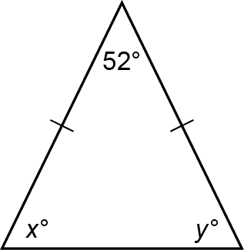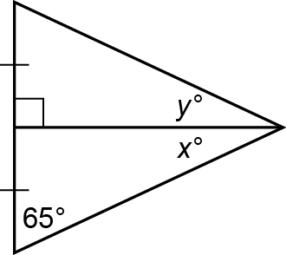

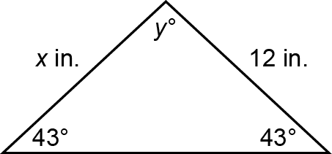

*x* =

*y* =

*x* =

*y* =

*x* =

*y* =

|  |  |  |
| --- | --- | --- |
| **Activity B:**  **Exploring equilateral triangles** | Get the Gizmo ready:   * Turn off the Gizmo rulers and unselect **Show bisector options**. | 186SE3 |

1. In the Gizmo, set **Condition** as **Three sides congruent** to create an equilateral triangle.
   1. First, are equilateral triangles also isosceles? Explain.

* 1. Use the Gizmo protractors to measure all three angles. What do you find?

* 1. Drag the vertices to create other triangles. What appears to be true for the angles of any equilateral triangle?

1. Set **Condition** to **Three angles congruent** to create an **equiangular** triangle.
2. Turn off the protractors and select the Gizmo rulers. Measure the three side lengths of the equiangular triangle. What do you find?

1. Drag the vertices around. Does your finding appear to be true for any equiangular triangle?
2. Explain the relationship between equilateral and equiangular triangles.

1. 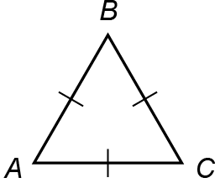The Isosceles Triangle Theorem states that if two sides of a triangle are congruent, then the angles opposite those sides are congruent. Use this theorem to explain why an equilateral triangle is also equiangular.

**Given:**  ≅  ≅ 

**Prove:**  ≅  ≅ 