Name: ______________________________________ Date: ________________________

Student Exploration: Laser Reflection

Vocabulary: angle of incidence, angle of reflection, laser, law of reflection, plane mirror, reflection

Prior Knowledge Questions (Do these BEFORE using the Gizmo.)
Imagine you shine a flashlight directly at a mirror, as shown below.

- Draw an arrow showing the direction you think the beam of light will most likely reflect off the mirror.
- Suppose you tilt the mirror. Draw an arrow showing the direction the beam will most likely reflect off the mirror now.

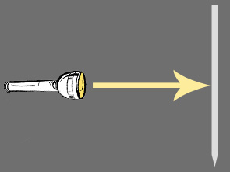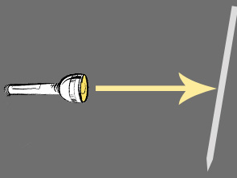

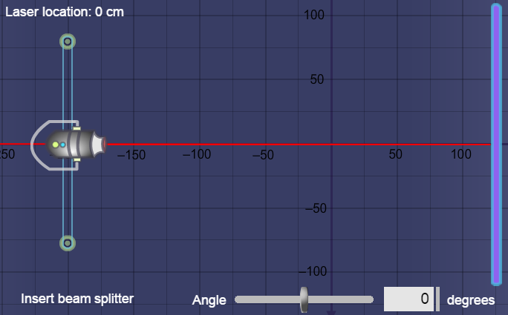
Gizmo Warm-up
Flashlights produce wide beams of light that have various wavelengths. A laser, on the other hand, is a narrow beam of light with only one wavelength. All the waves in a laser beam are parallel to one another. As a result, lasers are ideal for studying reflection, or how waves bounce off a surface.

Using the Laser Reflection Gizmo, you can adjust the position of a laser beam and mirror to study how light behaves when it is reflected.

- Drag the Angle slider back and forth. Describe what happens to the reflected laser beam:

_________________________________________________________________________

_________________________________________________________________________

- Drag the laser up and down. Describe what happens to the reflected laser beam: ________

_________________________________________________________________________

Activity A:  Reflection from a plane mirror | Get the Gizmo ready:  - Set the Laser location to 0 cm.  - Set the Angle to 25 degrees.  - Make sure Plane mirror is selected. | 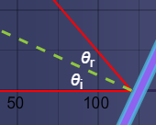

Introduction: A plane mirror is a perfectly flat, smooth surface. In this activity, you will study how plane mirrors reflect light.

Question: How does the angle of a mirror determine the angle of the reflected light?

- Observe: Turn on Show normal. The normal is the dotted line perpendicular to the mirror. The angle of incidence (θ_{i}) is the angle between the incoming laser beam and the normal. The angle of reflection (θ_{r}) is the angle between the reflected laser beam and the normal.

Move the Angle slider back and forth. What do you notice about the sizes of θ_{i} and θ_{r}?

_________________________________________________________________________

- Measure: Set the Angle to 40 degrees and turn on Show protractor. Each marking on the protractor represents 10 degrees.

What do θ_{i} and θ_{r} equal? θ_{i} = ____________ θ_{r} = ____________

- Make a rule: What is the relationship between θ_{i} and θ_{r}? ____________________________

_________________________________________________________________________

Turn on Show angles and move the Angle slider back and forth. Was your rule correct?

_________________________________________________________________________

The law of reflection states that the angle of incidence is equal to the angle of reflection.

- Gather data: Use the Gizmo to complete the table below.

Mirror angle | Angle of incidence (θ_{i}) | Angle of reflection (θ_{r})
0°
25°
50°

- Make a rule: How is the mirror angle related to the angles of incidence and reflection?
_________________________________________________________________________

Activity B:  Reflection from non-planar mirrors | Get the Gizmo ready:  - Turn off Show normal and Show protractor.  - Set the mirror Angle to 50°. | 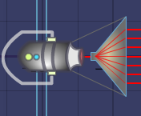

Question: How can you use the angle of refraction to determine the shape of a non-planar mirror’s surface?

- Observe: Turn on Insert beam splitter. How do the seven incoming beams compare with one another? How do the reflected beams compare with one another?

_________________________________________________________________________

_________________________________________________________________________

- Observe: From the dropdown menu at lower right, select Mirror 1. Unlike the plane mirror, mirror 1 is not flat.

    - Describe how the laser beams changed: ___________________________________

___________________________________________________________________

    - Why do you think this happened? ________________________________________

___________________________________________________________________

___________________________________________________________________

- Solve: Turn off Insert beam splitter. Set the mirror’s Angle to 0 degrees and the Laser location to 35 cm. Check that Show angles is on.

- What are the angle of incidence and angle of reflection (θ_{i} and θ_{r})? ______________

- What does this tell you about the surface of the mirror in this location? ___________

___________________________________________________________________

- Move the Laser location to 14 cm. How did the orientation of the beam change?

___________________________________________________________________

- What does this tell you about the surface of the mirror in this location? ___________

___________________________________________________________________

(Activity B continued on next page)
Activity B (continued from previous page)

- Summarize: What does it mean if the reflected beam is above the incident beam? What does it mean if the reflected beam is below the incident beam?

_________________________________________________________________________

_________________________________________________________________________

- Collect data: You will now use the laser to map the surfaces of mirrors 1, 2, and 3. In the rows of the table, record each mirror’s angle at all the listed locations. If the beam is deflected downward, the angle is negative. Otherwise the angle is positive.

Height | Mirror 1 Angle | Mirror 2 Angle | Mirror 3 Angle
35 cm
30 cm
25 cm
20 cm
15 cm
10 cm
5 cm
0 cm
-5 cm
-10 cm
-15 cm
-20 cm
-25 cm
-30 cm
-35 cm

- Draw: Use the data you collected to create drawings of the mirrors’ surfaces in the boxes below. Be sure to pay attention to negative signs, which indicate the direction of the angle.

Mirror 1 Mirror 2 Mirror 3
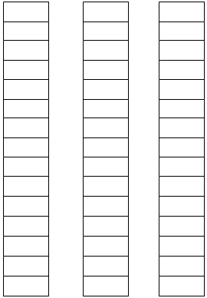

- Analyze: Does the law of reflection hold true for mirrors that aren’t flat? Use the Gizmo to explore this question, and describe your findings.

_________________________________________________________________________

_________________________________________________________________________

