Vocabulary: Laser Reflection

Vocabulary
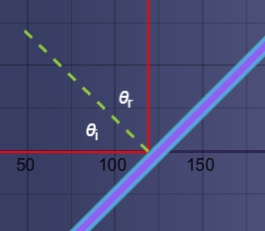
- Angle of incidence – the angle between an incoming light ray and the normal.
  - The normal is an imaginary line (shown in green in the image at right) that lies perpendicular to a surface.
  - The symbol for the angle of incidence is θ_{i}.

- Angle of reflection – the angle between a reflected light ray and the normal.
  - The symbol for the angle of reflection is θ_{r}.

- Laser – a concentrated beam of light of only one wavelength in which all the waves in the beam are parallel to one another.
  - Laser is an acronym for Light Amplification by the Stimulated Emission of Radiation.

- Law of reflection – a law stating that the angle of incidence is equal to the angle of reflection.
  - The law of reflection can be written as an equation: θ_{i} = θ_{r}.

- Plane mirror – a perfectly flat, smooth reflective surface.
  - The mirror on a bathroom wall is an example of a plane mirror.
  - Non-planar mirrors include curved mirrors such as concave and convex mirrors.

- Reflection – the deflection of light by a surface.
  - When light is reflected, it changes direction.

