Vocabulary: Solving Linear Systems   
(Matrices and Special Solutions)

dictionary2

**Vocabulary**

* Consistent system – a system of equations with at least one solution.
* Dependent system – a system of equations with an infinite number of solutions.
* Determinant – the difference of the products of the diagonal elements of a square matrix.
* The determinant of  is  = *ad* – *bc*.
* Inconsistent system – a system of equations with no solution.
* Independent system – a system of equations with exactly one solution.
* Matrix – a rectangular array of numbers and/or variables.

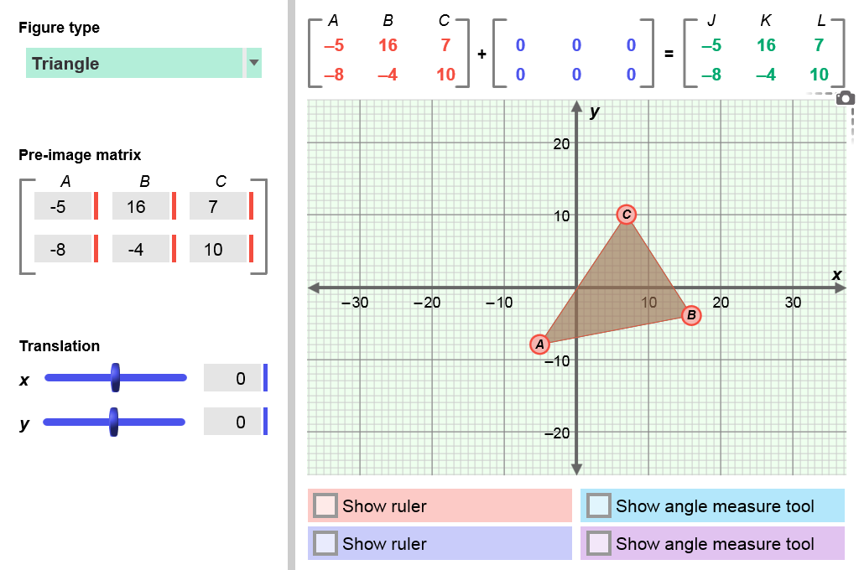

* + The matrix shown to the right has 2 rows and 3 columns, so it is a 2 × 3 matrix.
  + Each number or variable in a matrix is called an *element*.
* Solution – a value or values that makes an equation or system of equations true.
* For example, (2, 7) is a solution of the equation *y* = 3*x* + 1 because it makes the equation true: 7 = 3(2) + 1.
* System of linear equations – a set of two or more linear equations with the same variables.
* A summary of the types of systems is given below:

|  |  |  |  |
| --- | --- | --- | --- |
| **Graph** | Intersecting lines  161Vocab1 | Same line  161Vocab2 | Parallel lines  161Vocab3 |
| **Number of solutions** | exactly one | infinitely many | none |
| **Type of system** | consistent and independent | consistent and dependent | inconsistent |