Vocabulary: Solving Linear Systems
(Slope-Intercept Form)

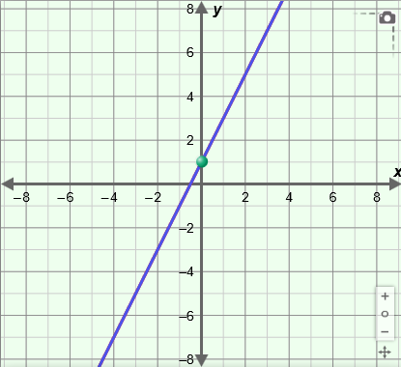
Vocabulary

- Slope-intercept form – a linear equation of the form
y = mx + b, where m is the slope and b is the y-intercept.
- For example, the line with the equation y = 2x + 1, shown to the right, has a slope of 2 and a y-intercept of 1.

- Solution – a value that makes an equation or inequality true.
- For example, (2, 7) is a solution of the equation y = 3x + 1 because it makes the equation true: 7 = 3(2) + 1.

- Substitution method – an algebraic method for solving systems of equations that involves solving one equation for a variable and substituting that expression into the other equation.

- System of linear equations – a set of two or more linear equations that contain the same variables.
- A system of linear equations can have one solution, no solution, or infinitely many solutions, as shown below:
Graph | Intersecting lines  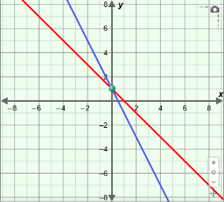 | Same line  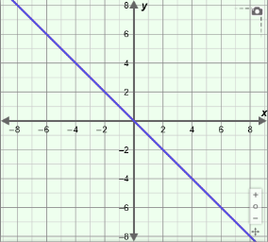 | Parallel lines  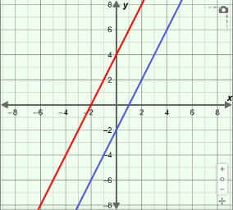
Number of solutions | exactly one | infinitely many | none
Type of system | consistent and independent | consistent and dependent | inconsistent

