Name: Date:

Student Exploration: Linear Functions

Vocabulary: coordinate plane, coordinates, equation, function, input, linear function,
mapping diagram, ordered pair, output, relation

Prior Knowledge Questions (Do these BEFORE using the Gizmo.)
In Musical Chairs six players circle five chairs as music plays. When the music stops, players rush to sit in a chair. The player left standing is eliminated. A chair is removed and play continues until only two players and one chair are left. The winner is the last seated player.

- How many chairs are needed for 8 people to play? __________

- In general, if x people want to play, how many chairs are needed? Explain. _____________

_________________________________________________________________________

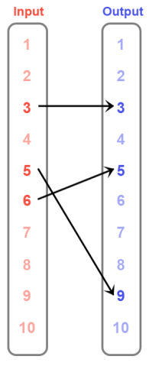
Gizmo Warm-up
In the Linear Functions Gizmo, you can create relations. A relation is a set of (input, output) or (x, y) ordered pairs. To make a relation in the Gizmo, either drag points onto the graph to create (x, y) points, or click-and-drag arrows from input values to output values in the mapping diagram.

A sample mapping diagram is shown to the right. The relation mapped here contains the ordered pairs (3, 3), (5, 9), and (6, 5).

- Click-and-drag an arrow in the Gizmo’s mapping diagram to map any input value to any output value.

  - What (input, output) ordered pair did you create? ________________

  - What happened in the graph? ___________________________________________

___________________________________________________________________

- Click Clear. Now, in the Gizmo, drag a point onto the graph.

- What ordered pair did you create? _________________

- What happened in the mapping diagram? __________________________________

___________________________________________________________________

Activity A:  Identifying functions | Get the Gizmo ready:  - Click Clear. | 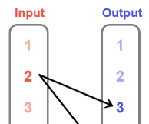

- In the Gizmo’s mapping diagram, click and drag arrows to map 4 to 3, 5 to 4, and 6 to 6.

  - Select Show linear function test. Describe the analysis of this relation you created. Does the Gizmo say this is a function?

___________________________________________________________________

___________________________________________________________________

  - Slowly drag one of the points around the graph. As you do, watch the numbers under Input in the mapping diagram. You should see a number being circled occasionally. What seems to cause an Input value to be circled?

___________________________________________________________________

___________________________________________________________________

  - Be sure that there are still at least 3 points on the graph. Again, slowly drag one of the points around the graph. This time, watch the Gizmo’s analysis under Show linear function test. When is a relation NOT a function, according to the Gizmo?

___________________________________________________________________

___________________________________________________________________

Input | Output
2 | 7
1 | 3
3 | 1
2 | 1
- Click Clear. Using the mapping diagram or points on the graph, create the relation shown to the right: (2, 7), (1, 3), (3, 1), and (2, 1).

- Why is this relation not a function?______________________

__________________________________________________

- What could you change to turn this relation into a function? ____________________

___________________________________________________________________

- In general, when is a relation a function and when is it not? __________________________

_________________________________________________________________________

_________________________________________________________________________

_________________________________________________________________________
Activity B:  Test for functions | Get the Gizmo ready:  - Click Clear. | 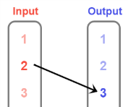

- In the Gizmo’s mapping diagram, click and drag arrows to map 2 to 3, 4 to 5, and 6 to 7.

  - Explain why this relation is a function. _____________________________________

___________________________________________________________________

___________________________________________________________________

  - Select Show linear function test. Why is this a linear function? _______________

___________________________________________________________________

  - Drag three more points onto the grid that lie on the same line segment. How are the (input, output) or (x, y) values related for every point in this linear function?

___________________________________________________________________

___________________________________________________________________

  - Write an equation in terms of input (x) and output (y) values to describe this relation.

___________________________________________________________________

- Click Clear. Use the mapping diagram to plot (1, 3), (3, 7), and (4, 9).

- Why do these points determine a function? _________________________________

___________________________________________________________________

___________________________________________________________________

- Select Show linear function test to see why this is a linear function. Write an equation in terms of input (x) and output (y) to describe the relationship.

___________________________________________________________________

- Drag one of the points to a different location so that the relation no longer represents a function. What are the new coordinates of the point? ________________
- Explain why this set of points is not a function now. __________________________

___________________________________________________________________

___________________________________________________________________
Activity C:  Horizontal and vertical lines | Get the Gizmo ready:  - Click Clear. | 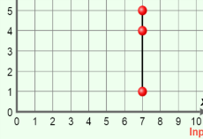

- In the Gizmo’s graph, plot a set of points that all have the same input (x) value.

  - What are the coordinates of the points you plotted? __________ and ____________

  - Examine the mapping diagram and tell why these points do not represent a function.

___________________________________________________________________

___________________________________________________________________

  - Select Show linear function test. Describe the properties of the graph in the grid.

___________________________________________________________________

___________________________________________________________________

  - Click the Table tab. Describe the relationship between the ordered pairs in the table and the graph of the segment. ___________________________________________
___________________________________________________________________
  - What equation describes all points on this segment? _________________________

- Click Clear. Plot two points that have the same output (y) value.

- What are the coordinates of the points you plotted? __________ and ____________

- Explain why the relation above is or is not a function. _________________________

___________________________________________________________________

- Click the Table tab. What equation describes the ordered pairs in the table and all points on this segment? ________________________________________________

- Use words or equations and describe the difference between points on a horizontal segment and points on a vertical segment. ______________________________________________
_________________________________________________________________________

_________________________________________________________________________

