Name: Date:

**Student Exploration: Logarithmic Functions**

**Vocabulary:** asymptote, base, domain, exponent, exponential function, inverse function,   
logarithmic function, range

**Prior Knowledge Questions** (Do these BEFORE using the Gizmo.)

1. An **exponent** indicates repeated multiplication. A function with a variable in the exponent is called an **exponential function**.
2. Evaluate the exponential expressions below. (Recall that negative exponents indicate fractions. For example, 2–3 =  = .)

23 = 22 = 21 = 20 = 2–1 = 2–2 = 2–3 = 

1. Based on your answers above, what points must lie on the graph of *y* = 2*x*?

1. An **inverse function** reverses the *x*- and *y*-values of the original function. What points must lie on the inverse of *y* = 2*x*?

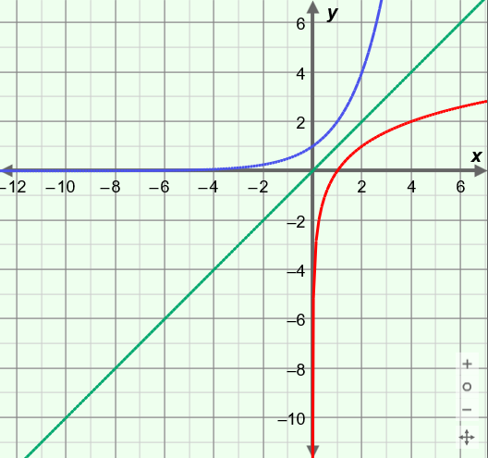**Gizmo Warm-up**

The inverse of an exponential function with **base** *b* (*y* = *bx*) is called a **logarithmic function**, also with base *b* (*y* = log*b*(*x*)). So, the inverse of *y* = 2*x* is *y* = log2(*x*). If a point lies on the graph of *y* = 2*x* (say, (3, 8)), then a corresponding point, with *x* and *y* flipped, lies on *y* = log2(*x*) (say, (8, 3)). In the *Logarithmic Functions* Gizmo, you can explore related logarithmic and exponential functions.

On the **CONTROLS** tab, set ***b*** to 2 to graph *y* = log2(*x*). (To quickly set the value of a slider, type the number into the text box to the right of the slider and press **Enter**.)

1. Use the slider to vary the value of ***b***. How does this affect the graph?

1. Vary ***b*** again. What happens to the *x*-intercept?

|  |  |  |
| --- | --- | --- |
| **Activity A:**  **Logarithmic function basics** | Get the Gizmo ready:   * Select **Show associated exponential** and **Show probe**. |  |

1. Because logarithmic functions are inverses of exponential functions, it helps to start by reviewing exponential functions. Consider the function *y* = 2*x*.
2. Complete the table for the function *y* = 2*x*, and plot the points on the grid.
3. Next, complete the table of values for the inverse function, *y* = log2(*x*), by switching the *x*- and *y*-values. The first row is done for you. Then plot the points on the grid.

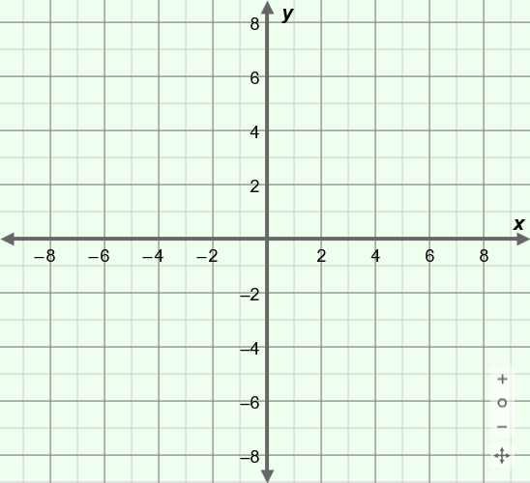

|  |  |
| --- | --- |
| ***y* = log2(*x*)** | |
| ***x*** | ***y*** |
|  | –2 |
|  |  |
|  |  |
|  |  |
|  |  |

|  |  |
| --- | --- |
| ***y* = 2*x*** | |
| ***x*** | ***y*** |
| –2 |  |
| –1 |  |
| 0 |  |
| 1 |  |
| 2 |  |

Graph *y* = log2(*x*) and *y* = 2*x* in the Gizmo. Then sketch the graphs as smooth curves through the points you plotted. (Use the probe to make sure your points are correct.)

1. The point (3, 8) lies on the graph of *y* = 2*x*, because 23 = 8. What corresponding point lies on the graph of the inverse function, *y* = log2(*x*)?
2. In general, if the point (*x*, *y*) lies on the graph of *y* = *bx*, what point lies on the graph of its inverse function, *y* = log*bx*?
3. Set ***b*** to 3 to graph *y* = log3(*x*).
4. Name 3 points on the graph of *y* = 3*x*. ( , ) ( , ) ( , )
5. Name 3 corresponding points on *y* = log3(*x*). ( , ) ( , ) ( , )

Explain why.

**(Activity A continued on next page)**

**Activity A (continued from previous page)**

1. Consider the function *y* = log5(*x*).
2. What function is the inverse of *y* = log5(*x*)?
3. Give exact coordinates of a pair of corresponding points on *y* = 5*x* and *y* = log5(*x*).

Point on *y* = 5*x*: ( , ) Point on *y* = log5(*x*): ( , )

1. Fill in the missing values. Then graph *y* = 5*x* and *y* = log5(*x*) to check your answers.

52 = log5(25) =

1. Use the probe to find the value of log5(1).
   1. Fill in the blanks: log5(1) = so the point is on the graph of *y* = log5(*x*).

This point is the of the graph.

* 1. Use the slider to vary the value of ***b***. What happens to the *x*-intercept as you do so?

* 1. Explain why that makes sense.

1. Consider the functions *y* = log5(*x*) and *y* = log(*x*). (Note: “log(*x*)” means “log10(*x*).”)
2. What is the value of log5(5)? What is the value of log(10)?

Check your answers in the Gizmo.

1. Use the slider to vary ***b***. In general, what is the value of log*b*(*b*)?
2. Explain why.

1. The points (1, 0) and (4, 1) lie on the graph of the logarithmic function shown here. What is the equation of this function?

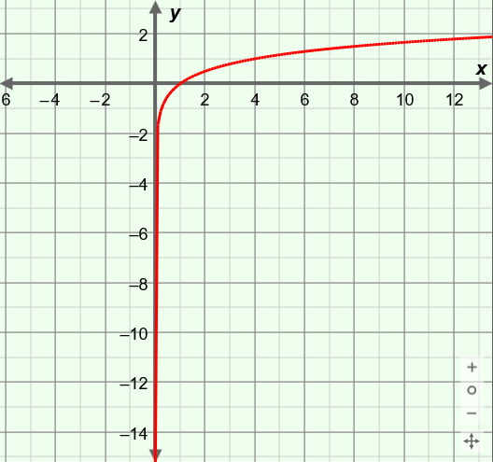

**(1, 0)**

**(4, 1)**

Check your answer in the Gizmo.

|  |  |  |
| --- | --- | --- |
| **Activity B:**  **Domain, range, and asymptotes** | Get the Gizmo ready:   * Select **Show associated exponential**. * Turn off **Show probe**. * Select **Show line *y* = *x***. |  |

1. Set ***b*** to 4. The inverse functions *y* = log4(*x*) and *y* = 4*x* should now be graphed in the Gizmo. Name a pair of corresponding points for *y* = log4(*x*) and *y* = 4*x*.

Point on *y* = 4*x*: ( , ) Point on *y* = log4(*x*): ( , )

1. Pan (drag) the grid so you can see more of the negative parts of the *x*- and *y*-axes.
2. How is the graph of *y* = 4*x* related to the *x*-axis (*y* = 0) as *x* goes to negative infinity?

The line *y* = 0 is a horizontal **asymptote** in the graph of *y* = 4*x*.

1. What is the equation of the vertical asymptote of the graph of *y* = log4(*x*)?
2. The **domain** is the set of all *x*-values of a function, and the **range** is all the *y*-values. What are the domain and range of the function *y* = 4*x* and its inverse, *y* = log4(*x*)?

Domain of *y* = 4*x*: Range of *y* = 4*x*:

Domain of *y* = log4(*x*): Range of *y* = log4(*x*):

1. Why do you think the range of *y* = 4*x* is the same as the domain of *y* = log4(*x*)?

1. Vary ***b***. In general, what is the equation of the asymptote, the domain, and the range of the function *y* = log*b*(*x*)?

Asymptote: Domain: Range:

1. Consider the exponential function graphed here. Fill in the table for this function, and for its inverse (not pictured).

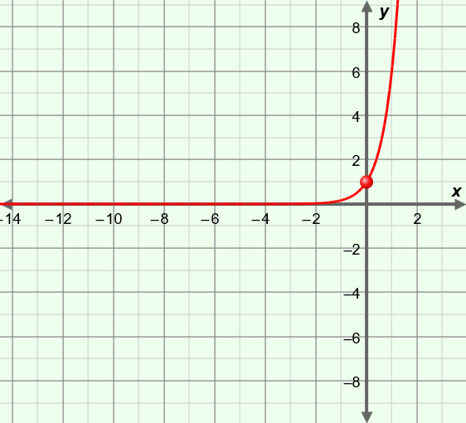

**(0, 1)**

**(1, 6)**

|  |  |  |  |  |
| --- | --- | --- | --- | --- |
|  | Equation | Domain | Range | Asymptote |
| Exponential function |  |  |  |  |
| Inverse of exponential function |  |  |  |  |

|  |  |  |
| --- | --- | --- |
| **Activity C:**  **Practice with logarithmic functions** | Get the Gizmo ready:   * Select **Show associated exponential**. * Set ***b***to 10. |  |

1. How are the functions *y* = 10*x* and *y* = log(*x*) related?
2. List the exact coordinates of four points that lie on the graph of *y* = log(*x*).

( , ) ( , ) ( , ) ( , )

1. Evaluate the expressions below. Check your answers in the Gizmo.

log7(49) = log9(1) = log3(81) = log2() =

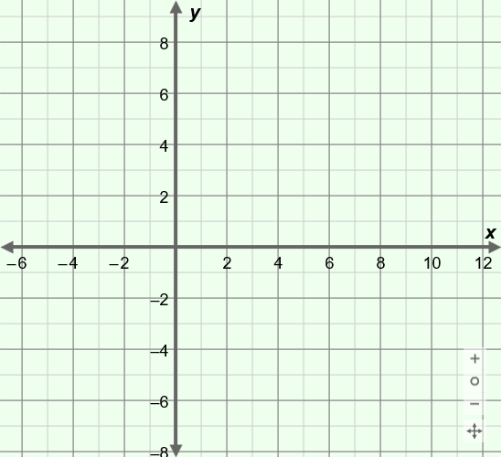

1. Consider the function *y* = log3(*x*).
2. What is the value of log3(3)?
3. What is the value of log3(9)?
4. What is the *x*-intercept of *y* = log3(*x*)?

Why?

1. Use your answers to help sketch the graph of *y* = log3(*x*) on this grid. Then check your graph in the Gizmo.
2. The graph of a logarithmic function is shown here.

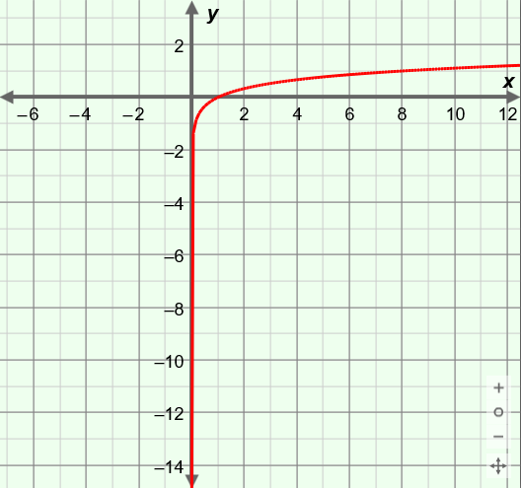

**(1, 0)**

**(8, 1)**

1. What function is graphed?
2. Give the coordinates of the point on this curve that has a *y*-value of 2. ( , 2)

Check your answers in the Gizmo.

1. Explain why log(–1) has no solution.