Vocabulary: Logarithmic Functions

dictionary2

**Vocabulary**

* Asymptote – a line that a curve approaches as *x* or *y* goes to infinity.
* Base – a number or expression raised to an exponent.
* The logarithmic function *y* = log*b*(*x*) is said to have base *b*, because *y* = log*b*(*x*) written in exponential form is *by* = *x*.
* Domain – the set of all *x*-values of a relation or function.
* Exponent – a number, written to the right of and just above a number or expression, that indicates how many times the number or expression is multiplied by itself.

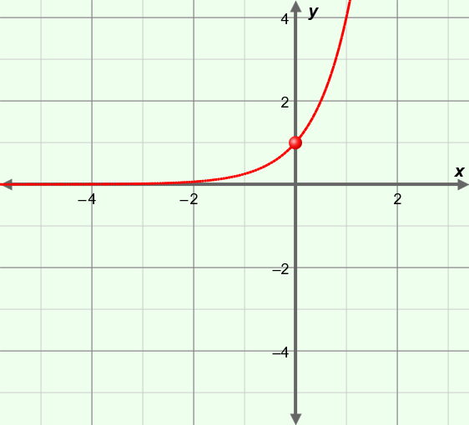

**(–1,** **)**

**(0, 1)**

**(1, 4)**

***y* = 4*x***

* Exponential function – a function of the form *y* = *a* • *bkx*, where *a* ≠ 0, *b* > 0, and *b* ≠ 1.
  + For example, the function *y* = 4*x*, graphed to the right, is exponential.
    - Some “key points” on the graph of *y* = 4*x* are (–1, ), (0, 1), (1, 4), (2, 16), etc.
    - For *y* = 4*x*, every time *x* increases by 1, *y* is multiplied by a factor of 4.
* Inverse function – a function that “reverses” or “undoes” another function.
* If the point (*x*, *y*) lies on the graph of the original function, then (*y*, *x*) lies on the graph of its inverse function.
* The graph of an inverse function is the graph of the original function reflected across the line *y* = *x*.
* Logarithmic function – the inverse of an exponential function.
  + The logarithmic function *y* = log*b*(*x*) is the inverse of *y* = *bx*, where *b* > 0 and *b* ≠ 1.

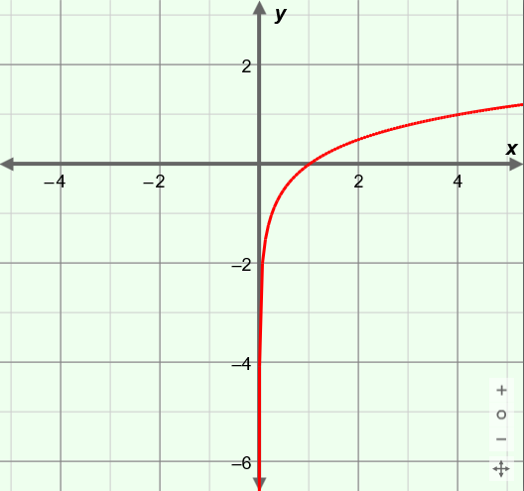

**(****, –1)**

**(1, 0)**

**(4, 1)**

***y* = log4*x***

* + For example, the function *y* = log4(*x*), graphed to the right, is logarithmic.
    - “Key points” on the graph of *y* = log4(*x*) include (, –1), (1, 0), (4, 1), (16, 2), etc.
    - The value of log4(1) = 0 because 40 = 1.
* Range – the set of all *y*-values of a relation or function.