Vocabulary: Logarithmic Functions:   
Translating and Scaling

dictionary2

**Vocabulary**

* Asymptote – a line that a curve approaches as *x* or *y* goes to infinity.
* Base – a number or expression raised to an exponent.
* The logarithmic function *y* = log*b*(*x*) is said to have base *b*, because *y* = log*b*(*x*) written in exponential form is *by* = *x*.
* Domain – the set of all *x*-values of a relation or function.
* Logarithmic function – the inverse of an exponential function.
  + The logarithmic function *y* = log*b*(*x*) is the inverse of *y* = *bx*, where *b* > 0 and *b* ≠ 1.

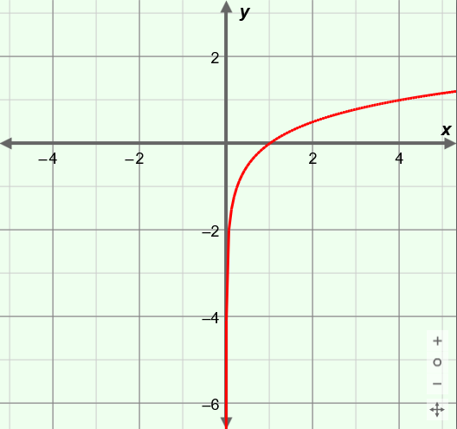

**(****, –1)**

**(1, 0)**

**(4, 1)**

***y* = log4*x***

* + For example, the function *y* = log4(*x*), graphed to the right, is logarithmic.
    - “Key points” on the graph of *y* = log4(*x*) include (, –1), (1, 0), (4, 1), (16, 2), etc.
    - The value of log4(1) = 0 because 40 = 1.
  + The graph of a logarithmic function is the graph of the associated exponential function reflected over the line *y* = *x*.
  + A logarithm to the base *e* (approximately 2.71828) is a *natural logarithm*, and is written as ln(*x*).
* Scale (a function) – to stretch or shrink a graph by multiplying the *x*- or *y*-values of a function by a constant.

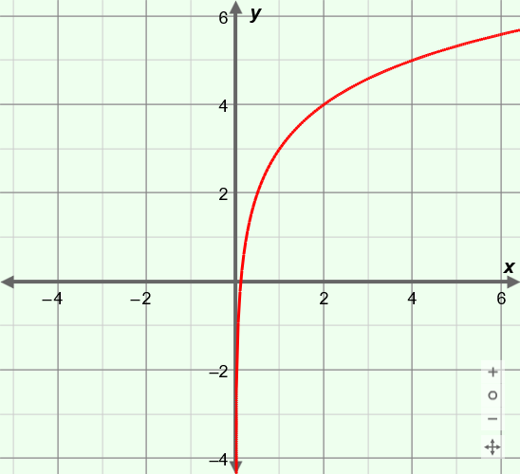

***y* = 2 log4*x* + 3**

* + For example, the graph of *y* = 2 log4(*x*) + 3, shown to the right, has been vertically scaled (stretched) by a factor of 2.

* Transform (a function) – to scale, translate, rotate, or reflect the graph of a function.
* Translate (a function) – to shift a graph by increasing or decreasing the *x*- or *y*-values of a function by a constant.
  + For example, the graph of *y* = 2 log4(*x*) + 3, shown above, has been translated up by 3 units.