Name: ______________________________________ Date: ________________________

Student Exploration: Longitudinal Waves

Vocabulary: antinode, compression, displacement, frequency, interference, longitudinal wave, medium, node, rarefaction, standing wave

Prior Knowledge Question (Do this BEFORE using the Gizmo.)

In many science fiction movies, an evil alien spaceship explodes with an enormous KABOOM!!

Suppose you were floating in space at a safe distance from a large explosion such as the supernova at left. Do you think you would you hear anything? Explain.

___________________________________________

___________________________________________

___________________________________________

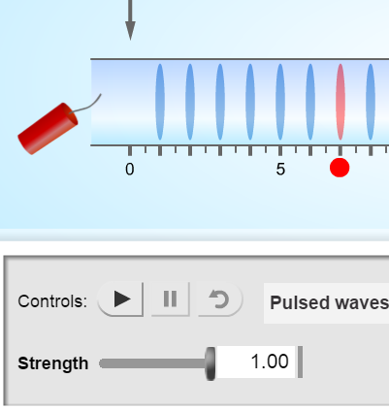
Gizmo Warm-up
No sounds can be heard in outer space because sound waves require a medium, such as air, to travel through. Sound waves are examples of longitudinal waves, or waves in which particles move back and forth in the same direction as the wave.

You can use the Longitudinal Waves Gizmo to explore the behavior of sound waves. In the Gizmo, an air-filled tube contains 24 evenly-spaced, airtight dividers. To begin, select the Pulsed waves setting and the Open tube. Set the Strength to 1.00. Deselect the graph options at lower right.

- Click Play () to set off the firecracker by the left end of the tube. What do you see?

_________________________________________________________________________

_________________________________________________________________________

- Do any individual air molecules travel the length of the tube? ________________________

How do you know? _________________________________________________________

Activity A:  Observing longitudinal waves | Get the Gizmo ready:  - Click Reset ().  - Select Continuous waves. Check that the Strength is 1.00 and Freq. is 30 Hz. | 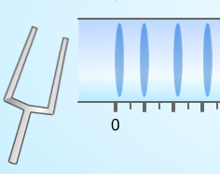

Introduction: When you strike a tuning fork on a hard surface, the tines of the fork start to vibrate back and forth at a certain frequency, or number of cycles per second. This motion causes nearby molecules to move back and forth, creating sound waves. The greater the frequency of the sound wave, the higher pitched the sound will be.

Question: What happens to air as a sound wave passes through it?

- Observe: Click Play, and then click Pause () after about 70 simulated milliseconds (does not have to be exact). Sketch the current positions of the dividers below.

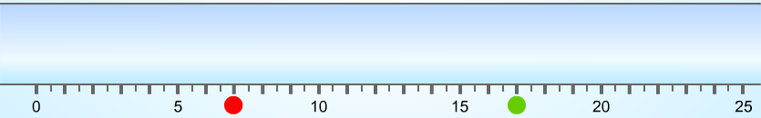

- Identify: Longitudinal waves have two important features. Compressions are regions where particles are squished together. Rarefactions are regions where particles are spread apart.

In your diagram above, draw a red rectangle around each compression and a blue oval around each rarefaction. (Note: The dividers were originally spaced one meter apart.)

- Observe: Turn on the Displacement graph. The displacement of a divider is equal to the change from its original position. The original positions of the red and green dividers are shown by the red and green dots below the tube.

In which direction has the red divider moved? __________ The green divider? __________

- Interpret: Compare the displacement graph to the dividers in the tube.

- How does the graph represent movement to the right? _______________________

___________________________________________________________________

- How does the graph represent movement to the left? _________________________

___________________________________________________________________

(Activity A continued on next page)
Activity A (continued from previous page)

- Analyze: Compare the displacement graph to the tube. What do you notice about the displacement near the center of a compression or a rarefaction?

_________________________________________________________________________

___________________________________________________________________________

- Observe: Click Play. How is the progress of the longitudinal waves shown on the displacement graph?

_________________________________________________________________________

_________________________________________________________________________

- Explore: Click Reset. Experiment with different values for the Strength and Freq. of the tuning fork.

- How does changing the strength of the fork’s vibration affect the characteristics of the longitudinal wave? _________________________________________________
___________________________________________________________________

___________________________________________________________________

- How does changing the frequency of the fork’s vibration affect the characteristics of the longitudinal wave? _________________________________________________
___________________________________________________________________

___________________________________________________________________

Activity B:  Explaining longitudinal waves | Get the Gizmo ready:  - Click Reset.  - Set the Strength to 1.00 and Freq. to 30 Hz. | 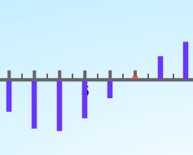

Question: What causes particles to move back and forth as a wave passes?

- Observe: Turn off Displacement and turn on Pressure. Click Play, and then click Pause after about 100 milliseconds. Identify the compressions and rarefactions in the tube.

- What do you notice about the air pressure in the compressions? ________________

___________________________________________________________________

- What do you notice about the air pressure in the rarefactions? _________________

___________________________________________________________________

- How does the spacing of dividers in the tube relate to the air pressure? __________

___________________________________________________________________

- Predict: You can predict the motion of a divider by comparing the air pressure on either side.

- Look at the bar representing the red divider. Is the air pressure higher in the chamber to the left or to the right of the divider? ____________________________________
- In which direction do you think the divider is being pushed right now? ____________

- Click Play. Were you correct? Explain. ____________________________________

___________________________________________________________________

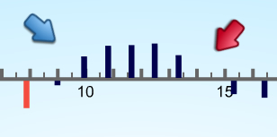
- Compare: Click Pause. Open the Tools palette at top right. Drag an arrow to a region of the graph where the pressure increases from left to right and a second arrow to a region where the pressure decreases from left to right. An example is shown at right.

Turn off Pressure and turn on Acceleration.

What do you notice? ________________________________________________________

_________________________________________________________________________

(Activity B continued on next page)
Activity B (continued from previous page)

- Analyze: What can you say about the acceleration of dividers when the pressure increases from left to right? ___________________________________________________________
_________________________________________________________________________

What can you say about the acceleration when the pressure decreases from left to right?

_________________________________________________________________________

- Make a rule: Based on what you have observed, how can you predict the acceleration of a divider based on the pressure graph? ___________________________________________
_________________________________________________________________________

- Think and discuss: Why do you think a longitudinal wave is also called a pressure wave?

_________________________________________________________________________

- Compare: Return the arrows to their tray and turn on the Displacement graph. How is the displacement graph related to the acceleration graph? ______________________________
_________________________________________________________________________

- Explain: To explain this relationship, imagine a single divider moving back and forth between two stationary walls.

- What happens to the air pressure on each side of the divider as it moves to the right? ___________________________________________________________________
- What happens to the air pressure on each side of the divider as it moves to the left? ___________________________________________________________________
- How does this explain the acceleration of the divider? ________________________

___________________________________________________________________

___________________________________________________________________

The fact that acceleration opposes displacement helps to explain the harmonic motion, or back-and-forth motion, of many waves.

Extension:  Standing waves | Get the Gizmo ready:  - Click Reset, and select a Closed tube.  - Set the Strength to 0.10 and Freq. to 14 Hz.  - Check that Displacement is on.  - Turn off Velocity, Acceleration, and Pressure. | 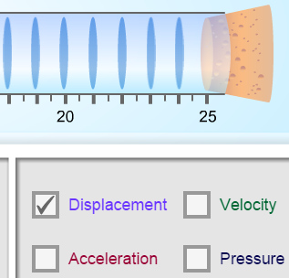

Introduction: When waves hit a wall, they often bounce back. The reflected waves can interact with the oncoming waves in a phenomenon called interference. Interference can increase or decrease the strength of waves, depending on how the waves are lined up.

Question: What is the result of wave interference?

- Observe: Click the zoom in button (+) on the graph twice. Click Play, and watch the simulation for about 500 milliseconds of simulation time.

- Over time, do the waves in the graph seem to be changing in size? ______________

- If so, are the waves getting bigger or smaller? ______________________________

- Are there dividers that seem to move less than the other dividers? ______________

- Can you see the path of individual waves from left to right in the tube? ___________

- Label: What you are watching is a standing wave. This occurs when the waves that reflect off the right wall of the tube interact with the waves moving down the tube from left to right.

- Locate the three points that do not show much displacement at all, and mark them with arrows from the POINTER tray. These are the nodes of the standing wave.
Click the camera icon () to take a snapshot of this graph. Right click the image, choose Copy, and then paste the image into a blank document. Label this image “Nodes of a standing wave.”

- Return the arrows marking the nodes, and now mark the antinodes where displacement is maximized. Take a snapshot, paste it into your document, and label this image “Antinodes of a standing wave.”

- Challenge: Experiment with other values of Strength and Freq. to create other examples of standing waves. What values of Strength and Freq. lead to a standing wave with four nodes? Five nodes? Describe your results on a separate page.

