Name: Date:

Student Exploration: Lucky Duck

Vocabulary: expected value, experimental probability, fair game, outcome, probability distribution, random variable, theoretical probability

Prior Knowledge Questions (Do these BEFORE using the Gizmo.)
Arnie the carnie, from behind his carnival booth, catches you on the way to the Ferris wheel. “Hey there! Think you can draw the lucky duck? Don’t let your chance float away!”
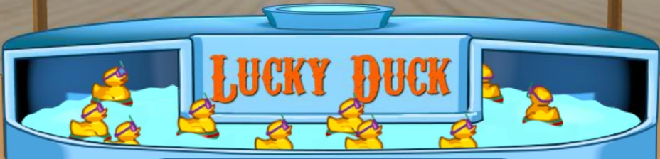

- Arnie’s game has 10 rubber ducks in a pond, each with a prize on the bottom. The ducks look identical, but 2 of them win you a big prize, 3 win a small prize, and 5 win no prize at all.

If you pick one duck at random, what is the probability of winning a small prize?

- After a player picks a duck, Arnie always puts that duck back in the pond. How does this affect the next player’s chances to win?

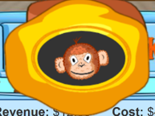Gizmo Warm-up
In the Lucky Duck Gizmo™, you draw ducks at a carnival game. You win the prize shown on the bottom of the duck. See if you can beat the odds! More importantly, see if you can help your friend Arnie the carnie break even, or make money.

- In the Gizmo, click on a duck to draw it (or click Draw 1).

What did you win?

The prize you win varies, and is random, so it is an example of a random variable.

- Click Clear. Press the Draw 10 button. How many of each type of prize did you win?

No prize Small prize (banana) Big prize (monkey)

The result of each draw is called an outcome of the experiment.

Activity A:  What happens in the long run? | Get the Gizmo ready:  - In Play the Game mode, be sure Game A is selected and the game cost is $1.50.  - If not, click refresh or reload in your browser.  - Click Clear to erase any old results. | 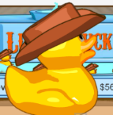

You are back at your favorite carnival game, Lucky Duck, run by your friend Arnie the carnie. Today’s prizes are a stuffed banana (small prize) and a stuffed monkey (big prize).

- You step up to play. Click Draw 1 (or click on a duck). What did you win?

- Curious about today’s odds, you decide to watch a few more people play the game.

  - Click Draw 10. Now that 11 people (including you) have played, how many won:

No prize Small prize Big prize

  - Now write the frequency of each outcome as a fraction (out of 11).

No prize Small prize Big prize

Each fraction gives the experimental probability of that outcome.

  - By the end of the day, 100 more people have played Lucky Duck (for a total of 111). Click Draw 100. Based on your results now, what are the experimental probabilities?

No prize Small prize Big prize

  - Why are “end-of-the-day” estimates probably better than early ones?

- As night falls, Arnie closes Lucky Duck, after 111 people played. He asks for your help figuring out if he made or lost money today. Fill in the values below:

  - Arnie’s revenue per player Total revenue today

  - How much did Arnie pay for each prize? (Click or tap a prize to see its value.)

Arnie paid for each small prize and for each big prize.

  - What were his total costs (total giveaway value) and avg. giveaway per player today?

Total giveaway value Avg. giveaway value (per player)

  - What is his net gain/loss today? Click Show cost/revenue to check.

(Activity A continued on next page)
Activity A (continued from previous page)

- Arnie has an app that graphs his data over the course of that day. Click the Trends tablet (or click Show trends). Zoom out (–) a few times to see today’s Net gain/loss graph.

  - What does today’s net gain/loss graph look like?

  - The next day, Arnie has 100 more people play his game. Click Clear and Draw 100. How does today’s net gain/loss graph compare to yesterday’s graph?

- Go to Design the game mode. This shows you the actual numbers of ducks Arnie has in the pond. Fill the table with the values from the Gizmo.

 | No prize | Small prize | Big prize
Number of ducks
Prize value | $0

  - How likely is each outcome when drawing one duck? (Write answers as fractions.)

No prize Small prize Big prize

These fractions give the theoretical probability of each outcome.

  - Theoretically, if 100 customers played Lucky Duck one day with the current setup (Game A), and the results exactly matched the probabilities, how many would win:

No prize Small prize Big prize

  - If a small prize costs Arnie $2, and a large prize costs $8, what would the total value of prizes given away to the 100 customers be?
  - For these 100 games, what would the average prize giveaway value be?

The expected value is the long-run average outcome of a random variable.

  - Why is Arnie losing money with his current game setup?

  - If Arnie wants to break even or make money, what would you advise him to do?

Activity B:  Fair games | Get the Gizmo ready:  - Be sure Game A is selected, and the cost to play is $1.50. (If not, refresh or reload your browser.)  - In Play the game mode, click Clear.

- Arnie the carnie runs Lucky Duck. He’s been losing money, and asks for your help. He tells you he uses the Game A setup, charges $1.50 to play, and gets about 100 players per day.

  - You ask for a few days of data. Open the Cost/revenue table and Trends graphs. Click Draw 100. Record Arnie’s net gain/loss and average giveaway for day 1.

 | Players | Net gain/loss | Avg. giveaway | Cost to play
Day 1 | 100 |  |  | $1.50
Day 2 | 100 |  |  | $1.50
Day 3 | 100 |  |  | $1.50

  - Click Clear and repeat the process for days 2 and 3. Fill in the values in the table.

  - Why is Arnie losing money?

- Arnie agrees to show you how many ducks of each type he actually has in the pond.

- Select Design the game. Use the numbers there to fill in this table.

 | No prize | Small prize | Big prize
Theoretical probability (as a fraction)
Prize value | $0
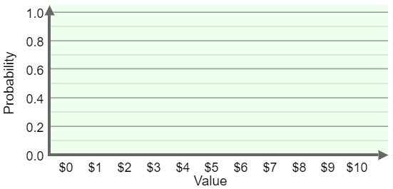
- Draw a bar graph that displays these probabilities, for the three prize values used in Game A.

When you are done, click Show probability distribution to check your bar graph in the Gizmo.

A probability distribution is a table or graph that lists all the possible outcomes and probabilities of a random variable.

(Activity B continued on next page)
Activity B (continued from previous page)

- Now that Arnie has shown you his Game A setup (numbers of ducks and prize values), you tell him that you’ll go run some numbers for him.

- In the given space, find the expected value of Arnie’s average giveaway.

Select Show expected value to see if your answer matches the carnival bookkeeper’s answer.

- How much should Arnie charge for this game, to break even?

- Set your game cost in the Gizmo. Then, in Play the game mode, click Draw 100 several times. How is Arnie doing now?

If Arnie’s long-term average gain/loss is zero, then from a player’s perspective, the cost to play equals their expected winnings. That is the definition of a fair game.

- Arnie would like to try two new games setups later this week – Game B and Game C.

- Figure out what Arnie should charge to make Game B and Game C fair games. Show your work in the space given here. Then check your answers in the Gizmo.

Fair cost for Game B: Fair cost for Game C:

- Play Game C with the fair cost you just found, for 5 days (100 players per day). Record Arnie’s gain or loss for all 5 days. (Click Clear at the start of each day.)

GAME C | Day 1 | Day 2 | Day 3 | Day 4 | Day 5
Gain/Loss

- Arnie calls you, a bit annoyed. He says he always sets up a fair game, but still loses money some days. He thinks something must be wrong. What would you tell him?

Activity C:  Lucky Duck game master | Get the Gizmo ready:  - Select Play the game.  - Click Clear.

Arnie is ready to have a business partner for his Lucky Duck game. He wants to hire you as his Lucky Duck assistant and game master, but first he wants to make sure you know your stuff.

- Arnie sets up a random game of Lucky Duck. (Select Random from the Game dropdown.) He asks you to draw ducks until you think you know what cost will make this a fair game.

  - What game cost do you estimate will make this game fair?

  - How many ducks did you draw to feel confident in your estimate? Explain.

  - In Design the game, click Show expected value. How close was your estimate?

- Next weekend, Arnie wants to charge $3.00 per draw on both Saturday and Sunday, but with different game setups (prize values and numbers of ducks) each day.

  - In Design the game, create two different setups for Arnie. Be sure they are fair games with a $3.00 cost. Write the values for each setup in the tables.

SATURDAY | No prize | Small prize | Big prize
Number of ducks
Prize value | $0

SUNDAY | No prize | Small prize | Big prize
Number of ducks
Prize value | $0

  - In this space, show Arnie why $3.00 is a fair price for both setups. Then, in the Gizmo, play each game for at least 100 draws. Click Show expected value for both.

(Activity C continued on next page)
Activity C (continued from previous page)

- 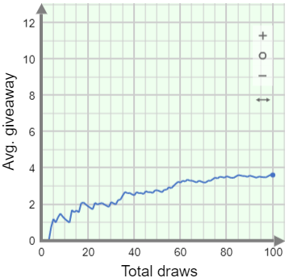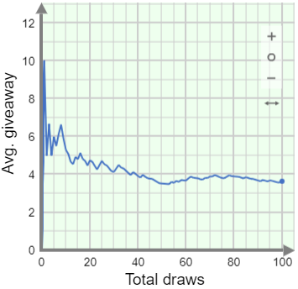Arnie wants help interpreting the graphs in his app. These two graphs show his average giveaway value for two different days. He used the same setup (ducks and prize values) on both days.

- Explain to Arnie how these graphs could happen, even with the exact same setup.

- Why do both graphs flatten out?

- Roughly what game cost would make this a fair game?

- Just for fun, Arnie asks you to design games with the biggest and smallest possible expected giveaway values. Enter your game setups in the Gizmo, and in the tables here.

BIGGEST | No prize | Small prize | Big prize
Number of ducks
Prize value | $0

SMALLEST | No prize | Small prize | Big prize
Number of ducks
Prize value | $0

What are the expected average giveaway values for these setups? Calculate them in the space given here. Then check them by playing your games in the Gizmo.

Expected average giveaway values: Biggest Smallest

