Name: ______________________________________ Date: ________________________

**Student Exploration: Magnetic Induction**

**Vocabulary:** current, induced magnetic field, magnetic field, Pythagorean Theorem, right-hand rule

**Prior Knowledge Questions** (Do these BEFORE using the Gizmo.)

1. Where does the needle on a compass normally point? ______________________________
2. What will happen to the compass needle if you hold a magnet close to it? ______________

_________________________________________________________________________

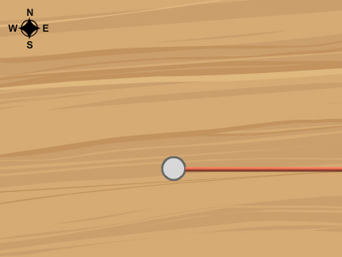**Gizmo Warm-up**

A compass is a useful tool for measuring the direction of a *magnetic induction field*—more commonly called a **magnetic field**—because the needle's northern tip points in the direction of a field. In the *Magnetic Induction* Gizmo, you will use compasses to measure the magnetic field caused by a **current**.

The left side of the Gizmo shows an overhead and front view of a table with a wire threaded vertically through its center, perpendicular to the surface of the table. Check that the **Current** is set to 0 amps.

1. Drag a compass to several different locations on the table. Where does the compass needle point? ____________________________________________________________________

The effect you see is due to Earth's magnetic field.

1. Slowly increase the **Current** value from 0 to 60 amps. Describe what happens: __________

_________________________________________________________________________

1. Move the compass around on the table. What do you notice? ________________________

_________________________________________________________________________

_________________________________________________________________________

|  |  |  |
| --- | --- | --- |
| **Activity A:**  **Observing induction** | Get the Gizmo ready:   * Set the **Current** to 0 amps. | SE2 |

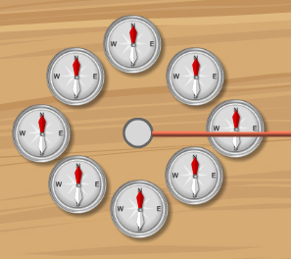**Goal: Use compasses to determine the direction of magnetic field induced by a current in a wire.**

1. Predict: Place the compasses in a circle around the wire as shown at right. What do you think will happen as you slowly drag the **Current** slider all the way to the right?

_________________________________________________

_________________________________________________

1. Test: Use the Gizmo to test your prediction. Describe the results: _____________________

_________________________________________________________________________

1. Observe: Look at the **Front view**.

In which direction is the current moving through the wire? ___________________________

(Note: By convention, the current direction shown is the direction of positive charge. In reality, electrons move in the opposite direction through the wire.)

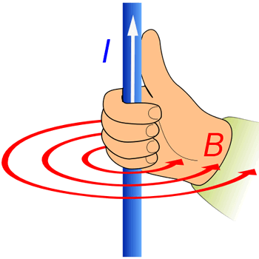

1. Predict: Scientists use the **right-hand rule** to predict the direction of an **induced magnetic field**—or a magnetic field created by a current. To use the right-hand rule, position your right hand so that the thumb points in the direction of the current. The magnetic field lines wrap around the wire in the same direction as the fingers of your right hand.

If the current was pointed down, will the induced magnetic field be clockwise or counterclockwise? ________________________

1. Test: Set the **Current** to -60 amps.
   * 1. In which direction is the current now moving through the wire? _________________
     2. What is the direction of the induced magnetic field? __________________________
2. On your own: Use a battery, wire, and small compass to demonstrate magnetic induction. Describe your results in your science journal or notebook.

|  |  |  |
| --- | --- | --- |
| **Activity B:**  **Magnetic field interactions** | Get the Gizmo ready:   * Remove all the compasses from the table. * Turn on **Show grid** and **Show magnetic field sensor**. * Set the **Current** to 0 Amps. | MagneticInductionSE5 |

**Question: How does Earth's magnetic field interact with an induced magnetic field?**

1. Experiment: You can use the probe to measure the strength of the magnetic field (represented by the symbol *B*) at various locations on the grid. The unit for magnetic field strength is the gauss (G). Move the probe to different places on the grid.
2. What is the strength of the magnetic field? _________________________________
3. Why is there a magnetic field even when there is no current? __________________

___________________________________________________________________

1. Observe: Set the **Current** to 50 amps. Place the probe at point (50, 0).
2. What is the strength of the field? _____________
3. To find the strength of the induced magnetic field alone, subtract the strength of Earth's magnetic field from value you measured in part A.

What is the strength of the induced magnetic field alone? _____________

1. Compare: Now, move the probe to (-50, 0).
2. What is the total strength of the field? _____________
3. How does this compare to the strength of the field at point (50, 0)? _____________
4. Infer: What do you think can account for the difference in field strengths at positions (50, 0) and (-50, 0)? ______________________________________________________________

_________________________________________________________________________

1. Observe: Place compasses at (50, 0) and (-50, 0). Use your observations to explain why the field strength is greater at position (50, 0). _______________________________________

_________________________________________________________________________

**(Activity B continued on next page)Activity B (continued from previous page)**

1. Predict: You will now use the observations you have made so far to predict what the strength of the field will be at point (0, 50).
2. Using the right-hand rule, which direction is the magnetic field at (0, 50)? _________
3. Since the magnetic field of the Earth and the induced field are at right angles, you can use the **Pythagorean Theorem** to determine the strength of the combined field.

This theorem states that the square of the length of a right triangle’s hypotenuse (*c*) is equal to the sum of the squares of the lengths of the two legs (*a* and *b*): *a2* + *b2* = *c2*. In this situation, *a* is the strength of Earth's magnetic field and *b* is the strength of the induced magnetic field.

Based on the strength of field at points (50, 0) and (-50, 0), what do you think the strength of the magnetic field will be at point (0, 50)? Show your work below.

Strength of field at (0, 50): _______________

Use the Gizmo to check your answer.

|  |  |  |
| --- | --- | --- |
| **Activity C:**  **Current and distance** | Get the Gizmo ready:   * Set the **Current** to 0 amps. * Turn on **Show grid** and **Show magnetic field sensor**. | SE5 |

**Question: How does current and distance affect the strength of an induced field?**

1. Predict: How do you think increasing the current running through the wire will affect the strength of the induced field? _________________________________________________
2. Collect data: For each of the currents listed below, record the strength of the field at (50, 0).

|  |  |  |
| --- | --- | --- |
| **Current (amps)** | **Strength of field at (50, 0)** | **Strength of induced field** |
| 10 |  |  |
| 20 |  |  |
| 30 |  |  |
| 40 |  |  |

1. Analyze: To calculate the strength of the induced field, subtract the strength of Earth's magnetic field (0.50 G) from the value in the middle column.

Describe any patterns you see: ________________________________________________

_________________________________________________________________________

1. Apply: What will the strength of the induced field be if you increase the current to 60 amps?

Strength at 60 amps: ___________________ Use the Gizmo to check your answer.

1. Collect data: Now, you'll investigate how distance affects magnetic field strength. Set the **Current** to 30 amps. Move the probe to each of the points listed below. Record the strength of the magnetic field for each of these locations in the second column.

|  |  |  |  |
| --- | --- | --- | --- |
| **Position of probe** | **Strength of field (G)** | **Strength of induced field (G)** | **Current/distance(*I*/*d*) (amps/mm)** |
| (30, 0) |  |  |  |
| (60, 0) |  |  |  |
| (120, 0) |  |  |  |

**(Activity C continued on next page)Activity C (continued from previous page)**

1. Analyze: To determine the strength of the induced field, subtract the strength of Earth's magnetic field from the total strength of the field. What do you notice about the relationship between the distance from the wire and the strength of the induced field?

_________________________________________________________________________

1. Calculate: Now, divide the current (30 amps) by the distance the probe is from the wire (*d*). (Note: The distance from the wire is given by the *x*-coordinate of the probe's position.) Use this value to complete the fourth column of the table.

What do you notice about this value? ___________________________________________

1. Create: Create a formula giving the strength of the induced field (*B*) in terms of current (*I*) and the distance from the wire to the probe (*d*).

*B* =

1. Apply: Use your formula to predict the strength of the induced field at point (110, 0).
2. What would the strength of the field be? ___________________________________
3. Use the Gizmo to check your calculation. What is the strength of the induced field at this point? (Note: Don't forget to subtract the strength of Earth's magnetic field.)

___________________________________________________________________

1. Test: Suppose you increase the current to 40 amps. What would the strength of the field be at (110, 0)? _______________________________________________________________

Use the Gizmo to check your answer.

1. Apply: Use what you learned in activity B and what you learned above to determine the strength of the field at point (0, 60) if the wire has a current of 15 amps. (Hint: First, calculate the induced field. Then, use the Pythagorean Theorem to determine the strength of the combined field.) Show your work below.

Strength of field at (0, 60): _______________

Use the Gizmo to check your answer.