Name: ______________________________________ Date: ________________________

Student Exploration: Magnetism

Vocabulary: attract, bar magnet, ferromagnetic, magnetize, north pole, repel, south pole

Prior Knowledge Questions (Do these BEFORE using the Gizmo.)

- What happens when you place two magnets close together? ________________________

_________________________________________________________________________

- What objects do magnets stick to? Make a list. ____________________________________

_________________________________________________________________________

- What do these objects have in common? ________________________________________

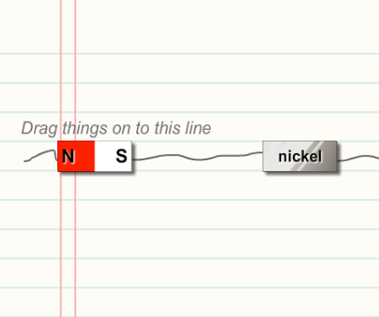
Gizmo Warm-up: What is attracted to magnets?

A bar magnet is a simple rectangular magnet. If you hang a bar magnet by a string, the north pole (N) of the magnet will tend to point north while the south pole (S) of the magnet points south.

- Look at the materials at the bottom of the Gizmo. Which ones do you think will stick to a bar magnet?

_________________________________________

- Ferromagnetic materials are strongly attracted to magnets. Drag a bar magnet and the piece of nickel onto the scribbled line. Press Play ().

A. Is nickel ferromagnetic? _________

B. How do you know? ____________________________________________________

- Test copper, wood, glass, and iron. Which ones are ferromagnetic? ___________________

_________________________________________________________________________

Activity A:  Attract or repel? | Get the Gizmo ready:  - Check that the MAGNETIC FORCES tab is selected.  - Click Reset (). | 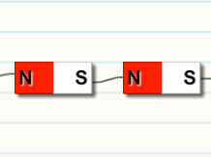

Question: How do magnets interact?

- Observe: Drag two bar magnets onto the paper and press Play. Then click Reset. Change one of the magnets (either from N-S to S-N, or vice-versa). Click Play again.

    - What happened the first time? ___________________________________________

    - What happened the second time? ________________________________________

- Form hypothesis: Magnets are either pulled together (attracted) or pushed apart (repelled). Based on what you have seen, when are magnets attracted and when are they repelled?

_________________________________________________________________________

_________________________________________________________________________

- Predict: Based on your hypothesis, which pairs of magnets will be attracted to each other? Which will be repelled? Record your predictions below. (Leave the result blank for now.)

Left magnet | Right magnet | Prediction  (Attract or repel?) | Result  (Attract or repel?)

- Run Gizmo: Test your predictions using the Gizmo. Record your results in the table.

- Draw conclusions: Fill in each blank below with the correct word.

    - The south pole of a magnet is attracted to the ___________ pole of another magnet.

    - The south pole of a magnet is repelled by the ___________ pole of another magnet.

    - The north pole of a magnet and the north pole of another magnet will ____________ each other.

Activity B:  Magnetic field lines | Get the Gizmo ready:  - Click Reset and drag all objects off the paper.  - Select the MAGNETIC FIELD LINES tab. | 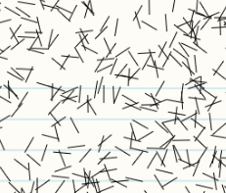

Question: If you scatter iron filings (little slivers of iron) around a magnet, you will see a pattern of magnetic field lines. What do these lines show you?

- Observe: Drag one magnet onto the paper. Click Sprinkle filings and then Tap table five or six times. Sketch the pattern you see in the box:

What do you notice about the iron filings?

________________________________________

- Observe: Drag a second magnet next to the first. Click Sprinkle filings and then click Tap table several times. Sketch what you see.

Will these magnets be attracted or repelled?

________________________________________

- Observe: Now switch one of the magnets. Click Sprinkle filings and then click Tap table several times. Sketch what you see.

Will these magnets be attracted or repelled?

________________________________________

- Draw conclusions: Compare the magnetic field lines you have sketched. How can you use the field lines to tell if magnets will be attracted or repelled?

_________________________________________________________________________

_________________________________________________________________________

- Extend your thinking: Observe the magnetic field lines produced by an N-S magnet and the mystery magnet. Will these magnets attract or repel each other? First, make a prediction below. Then, check your answer on the MAGNETIC FORCES tab.

Prediction: ________________________ Actual result: ________________________

Extension:  Magnetic materials | Get the Gizmo ready:  - Select the MAGNETIC FIELD LINES tab.  - Drag an S-N magnet and the copper bar onto the paper. | 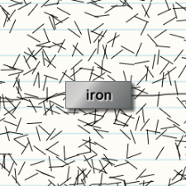

Question: Why do magnets attract certain materials?

- Observe: Click Sprinkle filings and then click Tap table several times. Look closely at the filings near the copper bar. Does copper have any effect on the filings?

_________________________________________________________________________

- Observe: Repeat the experiment with iron. What effect does iron have on the filings?

_________________________________________________________________________

_________________________________________________________________________

- Analyze: Which of these materials is ferromagnetic? _______________________________

- Draw conclusions: How can you tell if an object is ferromagnetic by looking at its field lines? Discuss your answer with your teacher and classmates.

_________________________________________________________________________

_________________________________________________________________________

- Apply: Select the MAGNETIC FORCES tab and experiment with the Gizmo. Try to answer the questions below. Share your findings with your classmates and teacher.

  - Can a magnet ever repel a ferromagnetic material? __________________________

  - In the Gizmo, does one ferromagnetic material attract another? _________________

- Experiment (optional): When a ferromagnetic material like iron is placed near a magnet, it becomes magnetized—it actually becomes a magnet! (Look at the field lines when iron is near a magnet.) Even after the magnet is removed, iron can stay magnetized for a while.

In “real life” (not in the Gizmo), rub a metal paper clip with a magnet. What happens when you touch another paper clip with your magnetized paper clip?

_________________________________________________________________________

