Name: Date:

**Student Exploration: Mascot Election**

**Vocabulary:** bar graph, frequency, frequency table, horizontal axis, pictograph, scale, tally chart

**Prior Knowledge Questions** (Do these BEFORE using the Gizmo.)

The table and graph below show the results of the 2008 South Carolina Republican Primary.

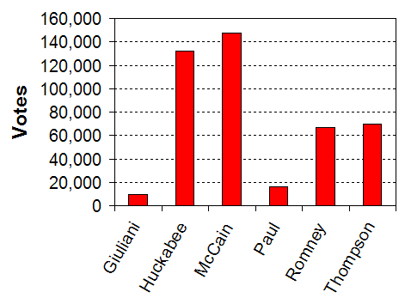

|  |  |
| --- | --- |
| **Candidate** | **Votes** |
| Giuliani | 9,494 |
| Huckabee | 132,440 |
| McCain | 147,283 |
| Paul | 16,054 |
| Romney | 67,132 |
| Thompson | 69,467 |

1. Which display makes it easier to see who won, the table or the graph? _________________
2. Explain. __________________________________________________________________



**Gizmo Warm-up**

It’s the grand opening of Bland Mountain Elementary School, and at the first school assembly the students get to elect a new mascot. There are four choices: Eagle, Lion, Bear, and Wolf.

In the *Mascot Election* Gizmo, check that the **Initial** scenario is selected. Click **New**. Drag the **Students** slider to fill the auditorium with 100 students. After the auditorium is full, click **Vote**.

1. Look at the students in the auditorium. Which mascot do you think won? _______________
2. On the right side, check that **Table** is selected. A **frequency table** reports the **frequency**, or number, of each result. According to the table, which mascot won? ____________________
3. A group of students decides to change their votes. Click and drag to select a row of students, and then click one of the mascots at the top left. How does this affect the results?

_________________________________________________________________________

|  |  |  |
| --- | --- | --- |
| **Activity A:**  **Tables and tallies** | Get the Gizmo ready:   * Select **One favorite** from the **Scenario** menu. * Next to **Display**, check that **Table** is selected. * Set the **Students** to 50. | 1029SE2 |

1. Click **New**, and then click **Vote**. Look at the table. What were the results?

Eagle: _____ Lion: _____ Bear: _____ Wolf: _____

1. In the **Display** menu, select the **Tally chart**. A **tally chart** uses vertical line segments called tally marks to display the results.
   1. How many votes does each tally mark (**|**) represent? __________
   2. How many votes does each set of tally marks (**||||**) represent? __________
   3. How would you show 18 votes with tally marks? _____________________________

1. Select **Table**. You can change votes by selecting students and clicking a mascot. You can also click and drag to select a group of students. Set the votes so that Eagle gets 16 votes, Lion gets 18 votes, Bear gets 12 votes, and Wolf gets 4 votes.

Make a tally chart at right to show these results. Then select **Tally chart** to check your work.

|  |  |
| --- | --- |
| **Mascot** | **Tally** |
| Eagle |  |
| Lion |  |
| Bear |  |
| Wolf |  |

1. Suppose you were standing at the classroom door, recording the shirt color of students as they walked in. Would you use a frequency table or a tally chart? _____________________

Explain why. ______________________________________________________________

_________________________________________________________________________

_________________________________________________________________________

1. Would you use a tally chart to display the result of a national election? _________________

Explain why or why not. ______________________________________________________

_________________________________________________________________________

_________________________________________________________________________

|  |  |  |
| --- | --- | --- |
| **Activity B:**  **Pictographs** | Get the Gizmo ready:   * Select **Three favorites** from the **Scenario** menu. * Check that **Tally chart** is selected. * Set the **Students** to 100. | 1029SE3 |

1. Click **New**, and then click **Vote**. Look at the tally chart. What were the results?

Eagle: _____ Lion: _____ Bear: _____ Wolf: _____

1. 1029SE4Select the **Pictograph**. This **pictograph** uses symbols to represent the results.
   1. 1029SE4Look at the **Key** at the bottom. How many votes does each represent? ________
   2. 1029SE4Now change the **Key** so that each represents 10 votes. How does this change the graph? _____________________________________________________________
   3. check partialWhat does it mean if you can see only part of a symbol, like ? _________________

___________________________________________________________________

1. Select **Table** and set the votes to: Eagle = 25 votes, Lion = 20, Bear = 15, and Wolf = 40.

Fill in the two pictographs below to display these results. Use a different scale for each pictograph, and fill in the keys below each pictograph. Check your work with the Gizmo.



1. What are some advantages and disadvantages of using a pictograph to display results?

_________________________________________________________________________

_________________________________________________________________________

_________________________________________________________________________

|  |  |  |
| --- | --- | --- |
| **Activity C:**  **Bar graphs** | Get the Gizmo ready:   * Select **Two favorites** from the **Scenario** menu. * Select **Table**. * Check that **Students** is set to 100. | 1029SE6 |

1. Click **New**, and then click **Vote**. Look at the table. What were the results?

Eagle: _____ Lion: _____ Bear: _____ Wolf: _____

1. 1029SE91029SE8Select the **Bar graph (horizontal)**. A **bar graph** uses bars to display the results. Click the and arrows to adjust the **scale** of the graph until all the bars are clearly visible.
2. The **horizontal axis** is the horizontal number line below the bar graph. What is the largest number you can see on the horizontal axis? __________________________
3. Compare the **Bar graph** to the **Pictograph**. How are they similar? ______________

___________________________________________________________________

1. How are the pictograph and bar graph different? ____________________________

___________________________________________________________________

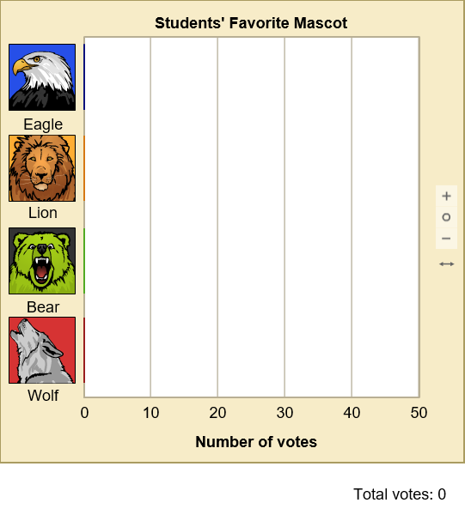

1. Click **New**. Select **Table**, and click **Vote**. What were the results?

Eagle: _____ Lion: _____

Bear: _____ Wolf: _____

1. Fill in the bar graph to the right to display these results. Use the Gizmo to check your work.
2. Suppose you wanted to quickly know who won an election. Would you rather look at a bar graph or a frequency table? Explain. ____________________________________________

_________________________________________________________________________

1. Suppose you wanted to know the exact number of people who voted for a candidate. Would you rather look at a bar graph or at a frequency table? Explain. _______________________

_________________________________________________________________________