Name: ______________________________________ Date: ________________________

Student Exploration: Measuring Motion

Vocabulary: distance, speed

Prior Knowledge Questions (Do these BEFORE using the Gizmo.)

The speed of an animal is how fast it is moving. A speed of 6 m/s (meters per second) means that the animal moves a distance of 6 meters every second.

- How would you measure the speed of an animal? _________________________________

_________________________________________________________________________

- What do you think are the fastest animals? _______________________________________

_________________________________________________________________________

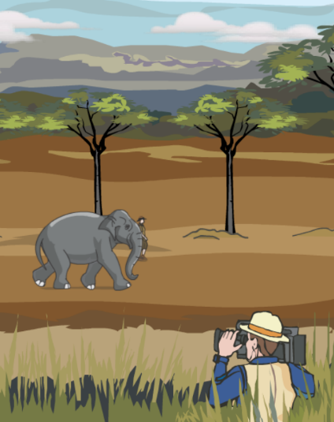
Gizmo Warm-up
You have been sent on an African safari by International Geography magazine. Your assignment is to find the fastest land animals in the world. Your only tool is a video camera.

The safari is shown in the Measuring Motion Gizmo.

- On the SAFARI ADVENTURE tab, wait for an animal to pass by. Press the record button ( ). Press stop ( ) when the animal has passed by.

  - Which animal did you record? _________________

  - Was the animal walking or running? ____________

- Select the PLAYBACK tab. Practice using some of the different buttons on this tab:
- Use the Play ( ) button to replay the simulation.
- Click Rewind ( ) to go back to the beginning.
- Click Advance frame ( ) to move forward exactly one second at a time.
- Click Tools at upper left, and drag some arrows ( ) onto the recording to mark the positions of the animals at different times.
- Use the Time slider to go to a specific time.

Activity A:  Estimating speed | Get the Gizmo ready:  - Select the SAFARI ADVENTURE tab.  - Remove all arrows from the screen.  - A calculator is recommended for this activity. | 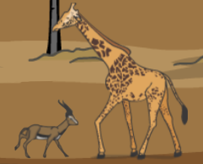

Question: How do you measure speed?

- Run Gizmo: Record an animal running. Then switch to the PLAYBACK tab and watch your recording. Which animal did you record? ________________________________________

- Measure: Click Rewind ( ). Use Advance frame ( ) to advance the recording one second. Mark the animal’s position with an arrow ( ) and repeat. Estimate the distance the animal traveled in one second. (Note: The trees in the background are 5 meters apart.)

    - About how far did the animal travel in 1 second? ____________________________

    - How did you make your estimate? ________________________________________

___________________________________________________________________

___________________________________________________________________

- Calculate: The distance an animal travels each second is its speed. What is the estimated speed of this animal? _________________________ (Units are meters per second, or m/s.)

- Measure: You can get a more accurate estimate of distance and time using these steps:
- Use the Time slider to position the animal so that its nose is even with the first tree. Record the current time in the table below as Time 1.
- Position the animal so that its nose is even with the last tree and record Time 2.
- Subtract the first time from the second to get the Time difference.
- Record the Distance from the first tree to the last. (The trees are 5 meters apart.)

Time 1 | Time 2 | Time difference (s) | Distance (m)

- Calculate: The speed of the animal is equal to the distance divided by the time difference.

    - What is the estimated speed of the animal now? ____________________________

    - Is this value close to the speed you calculated before? _______________________

Activity B:  Who’s fastest? | Get the Gizmo ready:  - Select the SAFARI ADVENTURE tab.  - Remove all arrows from the screen.  - A calculator is recommended for this activity. | 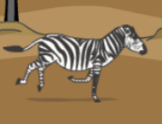

Question: Which animal is the fastest?

- Form hypothesis: Watch the SAFARI ADVENTURE tab for a while. Based on your observations, which animals run the fastest? _____________________________________

- Measure: For each animal, measure distance traveled and time using any method you wish. Divide distance by time to calculate speed. Measure running animals only.

Animal/object |  | Distance (m) | Time (s) | Speed (m/s)
Cheetah
Eagle | 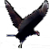
Elephant | 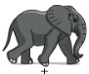
Gazelle | 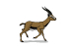
Giraffe | 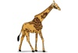
Jeep | 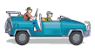
Lion | 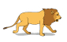
Person | 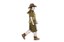
Rhino
Warthog
Zebra | 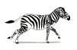

- Analyze: What is the fastest animal/object? _______________ Slowest? _______________

- Convert: There are 1,000 meters in a kilometer, and 3,600 seconds in an hour. You can convert units of meters per second (m/s) into kilometers per hour (km/h) by multiplying by 3,600 and dividing by 1,000. (Hint: That is the same thing as multiplying by 3.6.)

  - What is the speed of a cheetah in kilometers per hour? _______________________

  - What is the speed of a person in kilometers per hour? ________________________

