Name: _____________________________________ Date: ________________________

Student Exploration: Measuring Trees

Vocabulary: circumference, cross section, diameter, drought, growth ring, precipitation

Prior Knowledge Questions (Do these BEFORE using the Gizmo.)

- Trees grow throughout the year. During which season(s) do you think trees grow fastest? _________________________________________________________________________

- During which season(s) do trees grow most slowly? ________________________________

- What weather conditions could make trees grow more quickly than normal? _____________

_________________________________________________________________________

- What weather conditions could make trees grow more slowly than normal? _____________

_________________________________________________________________________

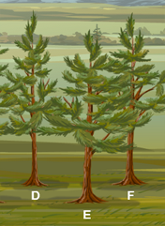
Gizmo Warm-up
The Measuring Trees Gizmo shows part of a forest. Click tree E to select it. On the right side of the Gizmo, a cross section of the tree is displayed. Click Show larger view for a larger image.

- The rings on the tree are called growth rings. Click Zoom in for a clearer view. How many rings can you count? _____________

- Click Return to forest, and then click Advance year once. How many growth rings are there now? _______________________

- Click Advance year again and count the rings. How many are there now? ______________

- What does the number of rings tell you about the tree? _____________________________

_________________________________________________________________________

Activity A:  Measuring trees | Get the Gizmo ready:  - Click Return to forest, and then click Reset.  - Check that the Preset forest is shown (text at top). If not, click Refresh or Reload on your browser. | 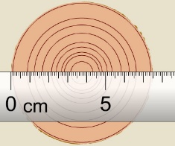

Question: How can you measure a tree?

- Observe: Look at the trees in the forest.

Which tree do you think is the youngest? ______________ Oldest? ______________

- Collect data: Measure each tree in the following ways. (Tree A has been done for you.)
  - Click the tree you want to measure. Estimate the height to the nearest tenth of a meter using the draggable ruler. (For example, the height might be 2.6 meters.)
  - Click Show larger view. Determine the age of the tree by counting growth rings. Use Zoom in as needed. (Hint: Do not count the bark of the tree as a separate ring.)
  - The diameter is the width of the tree trunk. Measure the diameter using the ruler. Write the diameter to the nearest tenth of a centimeter.
  - The circumference is the distance around the tree trunk. Click Find circumference to measure the circumference to the nearest tenth of a centimeter.

Tree | Height | Age | Diameter | Circumference
A | 6.9 m | 9 years | 7.4 cm | 23.3 cm
B
C
D
E
F

- Analyze: How does the age of a tree relate to its size? ______________________________

_________________________________________________________________________

- Extend your thinking: Compare the circumference values to the diameters. About how many times the diameter is the circumference? ________________________________________
_________________________________________________________________________

Activity B:  Tree growth | Get the Gizmo ready:  - If necessary, click Return to forest to see the forest view. | 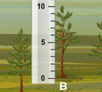

Question: How does precipitation (rain, snow, sleet, or hail) affect tree growth?

- Observe: Use the Gizmo to explore how precipitation affects tree growth. You can alter the amount of precipitation using the slider. Click Advance year to advance one year forward.

- Form hypothesis: If there is more precipitation, how will tree growth change? ____________

_________________________________________________________________________

- Experiment: Click Reset and select tree E. Set the Precipitation to 20 cm per year to show a period of low precipitation, or drought. Click Advance year. Measure the tree and record its height in the table below. Repeat these steps two more times.

Now set the Precipitation to 160 cm per year and click Advance year three times, recording the height of the tree after each click in the table below.

Year | 2 | 3 | 4 | 5 | 6 | 7
Precipitation | 20 cm/yr | 20 cm/yr | 20 cm/yr | 160 cm/yr | 160 cm/yr | 160 cm/yr
Height

- Analyze: Click Show larger view. Click Zoom in twice to see the rings up close.

  - Describe the six outermost rings. ________________________________________
___________________________________________________________________
___________________________________________________________________
  - About how wide are the growth rings for the drought years? ___________________
  - About how wide are the growth rings for the rainy years? ______________________

- Draw conclusions: How does precipitation affect the growth of the tree? ________________
_________________________________________________________________________
_________________________________________________________________________

Extension:  Graphing growth | Get the Gizmo ready:  - If necessary, click Return to forest.  - Click New forest. | 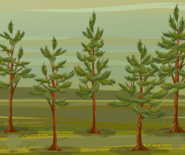

Question: At what point in its life does a tree grow most quickly?

- Form hypothesis: Do you think a young or old tree grows more quickly? ________________

Why do you think so? _______________________________________________________

_________________________________________________________________________

- Collect data: Set the Precipitation to 120 cm per year. Select a small tree and measure its age and height. Fill in the blank in the Age column with the starting age of the tree.

Click Advance year until the tree is ten years old and measure its height again. Measure and record the tree’s height at age 20, 30, 40 and 50 as well.
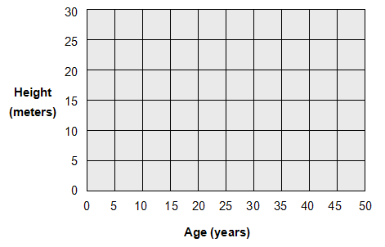
Age (years) | Height (meters)
10
20
30
40
50

- Make a graph: Plot a point on the graph for each row of data you have. Draw a line to connect the points in order.

- Analyze: Which part of the graph shows the fastest growth? _________________________

How do you know? _________________________________________________________

- Extend your thinking: How is the growth of a tree similar to the growth of a person? _______ _________________________________________________________________________
_________________________________________________________________________

