Vocabulary: Measuring Trees

Vocabulary

- Circumference – the distance around a circular object.

- Cross section – a section that is cut through the middle of a solid object.

- Diameter – the width of a circle.

- Drought – period of much lower than normal rainfall.

- Growth ring – a layer of wood added to a tree trunk during one growing season.
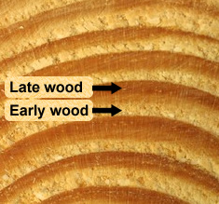
  - During the spring and early summer, trees grow quickly. Wood that forms at this time is light in color and is called early wood.
  - During the late summer and early fall, trees grow slowly. Wood that forms at this time is dark in color and is called late wood.
  - In some tropical locations there is little difference in seasons. Trees that grow there do not form growth rings.

- Precipitation – water that falls to Earth in the form of rain, snow, sleet, or hail.

