Name: ______________________________________ Date: ________________________

Student Exploration: Measuring Volume

Vocabulary: cubic centimeter, diameter, graduated cylinder, meniscus, milliliter, pipette, radius, rectangular prism, sphere, volume, water displacement
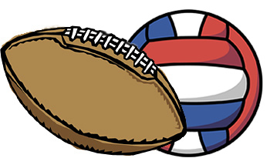

Prior Knowledge Question (Do this BEFORE using the Gizmo.)
Albert plays football. His sister Juliana plays volleyball. While walking home from practice one day, Albert and Juliana argue about which is bigger, a football or volleyball.

How would you measure and compare the sizes of the two balls? ________________________

____________________________________________________________________________

____________________________________________________________________________

____________________________________________________________________________
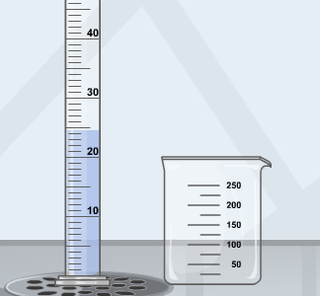

Gizmo Warm-up
When scientists talk about how big something is, they are really talking about its volume, or the amount of space it takes up. The Measuring Volume Gizmo allows you to measure the volumes of liquids and solids using a variety of tools.

To begin, remove the 50-mL graduated cylinder from the cabinet and place it below the faucet. To turn on the faucet, drag the slider next to the faucet up. Fill the cylinder about halfway, as shown.

- Place the magnifier over the waterline. Draw a sketch of what you see in the area at right. Label the large tick marks on your sketch.

What volume is represented by each small tick mark?

_______________________________________________

- What is the shape of the waterline? ____________________________________________

This curved shape is called the meniscus. Always read the volume at the bottom of the meniscus.

- What is the volume of water in the graduated cylinder? __________

Activity A:  Volume of liquids | Get the Gizmo ready:  - Drag all objects to the cabinet.  - Move the 25-mL graduated cylinder, the 250-mL beaker, and the 2-mL pipette to the counter. | 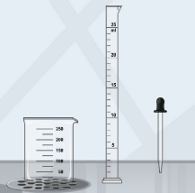

Introduction: Graduated cylinders are precise tools for measuring volume. Most graduated cylinders are marked in milliliters. There are 1,000 milliliters in 1 liter (about four cups).

Goal: Fill a graduated cylinder with a given amount of water.

- Prepare: Place the 250-mL beaker below the faucet and fill it with water. (Move the faucet handle up to pour faster.) You will use the beaker as a source of water in your experiments.

- Measure: To pour water from the beaker to the graduated cylinder, move the beaker over the graduated cylinder. Add about 15 mL of water to the graduated cylinder (does not have to be exact).

Place the magnifier over the waterline, and sketch what you see in the space at right. Label the large tick marks on your sketch.

- How many medium tick marks lie between two labeled tick marks? ______________

- How much volume does each medium tick mark represent? ______________

- How much volume does each small tick mark represent? ______________

- Estimate the water volume in the graduated cylinder to the nearest 0.1 mL.

(Remember to read from the bottom of the curved meniscus.) ______________

- Measure: Scientists use pipettes, also known as eyedroppers, to add or remove small amounts of water. To fill the pipette, place its tip in the beaker water and click the black bulb once.

To release a small amount of water, place the pipette above the graduated cylinder and click the bulb. Do this until the graduated cylinder contains exactly 17.5 mL of water. (Remember to read the volume at the bottom of the meniscus.)

- Show your work: Open the Tools tab at lower left and click the camera (). Right-click the screen shot, click Copy, and then paste the image into a blank document. Label the image “17.5 mL.” When you are finished, print out this document and turn it in with this worksheet.

(Activity A continued on next page)
Activity A (continued from previous page)

- Practice: Use the Gizmo to complete each of the following challenges. When you have finished each one, take a screen shot and add it to your document. Label each image with the volume.

- Fill the 25-mL graduated cylinder with 11.5 mL of water.

- Fill the 100-mL graduated cylinder with 76.0 mL of water.

- Fill the 50-mL graduated cylinder with 38.5 mL of water.

- Think and discuss: Suppose you needed to measure exactly 15.0 mL of water for an experiment. Which graduated cylinder would be the best one to use, and why?

_________________________________________________________________________

_________________________________________________________________________

_________________________________________________________________________

_________________________________________________________________________

- Further practice: Select the Practice button. In this mode, the Gizmo will give you a series of challenges. When you complete a challenge, click Submit. Click Reset if you would like to start over or try a problem again. As you practice, the Gizmo will keep a tally of right and wrong answers in the green and red circles.

Complete the first six challenges. Stop when you see the ruler and sphere (ball) on the screen.

Activity B:  Regular solids | Get the Gizmo ready:  - Select the Free Exploration mode.  - Return all items to the cabinet.  - Drag the block and the ruler to the counter.  - You will need a calculator for this activity. | 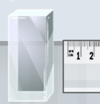

Introduction: The volumes of regular solids, such as spheres (balls) and rectangular prisms (blocks), can be determined by measuring their dimensions. The volume of a solid is usually expressed in cubic centimeters (cm³). One cubic centimeter is exactly the same volume as
1 milliliter.

Goal: Measure and calculate the volume of a rectangular prism and a sphere.
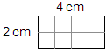
- Observe: Count the squares in the rectangle at right to find its area.

- What is the area of the rectangle? ______________________

- How does the area of the rectangle relate to the lengths of each side? ___________

___________________________________________________________________

- Observe: A block is an example of a rectangular prism. A rectangular prism has six rectangular faces. Look at the block shown below. Each cube inside the block has a 1-cm side and a volume of 1 cm³, or 1 mL.
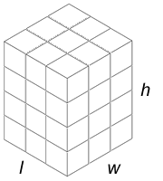
- What are the length, width, and height of the block?

Length: _____ Width: _____ Height: _____

- Multiply these three dimensions. What is the product of the length, width, and height? __________
- How many cubic centimeters are in the block? __________

- Measure: Just as the area of a rectangle is the product of its length and width, the volume of a rectangular prism is equal to the product of its length, width, and height. In the Gizmo, place the ruler over the block.

- What are the length, width, and height of the block?

Length: ________ Width: ________ Height: ________

- What is the volume of the block? __________ (Write your answer to the nearest 0.1.)

(Activity B continued on next page)
Activity B (continued from previous page)

- Measure: Return the block to the cabinet and drag out the large sphere. The volume of a sphere is calculated using the following formula:

V_{Sphere} = 4πr ³/ 3

The symbol π represents the number pi, which is about 3.14. The letter r stands for the radius of the sphere, which is the distance from the center of a sphere to its surface. The radius is exactly half of the diameter, which is the distance across the sphere. (The diameter is also equal to the length, width, and height of the sphere.)

- Place the ruler over the sphere. What is the diameter of the sphere? __________

- What is the radius of the sphere? __________

- What is the volume of the sphere? __________

- Measure: Return the large sphere to the cabinet and drag out the small marble. Use the ruler and your calculator to find the volume of the marble. Show your work.

Volume of the marble: __________

- Further practice: Select Practice. Do the next three problems, measuring the sphere, the marble, and the rectangular prism. (Note: The dimensions of each object vary slightly each time you go through the problems.)

Activity C:  Water displacement | Get the Gizmo ready:  - Select Free Exploration.  - Return all objects to the cabinet.  - Drag the large sphere, the overflow cup, the  250-mL beaker, the 50-mL graduated cylinder, and the magnifier to the counter. | 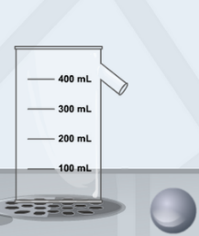

Introduction: Have you ever climbed into a tub and seen the water rise? The amount the water rises is related to your size—the bigger you are, the more the water will rise. This method, called water displacement, can be used to measure volume.

Goal: Use water displacement to measure the volume of an object.

- Get the Gizmo ready: Place the overflow cup under the faucet. Fill it until water starts to flow out of the spout. Place the 250-mL beaker next to the overflow cup so that the spout of the overflow cup is over the beaker. (If necessary, empty the beaker into the sink.)

- Measure: Place the sphere into the overflow cup, causing water to pour into the beaker. Empty the beaker into the 50-mL graduated cylinder. Place the magnifier over the waterline.

- What is the volume of water in the graduated cylinder? __________
- Recall that you used the ruler and the volume of a sphere equation to find the volume of the sphere in activity B. What is the volume of the sphere? __________
(Recall that 1 cm³ is the same volume as 1 mL.)

- Explain: Why does the water volume in the graduated cylinder match the sphere’s volume?

_________________________________________________________________________

_________________________________________________________________________

- Practice: Using what you have learned, find the volume of the rock. (Hint: For a more precise measurement, use the 25-mL graduated cylinder.)

What is the volume of the rock? __________

Describe how you found the rock’s volume: ______________________________________

_________________________________________________________________________

_________________________________________________________________________

(Activity C continued on next page)
Activity C (continued from previous page)

- Explore: You can find the volume of an object using just a graduated cylinder if you don’t have access to an overflow cup. This technique works if the object you are measuring is small enough to fit into the graduated cylinder.

Return the overflow cup and the 25-mL graduated cylinder to the cabinet. Take out the 100-mL graduated cylinder and the pipette. Fill the 100-mL graduated cylinder to exactly 40.0 mL, using the beaker and the pipette.

- Drag the rock into the 100-mL graduated cylinder. Use the magnifier to read the new volume.

What is the current water volume in the graduated cylinder? __________

- How much has the water volume changed in the graduated cylinder? ____________

___________________________________________________________________

- Based on your answers to A and B, what is the volume of the rock? __________

- Practice: Use the same method to find the volume of the marble. Use the 25-mL graduated cylinder.

What is the volume of the marble? __________

Describe what you did to find the volume of the marble: _____________________________

_________________________________________________________________________

_________________________________________________________________________

- Think and discuss: When measuring the volume of the marble, why is it better to use the
25-mL graduated cylinder than the 100-mL graduated cylinder? If possible, discuss your answer with your classmates and teacher.

_________________________________________________________________________

_________________________________________________________________________

_________________________________________________________________________

_________________________________________________________________________

- Further practice: Select Practice. Do the next four problems, using displacement to find the volume of the marble, rock, sphere, and rectangular prism. (Note: The dimensions of each object vary slightly each time you go through the problems.) Continue to practice as long as you like!

