Vocabulary: Measuring Volume

Vocabulary

- Cubic centimeter – a unit of volume equal to the volume of a cube that measures 1 centimeter on each edge.
  - The symbol for cubic centimeters is “cm³” or “cc.”
  - One cubic centimeter is the same volume as 1 milliliter.

- Diameter – a straight line segment that passes from one side of a circle or sphere to the other, passing through the center.
  - The term “diameter” also refers to the length of this line segment.

- Graduated cylinder – a tall, narrow container that is used for measuring volume.
  - The sides of a graduated cylinder have tick marks that show the volume of liquid inside.
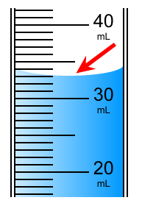
- Meniscus – the curved surface of liquid in a container.
  - The meniscus is caused by surface tension:
    - Water molecules along the waterline are attracted to the surface of the container, causing them to be pulled upward.
    - In some cases, the liquid molecules around the edges may be pulled downward because they are not attracted to the walls of the container, resulting in a convex meniscus.
  - When measuring volume in a graduated cylinder, read from the bottom of the meniscus.

- Milliliter – a unit of volume equal to one-thousandth of a liter.
  - The symbol for milliliter is “mL.”
  - A milliliter represents exactly as much volume as 1 cubic centimeter. Milliliters usually are used for liquids while cubic centimeters are used for solids.

- Pipette – a small tube with a bulb designed to release liquid one drop at a time.

- Radius – a straight line segment that connects the center of a circle or sphere to the edge.
  - The term “radius” also refers to the length of this line segment.

- Rectangular prism – a regular solid that has six rectangular faces.
  - The volume of a rectangular prism is equal to the product of its length, width, and height.
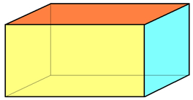

Rectangular prism

Sphere

- Sphere – a regular solid for which every point on the surface is the same distance from the center.

- Volume – the amount of space an object occupies or takes up.

- Water displacement – a method of measuring volume by measuring how much liquid is pushed away by an object.
  - If an object is immersed in a container of liquid, it will displace a volume of liquid exactly equal to the volume of the object.

