Name: Date:

Student Exploration: Modeling Decimals

Vocabulary: decimal, decimal point, equivalent, hundredth, tenth, whole number

Prior Knowledge Questions (Do these BEFORE using the Gizmo.)

- You are buying fruit at the corner store. Which costs more,
an apple that costs 4 dimes or a pear that costs 32 pennies? ________________________

Explain. __________________________________________________________________

_________________________________________________________________________

- Sally’s pencil is 15 hundredths of a meter long (0.15 m). Edward’s
pencil is 2 tenths of a meter long (0.2 m). Whose pencil is longer? ____________________

Explain. __________________________________________________________________

_________________________________________________________________________

Gizmo Warm-up
A decimal is a number written in a standard, base-10 system. It usually means a number with a decimal point. In the Modeling Decimals Gizmo, you can explore decimals between 0 and 1.

Each model is a square, representing one whole. You can shade the model by clicking in it, by typing a number in the text field and hitting Enter, or by clicking the up and down arrows.

Check that the first (red) model in the Gizmo is set to Whole number, the second (green) is set to Tenths, and the third (blue) is set to Hundredths.
- Shade the entire red model as shown to the right. What number does this represent? Number: __________ Number in words: ___________________
- Shade half of the green model as shown. What number does this represent?

Number: _____________ Number in words: _________________________

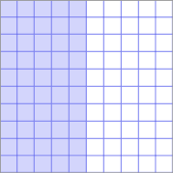
- Shade half of the blue model as shown. What number does this represent?

Number: _____________ Number in words: _________________________

Activity A:  Models of decimals | Get the Gizmo ready:  - Click Reset. | 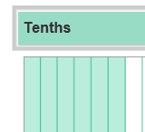

When you see the price of an item, such as $5.49, the decimal point separates the whole numbers (5 dollars) from the decimal part (49 cents, or 49 hundredths of a dollar).

- Set all three area models to Tenths. How many sections are in each model? ____________

- Shade 3 sections in the first model, 4 sections in the second, and 5 sections in the third.

  - What three numbers are modeled? First: ______ Second: ______ Third: ______

  - How would you model 0.1? _____________________________________________

  - How would you model 0.9? _____________________________________________

- Click Reset. Set the models to Hundredths. How many sections are in each model? _____

- Shade 77 sections in the first model, 36 sections in the second, and 51 sections in the third.

  - What three numbers are modeled? First: ______ Second: ______ Third: ______

  - How would you model 0.17? ____________________________________________

  - How would you model 0.81? ____________________________________________

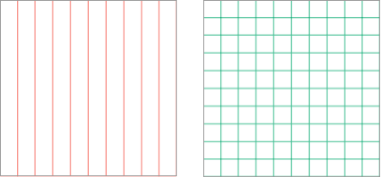
- How many hundredths are equal to 4 tenths (0.4)?
Shade in the models to the right and explain below.

___________________________________________

___________________________________________

- Equivalent decimals have different numbers of digits but are equal in value. Fill in the blanks with equivalent decimals in the examples below. Use the Gizmo to check your work.

9 tenths (0.9) = ____ hundredths (0.____) 40 hundredths (0.40) = ____ tenths (0.___)

3 tenths (0.3) = ____ hundredths (0.____) 70 hundredths (0.70) = ____ tenths (0.___)

Activity B:  Comparing decimals | Get the Gizmo ready:  - Click Reset.  - Make sure Show number line and Show comparison are turned off. | 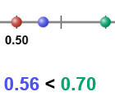

It is easy to compare the values of two numbers like 0.21 and 0.75. But how would you compare a number written in tenths, such as 0.8, to a number like 0.18 that is written in hundredths?

- Check that the first model is set to Tenths and the second model is set to Hundredths.

In the Gizmo, shade the grids to model 0.8 and 0.18. Then do the same (by hand) in the grids to the right.

Which number is greater, 0.8 or 0.18? _________

Turn on Show number line and Show comparison to check your answer.

- For each set of numbers, write them in order from least to greatest in the blanks below. For the first two sets, use the Gizmo to check your answers.

0.3, 0.46, 0.29 _________ < _________ < _________

0.50, 0.15, 0.05 _________ < _________ < _________

Challenge: 0.44, 0.7, 0.155 _________ < _________ < _________

- Turn on Show number line and Show comparison. Set all three models to Tenths. Model 0.2 on the first (red) model, and 0.3 on the third (blue) model.

  - With the second (green) model set to Tenths, is there any way to model a number between 0.2 and 0.3? ________ Explain. _________________________________
___________________________________________________________________
  - Now set the second model to Hundredths. Try to model a number between 0.2 and 0.3. What number did you find? _______________

- Write a decimal that is between each of the pairs of decimals below. Check your first three answers in the Gizmo. (The last three cannot be directly shown in the Gizmo. Can you figure them out anyway?)

0.4 < ________ < 0.5 0.9 < ________ < 1.0 0.0 < ________ < 0.1

1.7 < ________ < 1.8 72.1 < ________ < 72.2 0.67 < ________ < 0.68

