Name: Date:

Student Exploration: Moles

Vocabulary: atomic mass, Avogadro constant, conversion factor, dimensional analysis, formula mass, formula unit, mole, molar mass, scientific notation, significant figures, unified atomic mass unit
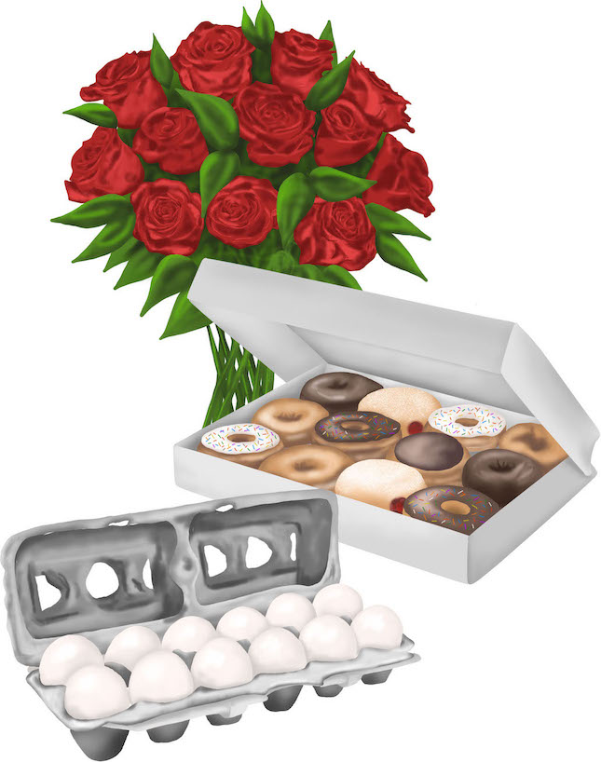

Prior Knowledge Questions (Do these BEFORE using the Gizmo.)

- In the image there are a dozen donuts, a dozen eggs, and a dozen roses. How many of each item do you have?

- Would a dozen of each object have the same mass?

- Suppose you have 12 carbon atoms, 12 gold atoms, and 12 iron atoms. Even though you have the same number of each, would you expect them all to have the same mass? Explain.

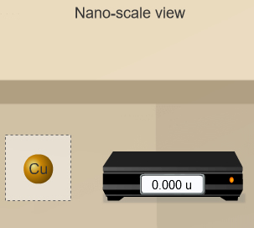
Gizmo Warm-up
When counting roses, eggs, or donuts, a dozen is a good unit to use. If you are counting atoms, however, a dozen is not much help. In the Moles Gizmo, you will learn about a unit used to count atoms.

On the AVOGADRO CONSTANT tab, place the copper (Cu) atom on the nano-balance on the left, which will show the average atomic mass of copper rather than the mass of a single copper atom.

- What is the average mass of a copper atom?

The unit “u” refers to unified atomic mass units. A single proton or neutron has a mass of approximately one atomic mass unit. (Officially, 1 u is one-twelfth the mass of a C-12 atom.)

- To gain an idea as to how many atoms are in a gram or so of copper, use the larger balance on the right. Press Add atoms to put a scoop of atoms in the weighing dish, and keep adding until the balance registers between 1 and 2 grams. If you don’t seem to be making much progress, adjust the exponent using the slider, which will make the scoop size bigger.

How many atoms did you need to add?
Activity A:  Molar Mass | Get the Gizmo ready:  - Select the AVOGADRO CONSTANT tab.  - Turn on Show hints and check that Copper (Cu) is selected. | 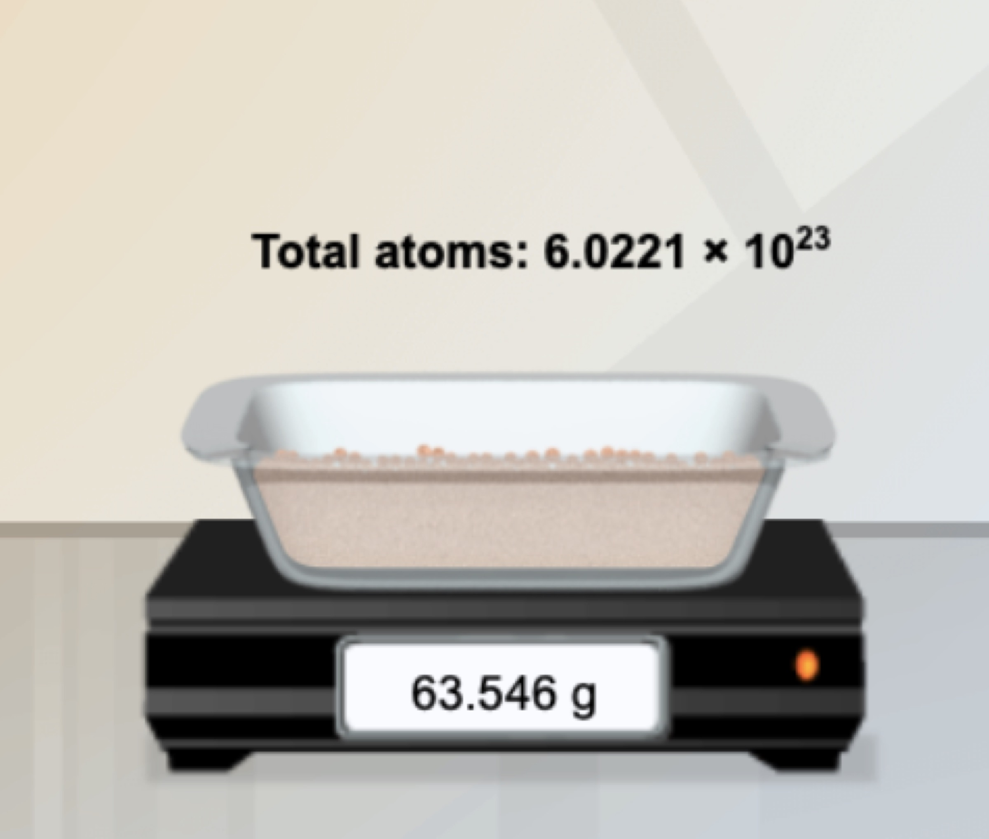

Introduction: Since atoms are so tiny, chemists have devised a unit known as the mole. A mole represents a macroscopic quantity of matter that can be used in the laboratory. One mole of any element has the same mass in grams as its atomic mass in u.

Question: How many particles are in a mole?

- Explore: Note the average atomic mass of copper on the nano-balance. Add atoms to the larger balance until it registers the same number (in g) as the reading on the nano-balance (in u). Use the Exponent slider to help get the correct amount. Stop adding atoms when the readings on both balances match exactly (to the nearest 0.001 g).

How many atoms did you need to add?

- Explore: Repeat the same procedure with carbon, then sulfur and aluminum.

- For each element, how many atoms did you need to add?

- What do you notice about the number of atoms in one mole?

- Discover: In each case, you measured out one mole of atoms, since the mass of one mole of any element, in grams, is equal to its atomic mass, in u. One mole of any element contains the same number of atoms, a number known as the Avogadro constant.

What is the exact value of the Avogadro constant?

- Illustrate: The Avogadro constant is so large it is normally written in scientific notation. To get an idea of the enormity of the Avogadro constant, write it out in standard form. (You will need to move the decimal place to the right 23 times, so you will need to add a lot of zeros!)

- Compare: While the number of atoms in a mole is constant, the number of grams in a mole changes based on the element. The number of grams in a mole (g/mol) is known as its molar mass, and has the same numerical value as an element’s atomic mass (in u). Use the Gizmo to find the atomic and molar mass of the following elements. Use proper units.

S: Atomic mass Molar mass

Al: Atomic mass Molar mass

(Activity A continued on next page)
Activity A (continued from previous page)

- Experiment: Select Copper(I) oxide, Cu₂O. Note that Cu₂O is a compound composed of different types of atoms bonded together. Place the Cu₂O formula unit on the nano-balance. (A formula unit of Cu₂O consists of two copper atoms and one oxygen atom.)

- Formula mass is the average mass of one formula unit, measured in unified mass units (u). What is the formula mass of Cu₂O?
- Add formula units to the larger balance until its reading matches that of the nano-balance exactly. How many formula units did you need to add?
- Repeat the above procedure with another compound of your choice. How many formula units did you need to add?

- Summarize: Complete the following statements:

- 1 mole of any element contains 6.0221 × 10²³ .

- 1 mole of any compound contains 6.0221 × 10²³ .

- Extend: For compounds, it is sometimes necessary to calculate the number of atoms of each element within a formula unit. Select Iron(II) chloride. Note the image of the unit.

- How many Fe atoms are within a single FeCl₂ formula unit?

- How many Cl atoms are within a single FeCl₂ formula unit?

- Use the nano-balance to find the mass of each of these atoms:

Mass of Fe atom: Mass of Cl atom:

- Find the sum of their masses (1 Fe atom + 2 Cl atoms):

- Place the FeCl₂ unit on the balance. Is the sum of the masses of the individual atoms equal to the formula mass of the compound?

- Calculate: Select Copper(I) oxide. Note the image of the unit. Place it on the balance.

- How many moles of copper would be needed to make 1 mole of Cu₂O?

- How many grams of copper would you need? Grams of oxygen?
Activity B:  Conversions | Get the Gizmo ready:  - Select the CONVERSIONS tab.  - Select Carbon (C). | 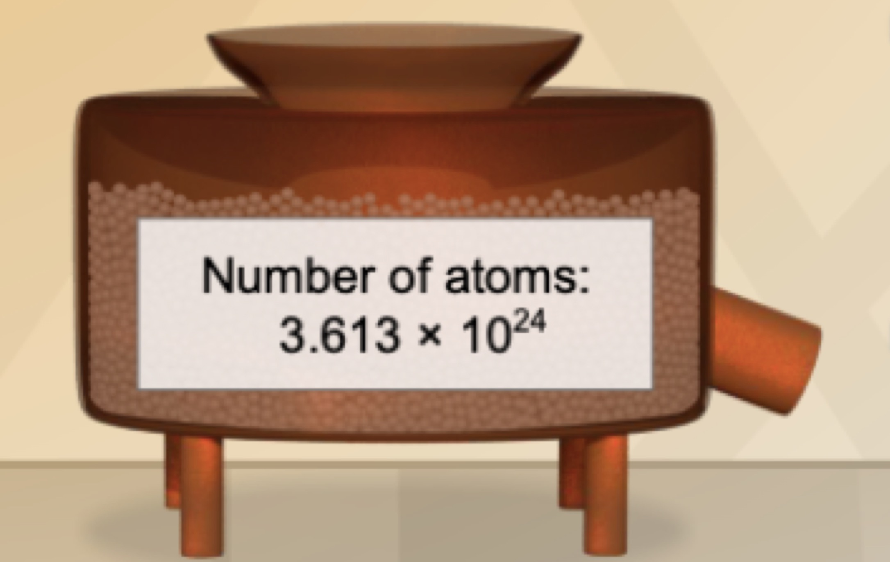

Introduction: Chemical formulas represent ratios. To make H₂O, you need two atoms of H for each atom of O; you would also need two moles of H for every mole of O. However, when performing experiments in the lab, substances are measured in grams, not atoms or moles. Therefore, it is important to be able to convert freely between atoms, moles, and grams.

Question: How do you convert particles to grams, and grams to particles?

- Investigate: Note the empty jars on the shelf that can be filled by using the slider. Set the amount to 2.000 moles of carbon (mol C), then press Start. Each jar holds exactly one mole of carbon. Your goal is to determine the mass in grams of two moles of carbon.

  - Before you can find the mass, what do you need to know?

  - Turn on Show molar mass. What is the molar mass of carbon?

  - What do you think the mass of 2.000 moles of carbon will be?

  - Drag the jars to the balance. What is the mass of 2.000 moles of C?

- Estimate: Press Reset. Turn off Show hints. Using the first drop-down menu, select Grams. Set the amount to 46.00 g of carbon, then press Start. (Note that the substance appears in the weighing dish on the balance, not in the jars.)

  - How many mole jars do you think can be filled with this amount?

  - Place jars under the balance to find the mole amount. Were you close?

  - Press Reset and start with 151.00 g of FeCl₂. How many mole jars do you think can be filled with this amount?
  - Place jars under the balance to find the mole amount. What is the value?

- Summarize: Consider the procedures you used to do the calculations in questions 1 and 2.

  - How did you convert moles to grams?

  - How did you convert grams to moles?

(Activity B continued on next page)
Activity B (continued from previous page)

- Investigate: Press Reset. Start with 2.000 moles of sulfur, then press Start.

- How many atoms do you think this amount represents?

- Pour the jars into the atom counter at left. How many atoms are there?

- How can you calculate this value?

- Estimate: Press Reset. Select Atoms, and using the slider, start with 1.000 × 10²³ atoms of sulfur. (Note that pressing Start puts atoms into the atom counter, not the jars.)

- Is this amount more or less than one mole?

- Place the jar underneath the counter. Was the jar completely filled?

- How many moles do you have?

- Calculate: Press Reset. Start with 1.900 × 10²⁴ (or 19.00 × 10²³) formula units of Cu₂O.

- Calculate the number of moles:

- Use the Gizmo to verify your calculation. Were you correct?

- Is the method for converting formula units to moles the same as for atoms?

- Summarize: Consider the procedures you used to do the calculations in questions 4 and 5.

  - How did you convert moles to atoms (or formula units)?

  - How did you convert atoms (or formula units) to moles?

- Explain: Select Carbon and start with 2.0 × 10²⁴ atoms. Press Start.

- Use the Gizmo to find the number of grams:

- Before you can find grams, what must you find first?

- How did you convert from atoms to grams?

Activity C:  Dimensional Analysis | Get the Gizmo ready:  - Select the DIMENSIONAL ANALYSIS tab.  - Start with Question 1. | 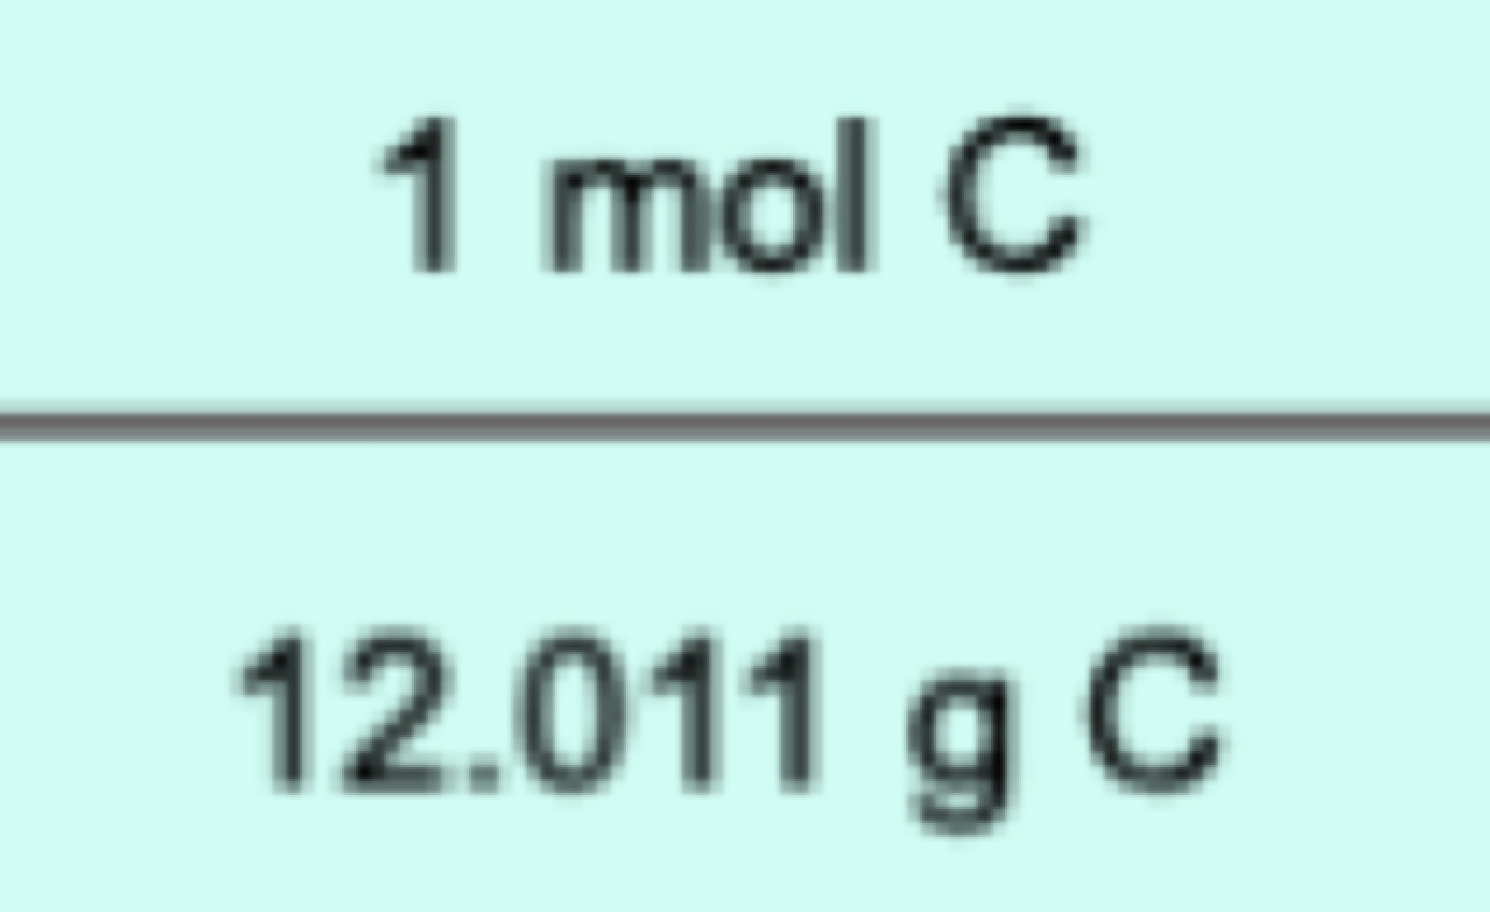

Introduction: Dimensional analysis is a method used to convert from one unit to another using conversion factors. A conversion factor is a fraction in which the numerator is equal to the denominator, such as$\frac{1 mol C}{12.011 g C}$. Multiplying a quantity by a conversion factor(s) changes the unit, but not the value, since multiplying by a conversion factor is in essence multiplying by one.

Question: How can dimensional analysis be used to make mole conversions?

- Analyze: Note Problem 1 at the bottom of the Gizmo.

- What is the starting unit? What is the answer unit?

- What do you need to know in order to find the mass of 3.00 moles of carbon?

- Calculate: Drag the appropriate conversion factor to the gray area. To make the units cancel, press Flip tile. It is important that all units cancel except the one you are trying to find. Check Show units to verify the ending unit, then check Show numerical results.

- What is the numerical result?

- Is this answer reasonable, given the mass of one mole of carbon?

- Press Check. Did you solve the problem correctly?

In problem 1, note that the mole amount (3.00) is given to 3 significant figures. Significant figures are used to indicate the accuracy of a measurement, and express the confidence we have in that measurement. The zeros after the decimal point tell us with certainty that we do not have an additional tenth or hundredth of a mole.

- Calculate: Using the Gizmo, solve problems 2, 3, and 4. Check each answer. Then, solve the problems below using the same techniques. Show your work.

- 95.0 g Al = mol Al

- 2.10 mol FeCl₂ = formula units FeCl₂

(Activity C continued on next page)
Activity C (continued from previous page)

- Analyze: Select problem 5, which is more complex and cannot be solved in one step. In order to solve this problem, what two pieces of information do you need to know?

Drag tiles into the gray area and solve. Check your answer when finished. Then do 6–12.

- Calculate: In problem 13, note that you are being asked to find the number of atoms in a certain quantity of a compound. Before you can solve, it is necessary to determine the number of atoms within a single formula unit.

How many atoms are in a single formula unit of FeCl₂?

Use the Gizmo to solve. Work through problems 14–19 for more of these types of problems.

For additional practice, work through as many of the remaining problems as you wish.

- Practice: Solve each of the following problems using dimensional analysis (or another method). Show your work. (Use a periodic table to look up the necessary atomic masses.)

- 75 g KMnO₄ = formula units KMnO₄

- 7.23 × 10²⁴ Al atoms = grams Al

- 9.23 × 10²³ Au atoms = moles Au

- 125 g H₃PO₄ = formula units H₃PO₄

- 0.75 moles CO₂ = total atoms

