Name: ______________________________________ Date: ________________________

Student Exploration: Moonrise, Moonset, and Phases

Vocabulary: horizon, Moon phase, moonrise, moonset

Prior Knowledge Questions (Do these BEFORE using the Gizmo.)

- When is the last day and approximate time of day you recall seeing the Moon?

___________________________________________________

In the space at right, draw what you saw.

- Does the Moon always rise and set at the same time? ______________________________

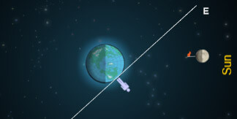
Gizmo Warm-up
The Moon is not always in the same position in the sky at a given time. Sometimes the Moon rises in the early evening, sometimes in the middle of the night, and sometimes during the day. The Moonrise, Moonset, and Phases Gizmo allows you to determine how the Moon phases are related to the timing of moonrise and moonset.

To begin, turn on Show horizon. The Gizmo shows Earth, the Moon, and an observer on Earth. The Sun is located far away to the right of Earth. The long white line is the horizon.

- Click Play (). Look at the VIEW OF MOON FROM EARTH pane. What do you see?

_________________________________________________________________________

_________________________________________________________________________

- Click Reset () and set the Speed to Slow. Click Play, and then click Pause () when the Moon is aligned with the eastern horizon (E).

Look to the upper left. What time is it? __________________ This is the time of moonrise.

- Click Play and then Pause when the Moon is aligned with the western (W) horizon.

What time is it? __________________ This is the time of moonset.
Activity:  Moonrise and moonset | Get the Gizmo ready:  - Click Reset.  - Check that Show horizon is on and the Speed is set to Slow. | 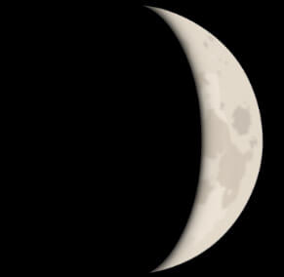

Introduction: For an observer on Earth, moonrise occurs when the Moon is just over the eastern horizon. Moonset occurs when the Moon has gone below the western horizon. Between moonrise and moonset the Moon will pass overhead.

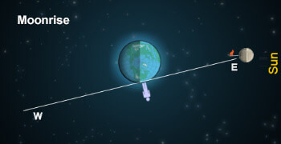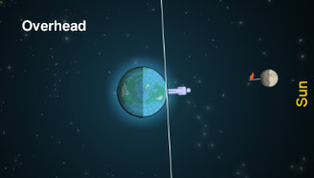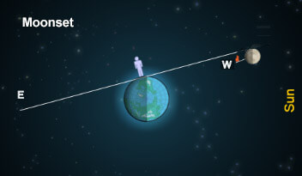

Question: How do Moon phases relate to the timing of moonrise and moonset?

- Observe: Drag the Moon to the left side of Earth. You will see a Full Moon on the VIEW OF MOON FROM EARTH pane. Use the Gizmo to find the time of moonrise and moonset.

    - What is the time of moonrise? __________________

    - At what time is the Moon directly over the observer’s head? __________________

    - What is the time of moonset? __________________

- Compare: In the Warm-up activity, you measured the time of moonrise and moonset during the New Moon phase. You found that the Moon rose at approximately 6:00 a.m. and set at approximately 6:00 p.m.

How do the times of moonrise and moonset compare for the Full Moon and New Moon?

_________________________________________________________________________

_________________________________________________________________________

- Predict: How do you expect the times of moonrise and moonset to change as the Moon orbits Earth? ______________________________________________________________
_________________________________________________________________________

_________________________________________________________________________

(Activity continued on next page)
Activity (continued from previous page)

- Gather data: For each Moon phase listed below, use the Gizmo to find the time of moonrise, the time that the Moon is overhead, and the time of moonset. List these in the table.

Phase | Illustration | Moonrise | Overhead | Moonset
New Moon
Waxing Crescent
First Quarter
Waxing Gibbous
Full Moon
Waning Gibbous
Third Quarter
Waning Crescent

- Analyze: What patterns do you notice in your data? ________________________________

_________________________________________________________________________

_________________________________________________________________________

_________________________________________________________________________

_________________________________________________________________________

_________________________________________________________________________

_________________________________________________________________________

- Apply: What is the phase of the Moon if it rises at 4:00 a.m.? ____________________

What is the Moon phase if it reaches its highest point at 9:00 p.m.? ____________________

- Extend your thinking: In its 29.5-day cycle, the time of moonrise changes by 24 hours. How much does the time of moonrise change each day? Check your answer using the Gizmo.

_________________________________________________________________________

