Name: ______________________________________ Date: ________________________

Student Exploration: Mouse Genetics (Two Traits)

Vocabulary: allele, genotype, phenotype, probability, Punnett square

[Note to teachers and students: This Gizmo was designed as a follow-up to the Mouse Genetics (One Trait) Gizmo. We recommend doing that activity before trying this one.]

Prior Knowledge Questions (Do these BEFORE using the Gizmo.)

- A single coin is flipped four times. What do you think is the most likely outcome?

  - Four heads
  - Three heads, one tail
  - Two heads, two tails
  - One head, three tails
  - Four tails
  - All are equally likely

- What do you think are the odds of getting four tails in a row? Explain your answer.

_________________________________________________________________________

_________________________________________________________________________

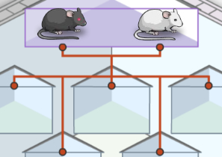

Gizmo Warm-up
On the Mouse Genetics (Two Traits) Gizmo, drag mice into the Parent 1 and Parent 2 spaces, and then click Breed to see their offspring. Experiment with different combinations of parent mice.

- What must be true to have offspring with black fur?

______________________________________________

- What must be true to have offspring with white fur? ________________________________

- What must be true to have offspring with black eyes? ______________________________

- What must be true to have offspring with red eyes? ________________________________

- What must be true to have offspring with red eyes and white fur? _____________________

_________________________________________________________________________
Activity A:  Exploring inheritance | Get the Gizmo ready:  - Click Clear.  - Turn on Show genotype. | 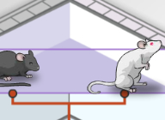

Question: What patterns appear when two traits are inherited?

- Observe: Breed a black-fur, black-eye mouse with a white-fur, red-eye mouse. Click Breed several times, and then drag two of the offspring into the Holding Cages below. Move the cursor over a mouse to see its genotype, or allele combination.

    - What is the genotype of the black-fur parent? _______________________________

    - What is the genotype of the white-fur parent? _______________________________

    - What are the genotypes of the offspring? __________________________________

- Analyze: The probability of an event is the likelihood that it will happen. Probability can be expressed as a percentage, such as 75%, as a decimal (0.75), or as a fraction (3/4).

What is the probability that an offspring mouse will have black fur and black eyes? _______

- Predict: Click Clear, and move the two mice from the Holding Cages into the parent box.

What do you expect the offspring of these mice to look like? _________________________

_________________________________________________________________________

- Experiment: Click Breed, and record the genotypes of the offspring on a sheet of paper. Repeat this several times to see a variety of offspring. What genotypes do you see?

_________________________________________________________________________

_________________________________________________________________________

- Extend: Turn on Show statistics, and click Breed until there are 100 offspring.

    - How many offspring have black fur and black eyes? __________________________

    - How many offspring have black fur and red eyes? ___________________________

    - How many offspring have white fur and black eyes? __________________________

    - How many offspring have white fur and red eyes? ___________________________

Activity B:  Probability and genetics | Get the Gizmo ready:  - Click Clear.  - Use the Gizmo to create an Ff Ee parent and an  Ff ee parent. | 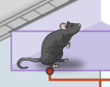

Introduction: If two events are independent, the probability of both events occurring together is equal to the product of their independent probabilities. For example, if there is a 1/2 chance of getting “heads” on a coin flip, there is a 1/2 • 1/2 = 1/4 chance of getting two heads in a row.

Question: When traits are inherited, what is the probability of each offspring’s genotype?

- Model: To determine the probability of a trait combination such as black fur and red eyes, consider each trait separately. Fill in the Punnett square for each trait. Then determine the probability of black fur and the probability of red eyes. Express each probability as a fraction.

Parent 1 fur genotype: Ff
Parent 2 fur genotype: Ff

Probability of black fur: ——

Parent 1 eye genotype: Ee
Parent 2 eye genotype: ee

Probability of red eyes: ——

- Predict: Now multiply the probabilities together to find the probability of black fur and red eyes. Express your answer as a fraction and as a percentage: —— _____%

- Experiment: Turn on Show statistics. Check that the parent mice genotypes are Ff Ee and Ff ee. Click Breed until there are 500 offspring.

    - How many of the offspring had black fur and red eyes? _______

    - What percentage of offspring had black fur and red eyes? _______

- On your own: Use this method to find the probabilities of other offspring trait combinations, such as black fur/black eyes, white fur/black eyes, and white fur/red eyes. Compare each predicted percentage to the actual percentage. In general, did this method work well?

_________________________________________________________________________

_________________________________________________________________________

Activity C:  Expanded Punnett square | Get the Gizmo ready:  - Click Clear.  - Use the Gizmo to create two Ff Ee parents. | 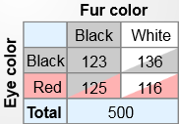

Introduction: A second method for calculating the probability of each offspring’s genotype is to use an expanded Punnett square.

Question: How can a 4x4 square model the inheritance of two traits?

- Model: Each parent mouse will contribute one allele for fur color and another for eye color. If a parent mouse is Ff Ee, there are four possible allele combinations the parent could pass to its offspring: FE, Fe, fE, and fe. The combinations are written along the top and sides of the expanded Punnett square, as shown below.

Fill in the empty spaces to complete the square. Then write the probability of each offspring’s phenotype (physical appearance) in the spaces to the right. Express each probability as a fraction and as a percentage.
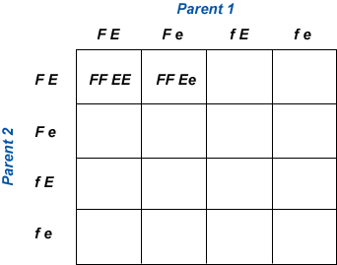

Black fur, black eyes: —— _____%

Black fur, red eyes: —— _____%

White fur, black eyes: —— _____%

White fur, red eyes: —— _____%

- Experiment: Check that Show statistics is turned on. Be sure there are two Ff Ee parents. Click Breed until there are 500 offspring. Write the results in the table below.

Trait combination: | Black fur,  black eyes | Black fur,  red eyes | White fur,  black eyes | White fur,  red eyes
Number:
Percentage:

- Analyze: How well did the results match the predictions of the Punnett square? __________

_________________________________________________________________________

- On your own: Try other parent combinations. Use any method to predict the percentages of each offspring’s phenotype. Use the Gizmo to test your predictions.

