Name: ______________________________________ Date: ________________________

Student Exploration: Mouse Genetics (One Trait)

Vocabulary: allele, DNA, dominant allele, gene, genotype, heredity, heterozygous, homozygous, hybrid, inheritance, phenotype, Punnett square, recessive allele, trait

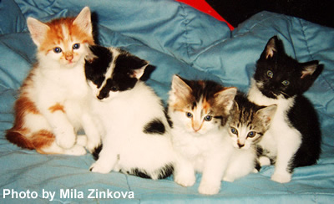

Prior Knowledge Questions (Do these BEFORE using the Gizmo.)

- The image shows a single litter of kittens. How are they similar to one another? _________________________
____________________________________________

- How do they differ from one another? ___________________________________________

- What do you think their parents looked like? ______________________________________

_________________________________________________________________________

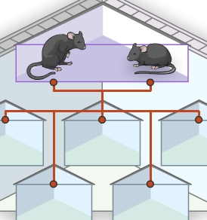
Gizmo Warm-up
Heredity is the passage of genetic information from parents to offspring. The rules of inheritance were discovered in the 19th century by Gregor Mendel. With the Mouse Genetics (One Trait) Gizmo™, you will study how one trait, or feature, is inherited.

- Drag two black mice into the Parent 1 and Parent 2 boxes. Click Breed to view the five offspring of these parents.

What do the offspring look like? _______________________

The appearance of each mouse is also called its phenotype.

- Click Clear, and drag two white mice into the parent boxes. Click Breed several times. What is the phenotype of the offspring now? __________________________________________

- Do you think mouse offspring will always look like their parents? ______________________

Explain: __________________________________________________________________
Activity A:  Patterns of inheritance | Get the Gizmo ready:  - Click Clear.  - Drag a black mouse and a white mouse into the parent boxes, but don’t click Breed yet. | 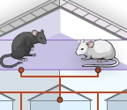

Question: What patterns are shown by offspring traits?

- Predict: What do you think the offspring of a black mouse and a white mouse will look like?

_________________________________________________________________________

- Observe: Click Breed several times. What do you see? _____________________________

- Observe: Drag two offspring into the Holding Cages. These mice are called hybrids because their parents had different traits. Click Clear, and then breed the two hybrids.

What do you see now? ______________________________________________________

- Experiment: Turn on Show statistics. Click Breed until there are 100 offspring.

How many offspring were black? ________ How many were white? ________

- Explore: Try other combinations of mouse parents. Write the results of each experiment in your notes. When you have finished, answer the following questions. (Note: You can refer to the parents as “pure black,” “pure white,” or “hybrid.”)

    - Which parent combination(s) yield only white offspring? _______________________

___________________________________________________________________

    - Which parent combination(s) yield only black offspring? _______________________

___________________________________________________________________

    - Which parent combination(s) yield a mixture of black and white offspring? ________

___________________________________________________________________

- Challenge: Based on experiments similar to these, Gregor Mendel devised a theory of inheritance. Use your own observations to come up with your own explanation of how a trait such as fur color is passed down from parents to offspring.

Write your explanation down on an extra sheet of paper and attach it to this worksheet. If possible, discuss your theory with your classmates and teacher.
Activity B:  Genetics basics | Get the Gizmo ready:  - Click Clear.  - Drag a black mouse and a white mouse into the parent boxes. | 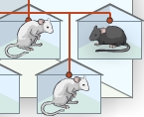

Introduction: Inherited traits are encoded on a molecule called DNA (deoxyribonucleic acid). Genes are segments of DNA that control a particular trait. Most genes have several different versions, or alleles. The genotype is the allele combination an organism has.

Question: How do alleles determine fur color?

- Observe: Turn on Show genotype. Move your cursor over a mouse to see its genotype.

    - What is the genotype of the black parent? _______ White parent? _______

These mice are homozygous for fur color, meaning both alleles are the same.

    - Click Breed. What is the genotype of the offspring mice? _______

These mice are heterozygous for fur color, meaning the alleles are different.

- Analyze: Dominant alleles are always expressed when present. Recessive alleles are not expressed when the dominant allele is also present. Look at the two alleles for fur color.

    - Which allele is dominant, and which fur color does it produce? _________________

    - Which allele is recessive, and which fur color does it produce? _________________

- Predict: Place two of the Ff offspring into the Holding Cages. Click Clear, and then place them into the parent boxes.

    - Which allele(s) could the offspring inherit from parent 1? ______________________

    - Which allele(s) could the offspring inherit from parent 2? ______________________

    - What are the possible genotypes of the offspring? ___________________________

___________________________________________________________________

- Experiment: Click Breed several times, and look at the genotypes of the offspring. Did you find all the predicted genotypes? Explain.

_________________________________________________________________________

_________________________________________________________________________

_________________________________________________________________________
Activity C:  Modeling inheritance | Get the Gizmo ready:  - Click Clear.  - Drag a black mouse and a white mouse into the parent boxes. | 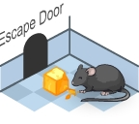

Question: How do scientists predict the genotypes of offspring?
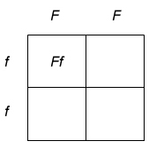

- Model: Scientists use a Punnett square to model the different possible offspring genotypes from a parent pair. The parent genotypes are written across the top and side of the square, as shown. The four possible offspring genotypes are then filled in.

The first square is filled in for you. Fill in the remaining squares.

    - What are the genotypes of the offspring? __________________________________

    - What percentage of the offspring will have black fur? _________________________

    - What percentage of the offspring will have white fur? _________________________

- Experiment: Click Breed several times. Were your predictions correct? ________________

- Model: Use the Punnett squares below to model each parent combination. After filling in each Punnett square, predict the percentages of black and white offspring.

Parent 1: Heterozygous black (Ff)
Parent 2: Heterozygous black (Ff)

Predicted % black offspring: ______

Predicted % white offspring: ______
Parent 1: Heterozygous black (Ff)
Parent 2: Homozygous white (ff)

Predicted % black offspring: ______

Predicted % white offspring: ______

(Activity C continued on next page)
Activity C (continued from previous page)

- Experiment: Turn on Show statistics and Show as approximate percentage. For each combination, breed approximately 500 offspring. Record the results in the table below.

(Hint: To obtain an Ff mouse, breed an FF mouse to an ff mouse. Place two Ff offspring into the holding cages, click Clear, and then drag the Ff mice into the parent boxes.)

Parent 1 Genotype | Parent 2 Genotype | % Black offspring | % White offspring
Ff | Ff
Ff | ff

- Draw conclusions: How well did the Punnett squares predict the offspring percentages for each parent pair? ___________________________________________________________
_________________________________________________________________________

- Summarize: In your own words, describe what heredity is and how it works in mice.

_________________________________________________________________________

_________________________________________________________________________

_________________________________________________________________________

_________________________________________________________________________

_________________________________________________________________________

_________________________________________________________________________

_________________________________________________________________________

- Think and discuss: Do you think most traits are inherited the way mouse fur color is? _____

Why do you think this is? _____________________________________________________

_________________________________________________________________________

_________________________________________________________________________

_________________________________________________________________________

_________________________________________________________________________

