Name: Date:

Student Exploration: Movie Reviewer

Vocabulary: data, mean, median, outlier

Prior Knowledge Questions (Do these BEFORE using the Gizmo.)
 | Score
Judge 1 | 9
Judge 2 | 9
Judge 3 | 8
Judge 4 | 7
Judge 5 | 5

- John’s science fair project is judged by 5 different people. What overall score would you give John’s project?

______________________________________________

- How did you choose your answer for question 1?

_________________________________________________________________________

_________________________________________________________________________

Gizmo Warm-up
In the Movie Reviewer Gizmo, groups of friends watch movies and rate them from 0 (worst) to 10 (best). Five friends saw the movie Black Belt Gizmo and gave it a rating. You can see their scores in the Gizmo. They are 2, 3, 5, 7, and 8.
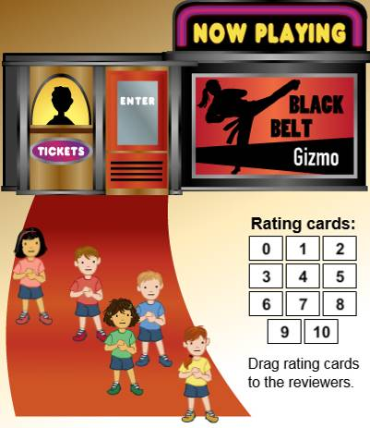
- One of the kids writes movie reviews for the school newspaper. She wants to take these five ratings and make one summary score of how they liked the movie.

What summary score would you use? __________

- Another friend saw the movie late. To add the new reviewer, drag a rating card (number card) onto a kid on the left, standing in front of the cinema.

What rating did the new reviewer give? __________

- Sometimes a reviewer changes her mind. Change one of the ratings by dragging a new rating card onto one of the reviewers on the right.

- What were the old and new ratings? Old: ________ New: _________

- How do you think this affects the summary score? ___________________________

Activity A:  Balancing act | Get the Gizmo ready:  - Click the NOW PLAYING movie poster, select Return to Planet Gizmo, and click Select. | 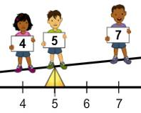

For their movie review, these friends need one single rating for each movie. But this can be difficult. How can they take many different scores and boil them down to one number?

- Ten friends have seen Return to Planet Gizmo and their scores are shown in the Gizmo.

- What number would you use as a summary score for these ratings? ________

- Click on Balance. Now the reviewers are lined up along a see-saw. Drag the yellow fulcrum (triangle) until they balance. At what number are they balanced? ________
- Click Calculate mean. What is the mean of this data set? ________

- The mean is often called the average. How do you calculate the mean of a data set?

___________________________________________________________________

___________________________________________________________________

- Select another movie from the NOW PLAYING list. First, name the movie and list its ratings.

- Movie: _________________________ Ratings: ____________________________

- What is the mean of the data? ________

- In the space, show the calculation of the mean.

- Pick the movie Gizmo, Private Eye. Place the fulcrum at 6. The see-saw is not balanced.

- What are the current ratings for this movie? ________________________________

- Add one new reviewer to balance the see-saw at 6. What score did you add? ______

- Add two more ratings, keeping it balanced at 6. What scores did you add? ________
- Click Clear to send all reviewers back to the cinema. Now add at least five ratings so that the mean score is 6. List your data. _________________________________
- Change some of the ratings. Does every change affect the mean? ______________

Activity B:  Score in the middle | Get the Gizmo ready:  - Click the NOW PLAYING movie poster, select This Gizmo Rides Alone, and click Select. | 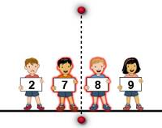

One friend suggests a new way to find the overall movie rating – just use the middle number.

- Some friends watched This Gizmo Rides Alone and their scores are shown in the Gizmo.

  - How many ratings are given for this movie? ________

  - Click on Order and select Find middle rating. Drag the vertical red bar to help find the middle. (This value is called the median.) Which score is the median? ________
  - Click on Calculate median. Were you correct? ________

- Turn off Calculate median. Select the movie Super Gizmo Saves Earth.

  - How many ratings are given for this movie? ________

  - Why is it trickier in this case to find the middle value? _________________________

___________________________________________________________________

  - What do you think is the median of this data set? ________

  - Select Calculate median. Were you correct? _______ (If not, correct your median.)

  - Describe how to find the median when you have an even number of data values.

___________________________________________________________________

___________________________________________________________________

- Select the movie Return to Planet Gizmo. Experiment with changing some of the ratings.

  - Does changing ratings always, sometimes, or never change the median? _________
  - Explain why. _________________________________________________________

___________________________________________________________________

- Click Clear. Make a data set whose median is not a whole number. List the data below.

Data set: ____________________________________________ Median: __________

Activity C:  Larry Lowball | Get the Gizmo ready:  - Click the NOW PLAYING movie poster, select Gizmo on Broadway, and click Select.

Larry Lowball is a grumpy guy. He often gives movies low scores. The rest of the friends have trouble agreeing on an overall score for their movie review when Larry’s scores are so low.

- Larry and some friends saw Gizmo on Broadway. Their scores are shown in the Gizmo. A value (like Larry’s) that is far away from the rest of them is called an outlier.

  - Larry is considering raising his score, but wonders how this will change the overall score. Choose 3 new scores for Larry. Find the mean and median of each data set.

Larry’s score | Other scores | Mean | Median
0 | 10, 10, 10, 10
 | 10, 10, 10, 10
 | 10, 10, 10, 10
 | 10, 10, 10, 10

  - How does changing Larry’s score change the mean? _________________________

___________________________________________________________________

  - How does changing Larry’s score change the median? _______________________

___________________________________________________________________

  - After seeing the effects of Larry’s scores, Sarah thinks they should use the mean for the overall score. Give one reason why Sarah might argue for using the mean.

___________________________________________________________________

  - Robbie disagrees. He thinks that the median would be a better overall score. Give one reason that Robbie might argue that it is better to use the median.

___________________________________________________________________

- Suppose you were promoting the movie Gizmo’s Secret Admirer. Which value would you use, the mean rating or the median rating? Explain your answer.

_________________________________________________________________________

_________________________________________________________________________

