Name: Date:

**Student Exploration:** **Multiplying Fractions**

**Vocabulary:** denominator, fraction, numerator, product, simplify

**Prior Knowledge Questions** (Do these BEFORE using the Gizmo.)

Ellen cuts a cake into thirds along one side and sixths along the other,   
as shown at the right.

1. How many pieces did she cut? \_\_\_\_\_\_\_\_\_\_\_
2. A **fraction** shows the relationship between a part and a whole. What fraction of the cake is one piece?

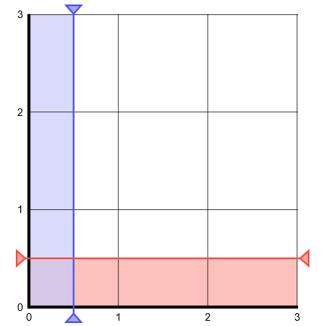

**Gizmo Warm-up**

In the *Multiplying Fractions* Gizmo™, you can use an area model to represent multiplying 2 fractions. The entire model is a 3-by-3 grid and contains a total of 3 • 3 = 9 square units.

The **denominators** (bottom numbers) of the fractions can be changed by dragging the red and blue sliders. (Or, you can click in the text field next to the slider, type a new value, and hit **Enter**.) The **numerators** (top numbers) can be changed by dragging the red and blue probes on the 3-by-3 grid.

1. Set **Denominator of the first fraction** to 5. Set **Denominator of the second fraction** to 1. Drag the vertical blue probe as far left as it will go. Turn on **Show fraction model**.
2. How many parts is each square unit in the 3-by-3 grid “chopped” into? \_\_\_\_\_\_\_\_\_
3. The red model shows the first fraction. Drag the red probe to shade 3 horizontal strips red. What fraction is modeled?
4. Set **Denominator of the second fraction** to 2. Drag the blue probe to shade one vertical strip blue. The blue probe now models .
5. How many little rectangles are shaded twice (both red and blue)? \_\_\_\_\_\_\_\_\_
6. How many little rectangles are there per unit square in the grid? \_\_\_\_\_\_\_\_\_
7. Turn on **Show calculation**. What is  • ?

|  |  |  |
| --- | --- | --- |
| **Activity A:**  **Finding the product** | Get the Gizmo ready:   * Set **Denominator of the first fraction** to 3. * Set **Denominator of the second fraction** to 5. * Turn off **Show calculation**. | 344SE2 |

1. With **Show fraction model** turned on, drag the red probe to shade 2 horizontal strips red. This models . Then drag the blue probe to shade 4 vertical strips blue. This models .
2. How many little rectangles are in each square unit in the grid? \_\_\_\_\_\_\_\_\_\_\_\_
3. How does the number of rectangles in each square unit relate to the denominators of the two fractions?
4. How many rectangles are shaded twice (both red and blue)? \_\_\_\_\_\_\_\_\_\_\_\_
5. How does the number of rectangles shaded twice relate to the numerators of the two fractions?
6. The answer to a multiplication problem is called the **product**. Fill in the equation below to find the product of the fractions. Turn on **Show calculation** to check your work.

•

•

 =  •  = =

1. Turn off **Show calculation**. Be sure **Show fraction model** is still turned on.
2. Drag the red probe to model a fraction greater than 1.

What fraction did you model?

1. Drag the blue probe to model a fraction greater than 1.

What fraction did you model?

1. Fill in the equation below to show the product of your two fractions. Turn on **Show calculation** to check your work.

•

•

• = =

**(Activity A continued on next page)**

**Activity A (continued from previous page)**

1. Turn off **Show calculation**. Be sure **Show fraction model** is still turned on.
2. What is  of 2? \_\_\_\_\_\_\_\_\_
3. Finding  of 2 is the same as finding the product  • 2 or  • . Fill in the equation below to show the product. Turn on **Show calculation** to check your work.

•

•

 •  = = = \_\_\_\_\_\_\_\_\_

1. Turn off **Show calculation**. Fill in the equation below to find  of . **Simplify** (reduce) the product if possible. Check your answer in the Gizmo.

•

•

• = = =

1. Find the product of each pair of fractions. Write each product in simplest form. Then check your answers in the Gizmo. (Note: The last three cannot be modeled in the Gizmo.)
2.  •  =
3.  •  =
4.  •  =
5.  •  =
6.  •  =
7.  •  =
8. What is  of ?
9. What is  of ?
10. What is  of ?
11. What is  of ?
12. What is  of ?
13. What is  of ?

|  |  |  |
| --- | --- | --- |
| **Activity B:**  **Finding missing numbers** | Get the Gizmo ready:   * Turn on **Show fraction model**. * Turn off **Show calculation**. | 2015-07-15 17_11_16-Multiplying Fractions Gizmo _ ExploreLearning |

1. Two fractions have a product of .
   1. The product of the denominators must be 9. If neither denominator is 1, what is the denominator of both fractions? \_\_\_\_\_\_\_\_\_\_\_\_
   2. In the Gizmo, set the denominators of both fractions to match your answer above. Then drag the red and blue probes to model a product of . Fill in the equation below to show your two fractions. Turn on **Show calculation** to check your answer.

• = 

1. Turn off **Show calculation**. The product of  and some fraction can be simplified to . The denominator of the missing fraction is 6.
   * 1. What is the denominator of the unsimplified product? \_\_\_\_\_\_\_\_ How do you know?

* + 1. Model the product in the Gizmo. Use the model to fill in the equation below. Turn on **Show calculation** to check your answer.

6

 • = = 

1. Fill in the blanks. Then check your answers in the Gizmo. (Note: The last two problems cannot be modeled in the Gizmo.)

5

1.  • = 
2.  • = 
3.  • = 

6

1.  • = 
2.  • = 

14

8

1.  • = 