Name: Date:

Student Exploration: Muscles and Bones

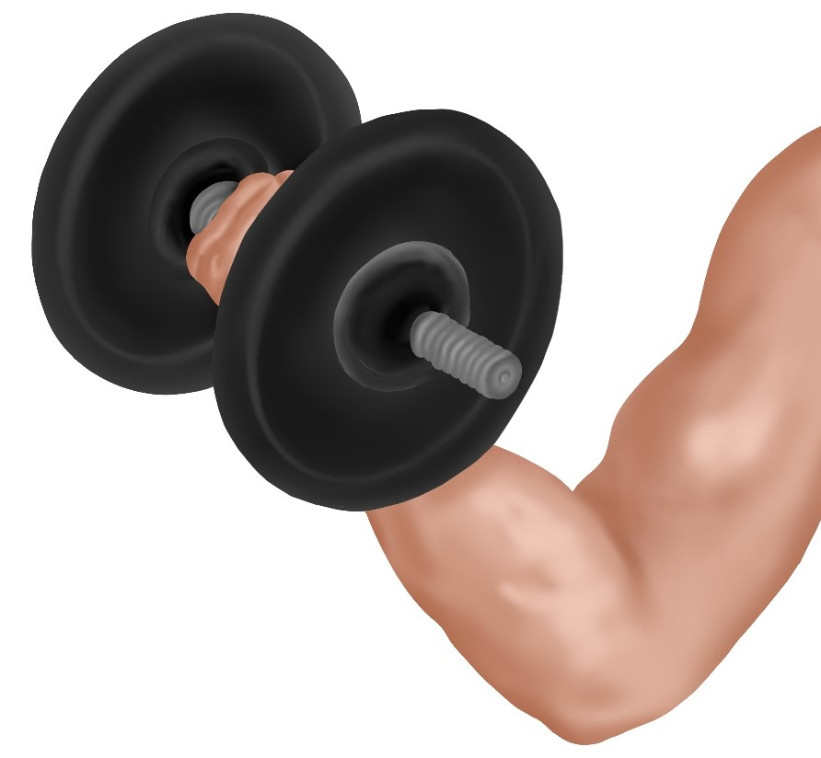
Vocabulary: actin, biceps, cartilage, contract, extend, fast twitch fiber, flex, fulcrum, humerus, lever, ligament, muscle fiber, myofibril, myosin, powerstroke, radius, sarcomere, skeletal muscles, slow twitch fiber, tendon, triceps, ulna

Prior Knowledge Questions (Do these BEFORE using the Gizmo.)

- When you lift a weight, what part of the arm is doing the most work?

- How do you think your arm muscles cause your forearm bones to move?

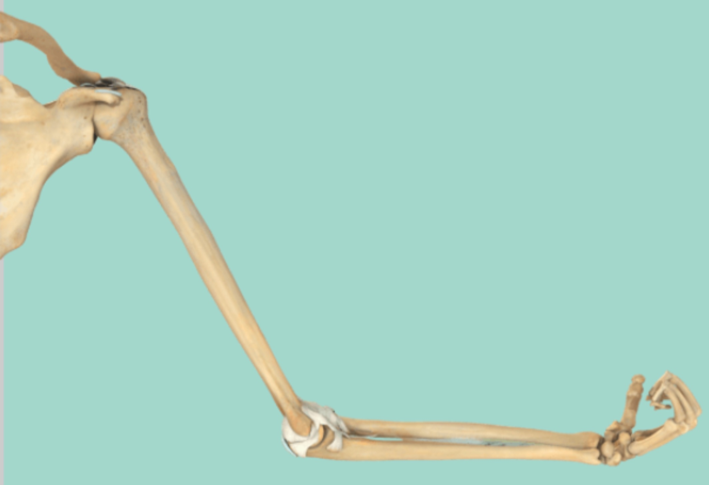
Gizmo Warm-up
In the Muscles and Bones Gizmo, you will learn about the anatomy of the arm. You will build an arm model, then test its ability to lift a dumbbell and throw a ball. You will see how making adjustments to the arm can affect its ability to lift and throw.

To begin, make sure you are on the ANATOMY tab, the entire arm is shown, and no circles are open. Select Hide muscles. Click Play.

- Describe what the arm bones are doing.

- Turn off Hide muscles and turn on Show labels. Describe what the biceps and triceps are doing as the forearm moves up and down.

Activity A:  Muscle anatomy | Get the Gizmo ready:  - Make sure the ANATOMY tab is selected and no circles are open. | 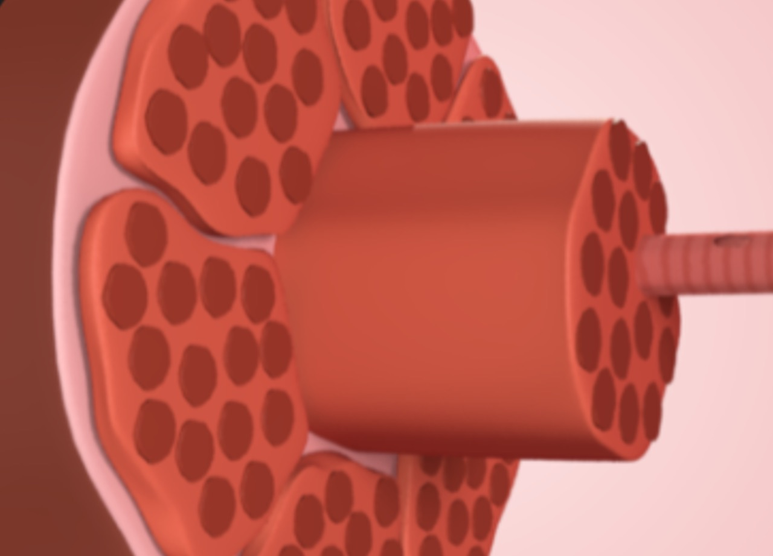

Introduction: Your arm contains muscles, bones, and other connective tissue. When muscles contract, they pull on the bones, causing them to move. In this activity, you will learn what causes muscles to contract.

Question: What causes muscles to contract?

- Observe: Turn on Hide muscles and Show labels.

- Which bone connects the shoulder to the forearm?

- What are the names of the two forearm bones?

- Observe: Note the white connective tissue along the elbow. Cartilage reduces friction between bones. Examine the ligament.

- Ligaments connect bones to .

- Turn off Hide muscles. Inspect the tendons. Tendons join bones to .

- Explore: Click Play. Observe the muscles as the forearm moves up and down.

- When the arm flexes (bends upward), which muscle contracts?

- Which muscle relaxes when the arm flexes?

- When the arm extends (straightens), which muscle contracts?

- Which muscle relaxes when the arm extends?

- Why do muscles work in pairs?

- Observe: Click on the biceps to see a close-up of the muscle.

- What is the muscle made of?

- Click Play. What happens to the muscle fibers (muscle cells) as the arm flexes and extends?
(Activity A continued on next page)
Activity A (continued from previous page)

- Observe: Click on the muscle fiber to see a close-up. Note that each muscle fiber consists of a bundle of still smaller rod-like structures known as myofibrils, which are striated (banded).

- What are the dark bands made of?

- What are the light bands made of?

- Observe: Click on the myofibril to see a close-up of a sarcomere.

- What protein are the thick filaments made of?
- What protein are the thin filaments made of?
- Click Play. What happens to the thick and thin filaments?

- How do these filaments enable muscles to contract and relax?

- Explore: Click on the sarcomere to take a closer look at the connection between actin and myosin. Click Play.

- Describe what is occurring.

The action of the myosin heads pulling on the actin filament is called a powerstroke.
- Where does myosin get the energy to perform a contraction?

- Summarize: Explain how actin and myosin work together to help you lift an object.

Activity B:  Arm design: Lifting | Get the Gizmo ready:  - Open the DESIGN tab.  - For the Challenge, select Lift. | 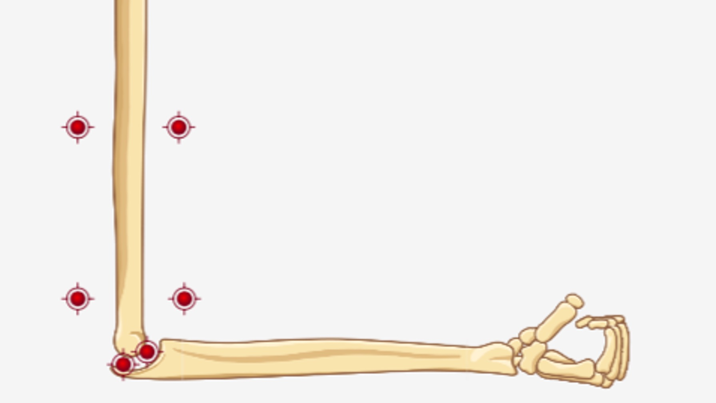

Question: How can an arm be constructed to lift weights most effectively?

- Experiment: In this activity, you will custom design an arm to lift a dumbbell using bones, muscles, and connective tissue. Drag pieces from the parts library to the red dots on the left. The arm is complete when all of the red dots are covered. Refer back to the ANATOMY tab if needed. When you are finished, select the TEST tab.

- Click Play. Did the arm lift the dumbbell? If not, modify your design.

- Which muscle must contract to lift the dumbbell?

- What happens to the length of this muscle when it contracts?

- Compare: Note the three different options for the ratio of slow twitch fibers to fast twitch fibers. Slow twitch (ST) fibers contract and relax more slowly than fast twitch (FT) fibers. Construct an arm using each of the three muscles, for both the biceps and triceps. Determine the maximum dumbbell mass each arm can lift and record in the table below.

Muscle | 80% ST, 20% FT | 50% ST, 50% FT | 20% ST, 80% FT
Maximum mass

What type of muscle fiber is best for lifting the most mass?

- Collect data: Set the dumbbell mass to 10 kg and select Multiple reps. Click Play.

- Record the number of reps each muscle type can do before it is too tired to continue:
80% ST, 20% FT: 50% FT, 50% ST: 20% ST, 80% FT:

- Which fiber type gets tired the fastest?

- Which type of fiber is best if you need a quick burst of energy?

- Which fiber is best for low intensity, sustained exercise?
Muscles made of slow twitch fibers use oxygen and are rich in blood vessels, giving them a dark red color. These fibers produce relatively little force but can last a long time before they get tired because they receive a constant supply of oxygen and fuel. Fast twitch fibers do not need outside oxygen, have fewer blood vessels, and are lighter in color. They can generate large amounts of force and provide a quick burst of energy. However, fast twitch fibers have a very limited supply of fuel and tire quickly.

(Activity B continued on next page)
Activity B (continued from previous page)
- Investigate: In the DESIGN tab, remove the cartilage from one of your designed arms. Compare the number of repetitions this arm can do compared to the arm with cartilage.

What do you find?

Since cartilage acts to reduce friction between the bones in a joint, the absence of cartilage forces the muscles to work harder and tire more quickly. Cartilage also prevents joint pain.

- Experiment: In the DESIGN tab, you can use a slider to adjust the length of the forearm bones. Use the Gizmo to see how bone length affects how much mass can be lifted.

- What do you find?

- On the TEST tab, for Data select Summary. Note the output. How does the force exerted on the same mass differ between short and long bones?

The arm acts as a lever, with the elbow serving as the pivot point or fulcrum. As the distance to the fulcrum increases, less weight can be lifted. So while shorter arms can lift more weight, longer arms can lift objects higher.

- Investigate: In the DESIGN tab, the white circles represent the insertion point of the tendons, where they connect the muscles to the bone. Use the Gizmo to see how the location of the insertion point affects the amount of mass that can be lifted.

- What do you find?

- Why do you think the location of the insertion point has this effect?

- Note how far the arm lifts the weight. What is a disadvantage of moving the insertion point farther from the elbow?
In an actual human arm, the insertion point is close to the elbow, allowing for a greater range of motion.

- Apply: Using the principles you have learned, construct an arm that can lift the most mass.

- How much mass can your arm lift?

- What settings did you use?

Forearm length: Muscle type: Insertion point:

Activity C:  Arm design: Throwing | Get the Gizmo ready:  - On the DESIGN tab, set the Length to 0.27 m.  - For the Challenge, select Throw. | 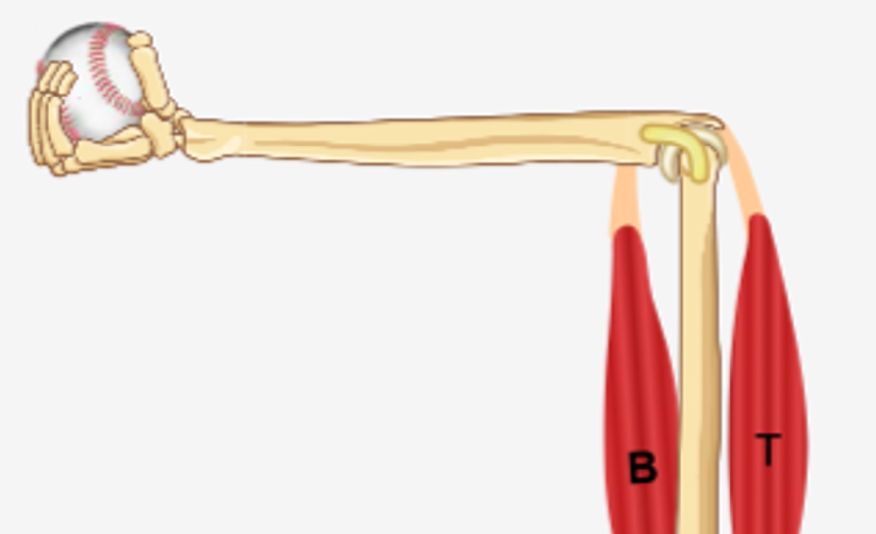

Question: How can an arm be constructed to throw a ball most effectively?

- Experiment: In this activity, you will see how arm muscles behave when throwing as opposed to lifting. (Even though other muscles are involved with throwing, we will only look at the upper-arm muscles here.) Construct an arm as before, making Biceps the contracting muscle. Go to the TEST tab, check that the challenge is Throw, and press Play.

- What happened?

- Make the necessary adjustment and throw again. Were you successful?

- Why is it necessary for the triceps to be the contracting muscle when throwing?

- Investigate: For each combination, find the triceps force and baseball velocity, recording data below. Keep mass of ball, insertion point, and length of forearm bones constant.

Muscle fiber type | Triceps force (N) | Baseball velocity (m/s)
80% ST, 20% FT
50% ST, 50% FT
20% ST, 80% FT

- Which muscle fiber type generated the greatest force?

- Which muscle fiber type enabled the fastest throw?

- Are slow or fast twitch fibers best for throwing fast?

- Explain your reasoning.

- Which fiber type do you think is best when making multiple throws?

- Predict: If you were throwing a very light ball, do you think it would be better to have a long or short arm?
How about when throwing a heavy ball?

(Activity C continued on next page)
Activity C (continued from previous page)

- Experiment: Construct an arm made of 50% FT, 50% ST fibers, for both muscles. Set the forearm length to 0.20 m and throw a 0.10 kg ball. Then, set the forearm length to 0.35 m and throw the same ball. Repeat the procedure with a 3.00 kg ball. Record data below.

Forearm bone length (m) | Mass of ball (kg) | Triceps force (N) | Output force (N) | Baseball velocity (m/s)

0.20 | 0.10
0.35 | 0.10

0.20 | 3.00
0.35 | 3.00

- Which forearm threw the 0.10 kg ball faster?

- Which forearm threw the 3.00 kg ball faster?

- Explain: Why do you think the short arm was a little bit better for throwing a heavy ball, and the long arm was slightly better for throwing a light ball? If possible, discuss your answers with your classmates and teacher.

- Apply: Using the principles you have learned, construct an arm that can throw a 0.14-kg baseball the fastest. (Hint: You can also vary the insertion point of the triceps tendon to the forearm.)

- How fast did the arm throw?

- What settings did you use?

Forearm length: Muscle type: Insertion point:

