Vocabulary: Muscles and Bones

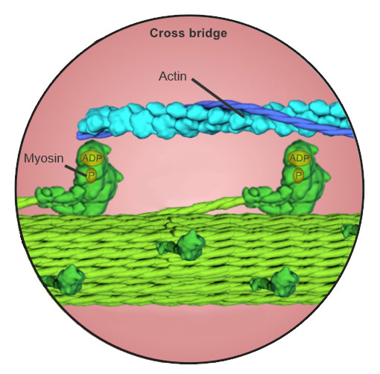
Vocabulary

- Actin – the protein that makes up the thin filaments within a myofibril.
  - The inward movement of the actin fibers within a sarcomere makes the muscle shorter during a contraction.
  - The region of the sarcomere containing only actin filaments is known as the I-band, and is lighter in color than the regions containing myosin.

- Biceps – the large muscle in the front of the upper arm, having two points of attachment on one end.
  - The biceps in the arm is technically known as the biceps brachii.
  - The biceps is a flexor muscle, a muscle that flexes (bends) a joint.

- Cartilage – the flexible connective tissue found at the end of bones where they come together to form a joint, reducing friction as the bones make contact.
  - Cartilage is also found in the nose, ear, rib cage, spine, and rings of the trachea and bronchi.
  - Cartilage lacks blood vessels and is either white or translucent in color.

- Contract – to get smaller.
  - Contracting muscles pull on bones, allowing the body to move.
  - As one muscle contracts, another muscle relaxes.

- Extend – to straighten a body part.

- Fast twitch fiber – a muscle fiber that contracts quickly and with relatively large force.
  - Fast twitch fibers are utilized when a short burst of energy is needed.
  - Fast twitch muscle tissue contains few mitochondria and fatigues quickly.

- Flex – to bend a body part.

- Fulcrum – the pivot point about which a lever turns.

- Humerus – the bone in the upper arm that connects the shoulder to the elbow.

- Lever – a simple machine that rotates about a fulcrum and increases either the force or distance put into it.

- Ligament – connective tissue that attaches one bone to another bone.
- Muscle fiber – a muscle cell, also called a myofiber.
  - Muscle cells are long and narrow and contain many nuclei.
  - Each muscle cell is composed of a bundle of myofibrils.

- Myofibril – small, rod-like structures within a muscle cell.
  - The striated appearance of muscles is due to alternating bands of light filaments (actin) and dark filaments (myosin) within the myofibrils.

- Myosin – the protein that makes up the thick filaments within a myofibril.
  - The heads of the myosin filaments grab onto the actin filaments and pull them inward, shortening the muscle fiber during a contraction.

- Powerstroke – the motion in which the myosin pulls the actin filaments inward, resulting in the shortening of the sarcomere.
  - The energy for the powerstroke is provided by ATP.

- Radius – the smaller of the two forearm bones, extending from the elbow to the thumb side of the wrist.

- Sarcomere – the contractile unit of the muscle cell.
- Sarcomeres are arranged in repeating units within each myofibril, encompassing all of the actin and myosin filaments between two Z discs.

- Skeletal muscles – one of three main muscle types, consisting of those muscles connected to the bones and responsible for all voluntary movement in the body.

- Slow twitch fiber – a muscle fiber that contracts slowly and with relatively little force.
  - Slow twitch fibers are used when small amounts of energy are needed for long periods of time, such as when walking or standing.
  - Slow twitch muscle tissue contains numerous mitochondria, allowing them to contract repeatedly without getting tired.

- Tendon – connective tissue that attaches bone to muscle.
- A tendon is also referred to as a sinew, and like ligaments can withstand a great deal of tension as they are stretched, much like a rubber band.

- Triceps – the large muscle in the back of the upper arm, having three points of attachment on one end.
  - The technical name for the triceps is the triceps brachii.
- The triceps is an extensor muscle, in that it enables a joint to be straightened.

- Ulna – the larger of the two forearm bones, extending from the elbow to the little finger side of the wrist.

