Name: ______________________________________ Date: ________________________

Student Exploration: Natural Selection

Vocabulary: biological evolution, camouflage, Industrial Revolution, lichen, morph, natural selection, peppered moth

Prior Knowledge Questions (Do these BEFORE using the Gizmo.)
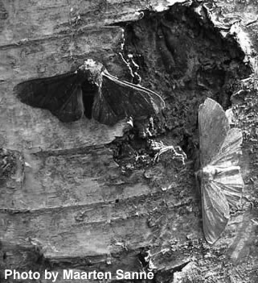
The peppered moth (Biston betularia) is a common moth found in Europe, Asia, and North America. It is commonly found in two forms, or morphs: a dark morph and a light, speckled morph. Birds are a frequent predator of the peppered moth.

- Which morph do you think would be easier to see on a dark tree trunk? _______________________________

- Which morph do you think would be easier to see on a light tree trunk? _______________________________
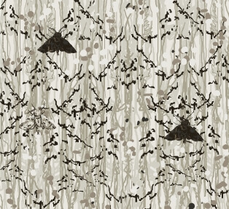

How many moths can you find?

Gizmo Warm-up
The Natural Selection Gizmo allows you to play the role of a bird feeding on peppered moths. The initial population of 40 moths is scattered over 20 tree trunks. Click on moths to capture them. Click the Next tree button (or the spacebar on your keyboard) to advance to the next tree.

- Check that LIGHT TREES is selected. Click Play (), and hunt moths for one year.

    - How many dark moths did you capture? _______

    - How many light moths did you capture? _______

    - Camouflage is coloring or patterns that help an organism to blend in with the background. Which type of moth is better camouflaged on light bark? ____________

- If a forest contained mostly light-colored trees, which type of moth would you expect to be most common? ____________________________________________________________
Activity A:  Light trees | Get the Gizmo ready:  - Click Reset ().  - Check that the LIGHT TREES tab is selected. | 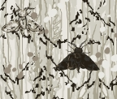

Introduction: Before the 19th century in England, the air was very clean. The bark on trees was usually light in color. Abundant lichens growing on tree trunks also lightened their appearance.

Question: How does the color of a peppered moth affect survival?

- Predict: Over time, what will to happen to the populations of light and dark moths on light trees? ____________________________________________________________________

- Experiment: Click Play and hunt peppered moths on light tree trunks for five years. In each year, try to capture as many moths as you can. Note: You can use the spacebar on your keyboard to quickly advance to the next tree.

After 5 years, select the TABLE tab and record the percentages of each moth type. (Note: The table shows current populations of each moth, not the number of captured moths.)

Year | Dark moths | Light moths
0
1
2
3
4
5

- Analyze: What do your results show? ___________________________________________

_________________________________________________________________________

- Apply: Which type of moth do you think was more common before the 19th century, when most trees were light in color? _________________________________________________

- Extend your thinking: What strategies did you use to hunt for moths? __________________

_________________________________________________________________________

_________________________________________________________________________
Activity B:  Dark trees | Get the Gizmo ready:  - Click Reset.  - Select the DARK TREES tab. | 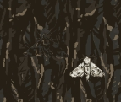

Introduction: The 19th century was the time of the Industrial Revolution in England. Most of the new industries used coal for energy, and the air was polluted with black soot. In forests near factories, the soot coated trees and killed lichens. As a result, tree trunks became darker.

Question: How did air pollution affect moth populations?

- Predict: Over time, what will to happen to the populations of light and dark moths on dark trees? ____________________________________________________________________

- Experiment: Click Play and hunt peppered moths on dark tree trunks for five years. In each year, try to capture as many moths as you can.

When you are done, select the TABLE tab and record the percentages of each moth type.

Year | Dark moths | Light moths
0
1
2
3
4
5

- Analyze: What do your results show? ___________________________________________

_________________________________________________________________________

- Apply: Which type of moth do you think was more common during the 19th century? Why?

_________________________________________________________________________

_________________________________________________________________________

_________________________________________________________________________

(Activity B continued on next page)
Activity B (continued from previous page)

- Draw conclusions: Natural selection is the process by which favorable traits tend to increase in frequency over time. How does this experiment illustrate natural selection?

_________________________________________________________________________

_________________________________________________________________________

_________________________________________________________________________

_________________________________________________________________________

_________________________________________________________________________

- Think and discuss: Did the changes you observed in the moth populations result from individual moths changing colors? Or did they occur because the best-hidden moths survived and reproduced, passing on their colors to their offspring? Explain your answer.

_________________________________________________________________________

_________________________________________________________________________

_________________________________________________________________________

_________________________________________________________________________

_________________________________________________________________________

- Extend your thinking: Biological evolution is the process by which populations of organisms change over time. How could natural selection lead to evolution? If possible, discuss your answer with your classmates and teacher.

_________________________________________________________________________

_________________________________________________________________________

_________________________________________________________________________

_________________________________________________________________________

_________________________________________________________________________

_________________________________________________________________________

_________________________________________________________________________

_________________________________________________________________________

