Name: ______________________________________ Date: ________________________

Student Exploration: Nuclear Decay

Vocabulary: alpha particle, atomic number, beta particle, daughter product, gamma ray, isotope, mass number, nuclear decay, positron, radioactive, subatomic particle

Prior Knowledge Questions (Do these BEFORE using the Gizmo.)
The chart below gives the locations, charges, and approximate masses of three subatomic particles. The approximate mass of each particle is given in universal mass units (u).

Particle | Location | Charge | Approximate mass
Proton | Nucleus | 1⁺ | 1 u
Neutron | Nucleus | 0 | 1 u
Electron | Orbitals | 1– | 0 u

- The mass number of an atom is equal to the sum of protons and neutrons in the nucleus.
A helium atom has 2 protons and 2 neutrons. What is the mass number of this atom? _____

- The atomic number of an element is equal to the number of protons in each atom of the element. All helium atoms have 2 protons. What is the atomic number of helium? _____
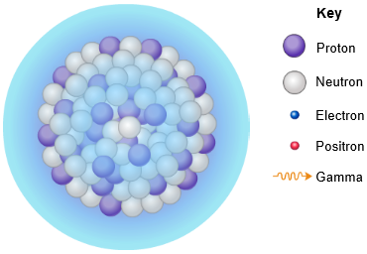
Gizmo Warm-up
While most atoms are stable, some are radioactive, which means that they have a tendency to undergo spontaneous nuclear decay. The decay of radioactive atoms generally results in the emission of particles and/or energy.

Several types of nuclear decay can be explored with the Nuclear Decay Gizmo. On the Gizmo, check that Alpha decay and Uranium are selected.

- Click Play (), and then click Pause () when the alpha particle is clearly visible. What is an alpha particle made of? _____________________________________________

- Click Play and observe. Besides the alpha particle, what else is emitted from the nucleus during alpha decay? ________________________________________________________
Gamma rays are energetic electromagnetic waves; they are often emitted in nuclear decay.
Activity A:  Alpha decay | Get the Gizmo ready:  - Click Reset ().  - Check that Alpha decay and Uranium are selected. | 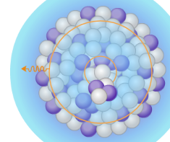

Question: How does alpha decay change the nucleus of a radioactive atom?

- Predict: As you observed in the warm-up activity, an alpha particle consists of two protons and two neutrons. How will the emission of an alpha particle affect the following?

    - The atomic number of the atom: _________________________________________

    - The mass number of the atom: __________________________________________

- Calculate: Turn on Write equation. What you see is an equation that shows the original uranium atom on the left. The boxes on the right represent the daughter product—the atom produced by radioactive decay—and the emitted alpha particle.

- In the top left box, write the mass number of the daughter product and press “Enter” on your keyboard. What is this number? ______________
- In the bottom left box, write the atomic number of the daughter product and press “Enter.” What is this number? ______________
- In the next set of boxes, enter the mass number and atomic number of the alpha particle, which has the same composition as the nucleus of a helium (He) atom. After filling in the boxes in the Gizmo, write the completed equation below:
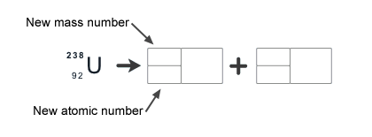
- According to your equation, what isotope remains after the alpha decay of
uranium-238? (Note: You can look up element symbols on the periodic table.)

___________________________________________________________________

- Check: Turn on Show equation, and click Play. The equation will appear at the end of the animation. Was your prediction correct? _____________ If not, modify your equation above.
(Activity A continued on next page)
Activity A (continued from previous page)

- Practice: Click Reset, turn off Show equation, and select Polonium. Write an equation for the alpha decay of polonium, and then use the Gizmo to check your answer.

What isotope remains after the alpha decay of polonium-212? _______________________

- Practice: Click Reset, turn off Show equation, and select Radium. Write an equation for the alpha decay of radium, and then use the Gizmo to check your answer.

What dangerous gas is produced by the decay of radium-226? _______________________

- Practice: Americium-241 is a radioactive isotope used in smoke detectors. Write an equation for the alpha decay of Americium-241 below.

- Analyze: In each equation, how is the mass number on the left side of the arrow related to the sum of mass numbers on the right side of the arrow? Is this true for atomic numbers?

_________________________________________________________________________

_________________________________________________________________________

- Summarize: In general, how can you determine the mass number of the daughter product after alpha decay has taken place? How can you determine the atomic number?

_________________________________________________________________________

_________________________________________________________________________

- Think and discuss: Helium is the second most abundant element in the universe, but it is rare in Earth’s atmosphere. Most of the helium used to fill balloons and blimps must be extracted from Earth’s crust. How do you think this helium formed?

_________________________________________________________________________

_________________________________________________________________________

Activity B:  Beta decay | Get the Gizmo ready:  - Click Reset, and turn off Show equation.  - Select Beta decay from the Type of decay menu.  - Check that Carbon is selected. | 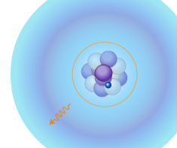

Question: How does beta decay change the nucleus of a radioactive atom?

- Observe: Click Play and watch the animation.

    - What happens to the decaying neutron during beta decay? ____________________
___________________________________________________________________
    - What is emitted from the nucleus during beta decay? _________________________
    - What is the mass number and charge of the emitted particle?
Mass number: _______ Charge: _______

- Predict: During beta decay, a neutron is transformed into a proton and an electron (the beta particle), which is emitted. Gamma rays are often emitted during beta decay as well.

How will beta decay affect the atomic number and mass number of the atom?

_________________________________________________________________________

- Calculate: Turn on Write equation. Fill in the first set of boxes with the mass number and atomic number of the daughter product and the next set of boxes with the mass number and atomic number of the beta particle. (Note: The atomic number of an electron is -1.)

Check your answer by turning on Show equation and clicking Play. Modify your equation if necessary. What isotope is produced by the beta decay of carbon-14? _________________

- Practice: Turn off Show equation. Fill in the equations for the beta decay of iodine-131 and sodium-24 in the spaces below. Use the Gizmo to check your answers.

Activity C:  Protons into neutrons | Get the Gizmo ready:  - Click Reset, and turn off Show equation.  - Select Positron emission.  - Check that Carbon is selected. | 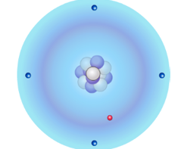

Introduction: A positron is a type of antimatter that is equivalent to an electron. If a positron and an electron meet, they will annihilate one another in a burst of gamma rays.

Question: How do positron emission and electron capture change an atom?

- Observe: Click Play and watch the animation.

    - What happens to the decaying proton during positron emission? ________________
___________________________________________________________________
    - What is the mass number and charge of the emitted positron? __________________
Mass number: _______ Charge: _______

- Predict: During positron emission, a proton is transformed into a neutron and a positron, which is emitted. The positron will fly through space until it encounters an electron. How will positron emission affect the atomic number and mass number of the atom?

_________________________________________________________________________

- Calculate: Turn on Write equation. Fill in the first set of boxes with the mass number and atomic number of the daughter product and the next set of boxes with the mass number and atomic number of the positron. (Note: The atomic number of a positron is 1.)
Check your answer by turning on Show equation and clicking Play. Modify your equation if necessary. What isotope is produced when carbon-11 emits a positron? _______________

- Practice: Turn off Show equation. Fill in the equations for the positron emission of xenon-118 and manganese-50 in the spaces below. Use the Gizmo to check your answers.

(Activity C continued on next page)
Activity C (continued from previous page)

- Observe: Click Reset. Select Electron capture, and make sure Tungsten is selected. Click Play and watch the animation.

    - What happened to the proton after absorbing an electron? ____________________
___________________________________________________________________
    - What is the mass number and charge of the absorbed electron?
Mass number: _______ Charge: _______

- Predict: During electron capture, an electron is absorbed into the nucleus, causing a proton to transform into a neutron. How will electron capture affect the atomic number and mass number of the atom?

_________________________________________________________________________

- Calculate: Note that in this equation the particle is absorbed, rather than emitted. Fill in the first set of boxes with the mass number and atomic number of the absorbed electron. Fill in the last set of boxes with the mass number and atomic number of the daughter product.

Turn on Show equation and click Play to check. Modify your equation if necessary.
What isotope is produced when tungsten-179 absorbs an electron? ___________________

- Practice: Turn off Show equation. Fill in the electron capture equations for gold-195 and neodymium-141 in the spaces below. Use the Gizmo to check your answers.

- Think and discuss: What do electron capture and positron emission have in common?

_________________________________________________________________________

_________________________________________________________________________

_________________________________________________________________________

