Name: Date:

Student Exploration: Number Systems

Vocabulary: base-10, binary system, digit, place value

Prior Knowledge Questions (Do these BEFORE using the Gizmo.)
An odometer, like the one shown to the right, shows a car’s mileage. When a car is new, every digit of the odometer is a zero: 000,000 miles. (Each individual numeral, 0 through 9, that makes up a number is called a digit.)

- Most odometers display 6 digits. Suppose you notice that every digit on your odometer is a zero, except for one of them, which is a 1. What could the mileage of your car be? Explain.

- Suppose the six digits on your odometer are three 0’s, a 2, a 3, and an 8. If the mileage is less than 1000, what is the largest it could be? The smallest?

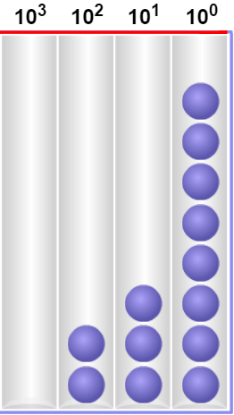
Gizmo Warm-up
Numbers, like mileage on an odometer, can have the same digits but very different values. This is because the value of a digit depends on its place value. In a base-10 system like we use, place values are powers of 10 such as ones (10⁰), tens (10¹), hundreds (10²), etc. In the Number Systems Gizmo, you can model numbers with beads to help explore place value. You can also experiment with other number systems, like binary (base-2).

Drag the Base and the Base-10 value sliders to vary the values. You can also drag one bead at a time into a column. To enter a specific value, click in the text field, type the value, and hit Enter.

- In the Gizmo, set the Base-10 value to 238. Be sure the Base is 10.

- How many beads are in each column? 10³: 10²: 10¹: 10⁰:

- Which column corresponds to the ones digit?

- Click Clear. What is the smallest number you can model with one bead?

What is the largest number you can model with just one bead?

Activity A:  Exploring base-10 | Get the Gizmo ready:  - Click the Clear button.  - Be sure that the Base is set to 10. | 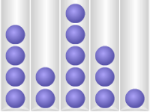

- In the Gizmo, drag a bead from the bin and place it in the 10² column.

- When one bead is in the 10² column what is the value?

- Move the bead one column to the right (to 10¹). What is the new value?

- Move the bead one column to the right (to 10⁰). What is the new value?

- As the bead moves one place value to the right, how does the value change?

- What is the value of 10⁰?

- Without the Gizmo, consider the base-10 number 427.

- If you modeled 427, how many beads would be in each column?

10²: 10¹: 10⁰:

- In the Gizmo, set the Base-10 value to 427. Click Show expanded form. Using exponents, express the number 427 in expanded form.

- In the number 427, 4 is in the “hundreds place,” 2 is in the “tens place,” and 7 is in the “ones place.” Look at the expanded form and explain why that makes sense.

- Drag a new bead from the bin on the right to the tens place (10¹ column). How does this change the number modeled?
- What number will be modeled if a new bead is placed in the 10⁴ column? Explain your answer. Then try it in the Gizmo.

(Activity A continued on next page)
Activity A (continued from previous page)

- Click Clear. Then model the number 350 by dragging beads into the columns.

- How many beads are in each column? 10³: 10²: 10¹: 10⁰:

- Express 350 in expanded form.

- How many beads did you use, total?

- What is the sum of the digits in the number 350?

- Click Clear. Using the beads, model the number 23,062.

- How many beads did you place in each column?

10⁵: 10⁴: 10³: 10²: 10¹: 10⁰:

- On the line below, express 23,062 in expanded form.

Check your answer in the Gizmo.

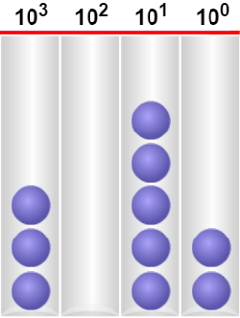
- The beads in the chart on the right model a number in base-10.

- How many beads are in each column?

10³: 10²: 10¹: 10⁰:

- What number is modeled?

- Express the number in expanded form.

Check your answer in the Gizmo.

- In the Gizmo, click Clear. Then experiment with modeling numbers using 10 beads total.

- What is the largest number that can be modeled using 10 beads?

Explain.

- What is the smallest number that can be modeled using 10 beads?

Explain.

Activity B:  Exploring the binary system | Get the Gizmo ready:  - Click the Clear button.  - Select Show expanded form. | 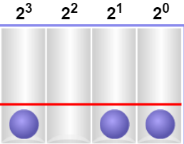

The binary system, a base-2 number system, is widely used by computers. The only digits in a binary number are 0 and 1. A number in binary is written with a subscript of 2, like this: 101₂.

- In the Gizmo, set the Base to 2. Drag one bead to the rightmost column.

- What base-2 (binary) number is modeled?

- What is the base-10 equivalent of this binary number?

- Now add a new bead, in the 2¹ column. What binary number is modeled?

- Write the number in expanded form.

- What is the base-10 equivalent of this new binary number?

Check your answers in the Gizmo.

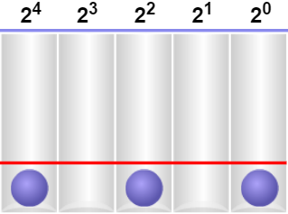
- A binary number is modeled to the right.

- What binary number is modeled?

- Write the number in expanded form.

- What is the equivalent base-10 value? Check your answers in the Gizmo.

- What are the place values of a five-digit binary number? Explain your answer.

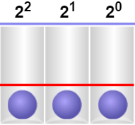
- In the Gizmo, use beads to model the binary numbers 111₂ and 1000₂.

- What is the base-10 value of 111₂? 1000₂?

- You should have found that the values of 111₂ and 1000₂ are only one apart. Explain why this makes sense.

