Vocabulary: Observing Weather (Customary)

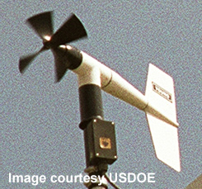
Vane anemometer
Vocabulary

- Anemometer – an instrument used for measuring the speed (and sometimes direction) of the wind.
  - A vane anemometer (also called a propeller anemometer) uses a propeller to measure the wind speed and rotates to show wind direction. The propeller points in the direction the wind is coming from.

- Atmosphere – the layer of gases that surrounds Earth or another planet.
  - Earth’s atmosphere is about 60 miles thick.
Aurora australis

- Aurora borealis – a glowing light in Earth’s atmosphere, usually near the North Pole, caused by the collisions of charged particles with atoms in Earth’s atmosphere.
  - Aurora borealis is also known as “northern lights.”
  - In the southern hemisphere, the aurora is called aurora australis or “southern lights.”

- Cumulonimbus cloud – a large, tall, and dense cloud that often produces heavy rain and thunderstorms.
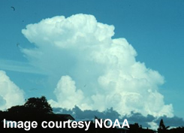
Cumulonimbus cloud
  - Cumulonimbus clouds form when hot, moist air rises rapidly within the cloud, giving the cloud a great height.

- Equator – an imaginary line drawn around the middle of Earth, halfway between the north and south poles.

- Evaporate – to change from a liquid to a gas.
  - Evaporation is occurring when a puddle of rainwater dries up.
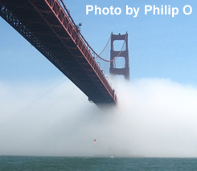
Fog

- Fog – a thick, dense cloud located near the ground.
  - Fog forms when moist air is cooled near the ground. This may happen when the ground cools at night or when moist air is cooled by a cold ocean surface.
  - Unlike mist, fog is very hard to see through. Driving or sailing in fog can be very dangerous.

- Humidity – the amount of water vapor in the air.
  - The relative humidity is the amount of water vapor in the air divided by the maximum amount of water vapor the air can hold.
    - For example, a relative humidity of 60% means that the air contains 60% of the maximum amount of water vapor it can hold.

- Hygrometer – an instrument used to measure humidity.
  - One form of hygrometer uses a human hair to measure humidity. The hair is attached to a weight. As humidity increases, the hair stretches to a longer length. When humidity decreases, the hair contracts.

- Latitude – angular distance north or south of the equator.
  - The latitude of the equator is 0°, the latitude of the North Pole is 90° N, and the latitude of the South Pole is 90° S.

- Precipitation – any form of water that falls to the ground.
  - Examples of precipitation include rain, snow, sleet, and hail.

- Rain gauge – an instrument used to measure the amount of liquid precipitation.
  - A typical rain gauge uses a funnel to collect water into a graduated cylinder. Rainfall is measured in millimeters.

- Thermometer – an instrument used to measure temperature.
  - Inside a thermometer, a liquid (usually alcohol) expands when heated, causing it to rise into a narrow tube. The level of the liquid indicates the temperature.

- Temperature – the hotness or coldness of a substance, such as air.

- Thunderstorm – a storm that produces lightning.
  - Lightning is an electrical discharge from one part of a cloud to another or from the cloud to the ground.
  - A lightning bolt causes the air around it to heat and expand rapidly. This causes sound waves to be transmitted, which we hear as thunder.
  - Thunderstorms typically produce high winds and heavy rains.

- Weather – the state of the atmosphere at a time and place.
  - Weather is described by temperature, wind speed, humidity, cloud cover, precipitation, and barometric pressure.

- Weather station – a structure containing instruments for measuring the weather.
  - A typical weather station contains a thermometer for measuring temperature, an anemometer for measuring wind speed and direction, a rain gauge for measuring precipitation, a hygrometer for measuring humidity, a barometer for measuring pressure, and a pyranometer for measuring the intensity of sunlight.

