Name: Date:

Student Exploration: Observing Weather (Metric)

Vocabulary: anemometer, atmosphere, aurora borealis, cumulonimbus cloud, equator, evaporate, fog, humidity, hygrometer, latitude, precipitation, rain gauge, thermometer, temperature, thunderstorm, weather, weather station

Prior Knowledge Questions (Do these BEFORE using the Gizmo.)

- If you were describing the weather to someone, what kinds of things would you talk about?

- What instruments can you use to gather information about weather?

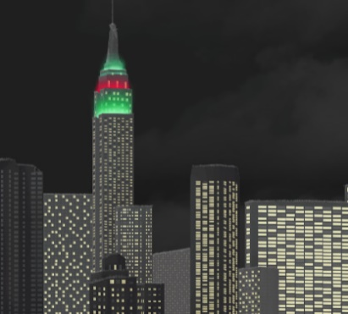
Gizmo Warm-up
Earth is surrounded by a blanket of air called the atmosphere. The weather is the state of the atmosphere at a given time and place. In the Observing Weather (Metric) Gizmo, you will record and compare weather conditions in several locations.

To begin, check that New York is selected on the world map. Check that the date is January 1. Click Observe weather and select Metric units.

- Click Play () and observe for one day.

- What types of weather do you see?

- Based on the weather, do you think the day was hot or cold?

- Click the thermometer ( ) to measure the temperature, or how hot or cold it is. Temperature is measured in degrees Celsius (°C). Water freezes at 0 °C and boils at
100 °C. If the temperature is below 0 °C, use a negative number, like –8 °C.

What is the temperature at 11:59 PM?

Activity A:  Collecting weather data | Get the Gizmo ready:  - Check that the selected location and date is New York, January 1.  - With Observe weather selected, click Reset (). | 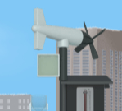

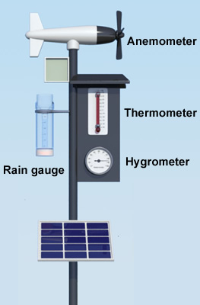
Question: How do we measure weather conditions?

- Measure: The time should be 12:00 AM, or midnight. Notice the weather station, shown at right. Select the thermometer. Each line on the thermometer represents 2 °C.

What is the current temperature?

Record this value in the first row and of the Weather journal on the right side of the Gizmo, under Temp. (°C).

- Measure: Select the anemometer, an instrument used to measure the wind speed and direction. Wind direction is the direction the wind is blowing from. For example, a “north” wind is moving from north to south.

What are the wind speed and direction? Record these values in the journal.

- Measure: Select the rain gauge. The rain gauge collects any precipitation (rain, snow, sleet, or hail) that falls from the sky. Precipitation is measured in millimeters.

Is there any water in the rain gauge? If not, record “0” in the journal.

- Measure: Select the round hygrometer. The hygrometer measures humidity, or how much water is in the air. Humidity is measured as a percentage. Perfectly dry air has 0% humidity, while air with a maximum amount of moisture has 100% humidity.

What is the current humidity? Record this value in the journal.

- Record: Select the Pause simulation every three hours box. Click Play. At 3:00 AM, record the temperature, wind speed, wind direction, precipitation, and humidity in the journal. Then click Play and repeat for 6:00 AM. Copy your data into the table below.

Time | Temp. (°C) | Wind Spd. (km/h) | Wind Dir. | Precip. (mm) | Hum. (%)
3:00 AM
6:00 AM

(Activity A continued on next page)
Activity A (continued from previous page)

- Record: Click Play. When the simulation stops at 9:00 AM, you will notice a new Enter data button. Click this button to record all data automatically in the journal. Continue this procedure to record data every 3 hours until the last row of data is recorded at 11:59 PM. As you go, look for any changes in the weather and record these in the “Notes” section.

- About what time does the rain start?

- About what time does the rain turn to snow?

- Explain: Click Reset. Click Play, and then Pause (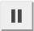) close to 3:30 PM.

- Select the thermometer. What is the temperature?

- How does the type of precipitation change at this time?

- Why did the precipitation change?

- Predict: Click Reset and then select July 1. Notice a new page is shown on the journal. How do you think the weather on July 1 will be different from the weather on January 1?

- Collect data: If necessary, turn on Pause simulation every three hours. Use the weather instruments to record data for 12:00 AM. Then, use the Enter data button to enter data for 3:00 AM, 6:00 AM, and so on until 11:59 PM. What types of weather did you observe?

- Compare: Click Reset and select Graph data. Select Compare graphs, and then click Page back on the left so January 1 is on the left and July 1 is on the right.

- Select the Temperature graph. How does the July 1 graph compare to the January 1 graph?
- Look at the graphs of wind speed, precipitation, and humidity. What differences do you see?

Activity B:  San Francisco and Kansas City | Get the Gizmo ready:  - Choose the World map.  - Select San Francisco and January 1.  - Click Observe weather. | 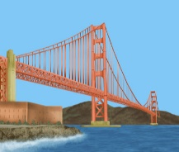

Question: How does weather depend on a location?

- Predict: In the first part of this activity, you will compare the weather in San Francisco, which is on the Pacific coast, to the weather in Kansas City, which is in the middle of the continent.

- How do you think a winter day in San Francisco will be different from Kansas City?

- How do you think a summer day in San Francisco will be different from Kansas City?

- Record: Turn on Pause simulation every three hours. Use the weather instruments to record weather conditions in San Francisco at 12:00 AM in the journal. Then, use the Gizmo to fill in data for 3:00 AM, 6:00 AM, and so on until 11:59 PM.

How would you describe the weather on this day?

Record this in the notes section of the journal.

- Record: Click Reset and select July 1. Use the same process to fill in the weather journal for this day.

What interesting weather condition did you see?

San Francisco is famous for low clouds called fog. Fog occurs when warm air is cooled by cold ocean waters. This causes water vapor in the air to cool and condense to form a cloud.

- Connect: Click Reset and turn off the Pause simulation every three hours checkbox. Click Play, and then Pause when the fog goes away.

- About what time does the fog go away?

- Look at the data in the weather journal. Are the temperature and humidity increasing or decreasing at this time of day?
As air warms it is able to hold more water vapor. The fog evaporates as the humidity drops.

(Activity B continued on next page)
Activity B (continued from previous page)

- Record: Click Reset. On the World map, select Kansas City and January 1. Select Observe weather and use the Gizmo to fill in the journal for both January 1 and July 1.

Describe the weather on January 1:

Describe the weather on July 1:

On July 1 there was a thunderstorm. Thunderstorms occur when hot, moist air rises rapidly, then cools to form tall cumulonimbus clouds. These clouds can produce heavy rain, wind, and lightning. Thunderstorms often happen in the late afternoon.

- Calculate: Click Reset and Graph data. Turn on the Compare graphs box. Use the Page back and Page forward buttons to get San Francisco, January 1 on the left and San Francisco, July 1 on the right.

- About how high was the highest temperature on July 1?

- About how high was the highest temperature on January 1?

- About how much hotter was it in July than it is in January?

- Calculate: Now look at Kansas City, January 1 and Kansas City, July 1.

- About how high was the highest temperature on July 1?

- About how high was the highest temperature on January 1?

- About how much hotter was it in July than it is in January?

- Compare: Which location has a bigger temperature change from January 1 to July 1, San Francisco or Kansas City?

- Extend your thinking: The weather in San Francisco is affected by its position next to the Pacific Ocean. Because it is such a large body of water, the temperature of the Pacific Ocean does not change as much as the land over the course of a year.

How does the Pacific Ocean help explain the weather differences between San Francisco and Kansas City? If possible, discuss your answer with your classmates and teacher.

Activity C:  Yellowknife and Miami | Get the Gizmo ready:  - Turn off Compare graphs.  - On the World map, choose Yellowknife and January 1.

Introduction: The latitude of a location describes how far north or south it is. In this activity, you will compare the weather in Yellowknife, which is near the North Pole, with Miami, which is near the equator, or Earth’s middle. In the Gizmo, the equator is marked by a dashed line.

Question: How does weather depend on latitude?

- Predict: Compare the positions of Yellowknife and Miami on the world map. How do you think winter and summer days will compare in these two locations?

- Record: Record weather data for Yellowknife every three hours on January 1 and July 1.

- What were weather conditions like on January 1?

- What were weather conditions like on July 1?

Date | Sunrise | Sunset
January 1
July 1

- Estimate: Select January 1 and turn off Pause simulation every three hours. Click Play, and then Pause when it gets light. Record the sunrise time at right. Click Play, and then Pause when it gets dark. Record the sunset time. Then, repeat this procedure for July 1.

- What do you notice about how long the daylight lasts on each of these dates?

- Click Reset and select January 1. Click Play, and pause around 8:00 PM. What do you see?
The swirls of color are called aurora borealis, or “northern lights.” This beautiful display is caused by electrically-charged particles from the Sun hitting Earth’s atmosphere.

(Activity C continued on next page)
Activity C (continued from previous page)

- Record: On the World map, select Miami. Using the same procedure as earlier, record weather data every three hours on January 1 and July 1. As you do this, record the kind of precipitation (or the kind of weather) you see here.

- What was the weather in Miami like on January 1?

- What was the weather in Miami like on July 1?

Date | Sunrise | Sunset
January 1
July 1

- Estimate: As you did for Yellowknife, use the Gizmo to estimate sunrise and sunset times for each date in Miami. Record these in the table to the right.

Did the sunrise and sunset times change as much from January to July in Miami as they did in Yellowknife? Explain your answer.

In general, areas near the North and South Pole have greater changes in hours of daylight during the year. Areas near the equator have similar hours of daylight year-round.

- Compare: Click Reset and select Graph data. Turn on Compare graphs. Look at the Temperature graphs for Yellowknife and Miami for each date.

- In which city was there a bigger change from January 1 temperatures to July 1 temperatures?
- How do you think the temperature changes between winter and summer relate to the hours of daylight in each location?

- On your own: Using the Gizmo, explore weather conditions in other parts of the world. You can look at weather in a Brazilian rainforest, an Egyptian desert, on the Spanish coast, the Mongolian steppe, or in Australia. Summarize your observations from each location on a separate sheet of paper.

