Name: ______________________________________ Date: ________________________

Student Exploration: Ocean Mapping

Vocabulary: coordinates, latitude, longitude, sonar

Prior Knowledge Questions (Do these BEFORE using the Gizmo.)
You are exploring a cave. As you enter a room, your light suddenly goes out—dead batteries! While waiting for your companions to catch up, you try to estimate the size of the room by clapping your hands.

- You clap your hands, and instantly you hear an echo of the clap. What does this tell you about the size of the room? ___________________________________________________
_________________________________________________________________________

- Suppose when you clap your hands you hear the echo a few seconds later. What can you say about the size of this room? _______________________________________________
_________________________________________________________________________

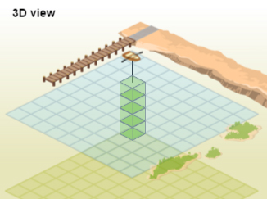
Gizmo Warm-up
To measure the depth of the ocean floor, scientists use a technology called sonar. A pulse of sound waves is emitted by a transmitter. The waves bounce off the ocean floor and return to the instrument. The time it takes the signal to return to the device is recorded and analyzed to determine the depth of the ocean at that point. The Ocean Mapping Gizmo™ allows you to create and interpret maps made by this method.

- On the 3D POINT pane, the blue grid represents the ocean surface. The tan grid represents a depth of 6 meters (19.7 feet). Each cube has a height of 1 meter. To find the depth of the ocean, subtract the number of cubes from 6 meters.

- How many cubes are stacked below the boat? ____________________

- How deep is the ocean at this point? ____________________

- Select the TABLE tab to check your answer. Were you correct? ____________________

- Select the 2D MAP tab. What color represents this depth? ____________________

Activity:  Create a map | Get the Gizmo ready:  - Turn on Show grid.  - If necessary, click in the upper-left corner of the map to place the boat there. | 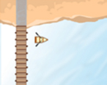
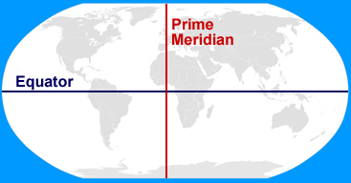
Introduction: Each point on a map of the ocean surface is described by two numbers, or coordinates. The latitude of a point describes its position north or south of the equator. The longitude of a point describes its position east or west of the prime meridian.

Goal: Create and interpret an ocean depth map.

- Record: The current latitude and longitude of the boat are shown in the top left square of the table at right. Move the boat one square to the right (east) by clicking in that square, and record the new latitude and longitude in the same format. Then, move the boat one square down and one square left. Finish filling in the table.

30.4° N, 90.4° W

- Analyze: Which value changes if you move the boat to the east or west? _______________

Which value changes if you move the boat north or south? _______________

- Apply: If the coordinates of the top-left point () of the map at right are 30.4° N, 90.4° W, what are the coordinates of the boat shown?

______________________________________

Use the Gizmo to check your answer.

- Gather data: You have been assigned to measure the ocean depth at three locations. Select the 2D MAP tab. Click on each point in the SIMULATION pane based on the given latitude and longitude and record the depth. Check your answers using the TABLE tab.

Point | Latitude | Longitude | Depth (m)
1 | 29.6° N | 90.3° W
2 | 30.1° N | 89.5° W
3 | 29.9° N | 89.6° W

(Activity continued on next page)
Activity (continued from previous page)

- Create a map: Click New ocean. Click in each square of the grid to create a map of the entire ocean floor. View the resulting map on the 3D MAP tab. You can use the () and
() buttons to spin the map.

Click the camera () to take a snapshot of the map. Right-click the image and select Copy Image, then paste the image it into a blank document. Then, choose the 2D MAP tab. Take a snapshot of this map and paste it below the 3D map. Print this document out and turn it in with this worksheet.

Which map is easier to interpret, and why do you think so? __________________________

_________________________________________________________________________

_________________________________________________________________________

- Interpret: A boat is looking for a safe passage from the beach at the top (north) end of the map to the open ocean at the bottom (south) end of the map. On the maps you have printed out in the previous question, use a marker to trace a continuous route that is at least 4 meters deep the whole way.

In the space below, write the latitude and longitude of five points along this route.

- ____________________ 2. ____________________ 3. ____________________

- ____________________ 5. ____________________

