Name: Date:

**Student Exploration:** **Operations with Radical Expressions**

**Vocabulary:** perfect square, radical expression, square root

**Prior Knowledge Questions** (Do these BEFORE using the Gizmo.)

A **perfect square** is a number that is equal to an integer squared. A **square root** is the number or expression which, when squared, gives the original number or expression.

1. Find the square root of each of perfect square.
2.  =
3.  =
4.  =
5. Find two factors for each radicand (the number under the radical sign). One factor should be a perfect square. Then simplify the radical expression.
6.  =
7.  =

**Gizmo Overview**

In the *Operations with Radical Expressions* Gizmo, you will be given **radical expressions** (expressions that contain a root) to add, subtract, or multiply.

Here’s how the Gizmo looks at first:

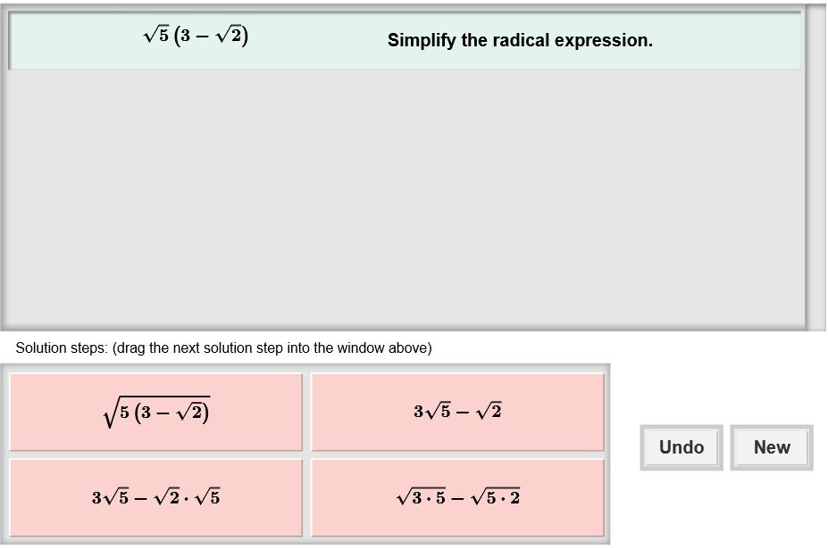

The radical expression for you to simplify is here.

The tiles give you four choices for the next step. Choose the one you think is correct and drag it into the white area above.

Click **Undo** to undo your last choice.

Click **New** to go to a different problem.

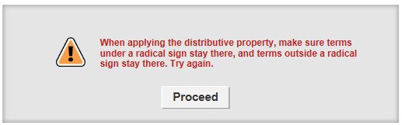

Read your feedback in the Gizmo.

(No feedback is given for correct answers.)

Click **Proceed** to go to the next step.

Continue until the expression is simplified. Then click **New** for a new problem to work on.

|  |  |  |
| --- | --- | --- |
| **Activity:**  **Simplifying expressions** | Get the Gizmo ready:   * You should see the expression 4 + 7. If not, click **Refresh** in your browser. |  |

1. You should see the expression shown to the right at the top of the Gizmo.
2. Radical expressions can be combined only if they have the same radicand. Can these expressions be combined, as they are written now?
3. A radical expression can be simplified if the radicand has a perfect square factor. Which of these radicands has a perfect square factor?
4. In the Gizmo, choose the correct first step. If your choice is incorrect, read the given feedback and try again. What should you do to simplify the expression on the left?

1. You should now have 12 + 7. Explain why these terms can now be combined.

1. Choose the next correct step. What is the answer?



1. Click **New**. You should see the expression shown to the right in the Gizmo.
2. How do you multiply two binomials?

1. Choose the correct first step. What is the product?
2. Choose the next correct step. What is the result?
3. Is this expression completely simplified? Why or why not?

1. Click **New**. Work through more problems in the Gizmo. Be sure to read the feedback in the Gizmo along the way.

**(Activity continued on next page)**

**Activity (continued from previous page)**

1. Simplify each expression below. Write all your steps in the space below each problem.
2. 8 + 2
3. (3 – 7)
4. (5 – )(5 + )
5. (12 + )(4 – )
6. 9 – 6
7. (8 + 4)
8. (3 + 1)(3 – 1)
9. (6 – 4)(5 – 2)