Name: ______________________________________ Date: ________________________

**Student Exploration: Orbital Motion – Kepler’s Laws**

**Vocabulary:** astronomical unit, eccentricity, ellipse, force, gravity, Kepler’s first law, Kepler’s second law, Kepler’s third law, orbit, orbital radius, period, vector, velocity

**Prior Knowledge Questions** (Do these BEFORE using the Gizmo.)

1. 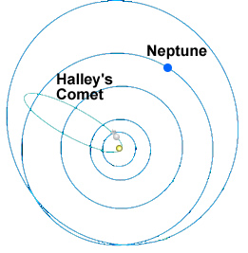The **orbit** of Halley’s Comet, shown at right, has an oval shape. In which part of its orbit do you think Halley’s Comet travels fastest? Slowest? Mark these points on the diagram at right.
2. How might a collision between Neptune and Halley’s Comet affect Neptune’s orbit?

__________________________________________

__________________________________________

__________________________________________

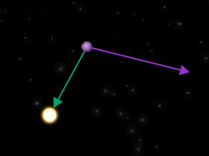

**Gizmo Warm-up**

The path of each planet around the Sun is determined by two factors: its current **velocity** (speed and direction) and the **force** of **gravity** on the planet. You can manipulate both of these factors as you investigate planetary orbits in the *Orbital Motion – Kepler’s Laws* Gizmo.

On the CONTROLS pane of the Gizmo, turn on **Show trails** and check that **Show vectors** is on. Click **Play** (Play).

1. What is the shape of the planet’s orbit? _________________________________________
2. Watch the orbit over time. Does the orbit ever change, or is it stable? _________________
3. Click **Reset** (Reset). Drag the tip of the purple arrow to shorten it and reduce the planet’s initial velocity. Click **Play**. How does this affect the shape of the orbit?

_________________________________________________________________________

_________________________________________________________________________

|  |  |  |
| --- | --- | --- |
| **Activity A:**  **Shape of orbits** | Get the Gizmo ready:   * Click **Reset**. * Turn on **Show grid**. |  |

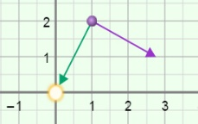

**Introduction:** The velocity of a planet is represented by an arrow called a **vector**. The vector is described by two components: the **i** component represents east-west speed and the **j** component represents north-south speed. The unit of speed is kilometers per second (km/s).

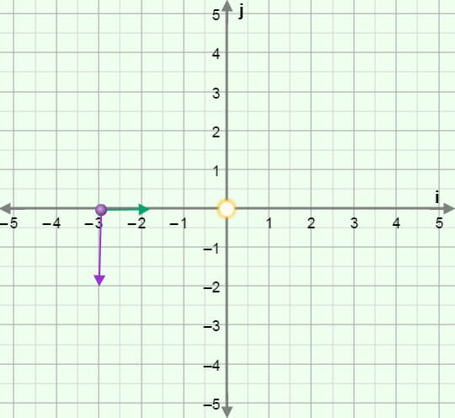**Question: How do we describe the shape of an orbit?**

1. Sketch: The distance unit used here is the **astronomical unit** (AU), equal to the average Earth-Sun distance. Place the planet on the **i** axis at **r** = –3.00**i** AU. Move the velocity vector so that **v** = -8.0**j** km/s (|**v**| = 8.00 km/s). The resulting vectors should look like the vectors in the image at right. (Vectors do not have to be exact.)

Click **Play**, and then click **Pause** (Pause) after one revolution. Sketch the resulting orbit on the grid.

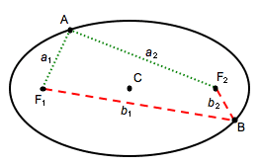

1. Identify: The shape of the orbit is an **ellipse**, a type of flattened circle. An ellipse has a center (C) and two points called *foci* (F1 and F2). If you picked any point on the ellipse, the sum of the distances to the foci is constant. For example, in the ellipse at left:

*a*1 + *a*2 = *b*1 + *b*2

Turn on **Show foci and center**. The center is represented by a red dot, and the foci are shown by two blue dots. What do you notice about the position of the Sun?

________________________________________________________________________

1. Experiment: Try several other combinations of initial position and velocity.
2. What do you notice about the orbits? _____________________________________

___________________________________________________________________

1. What do you notice about the position of the Sun? ___________________________

___________________________________________________________________

You have just demonstrated **Kepler’s first law**, one of three laws discovered by the German astronomer Johannes Kepler (1571–1630). Kepler’s first law states that planets travel around the Sun in elliptical orbits with the Sun at one focus of the ellipse.

**(Activity A continued on next page)Activity A (continued from previous page)**

1. Observe: Use the Gizmo to create an orbit that is nearly circular. Then create an orbit that is flattened. Observe the foci in each ellipse.
2. What do you notice about the spacing of the foci when the ellipse is very round?

___________________________________________________________________

1. What do you notice about the spacing of the foci when the ellipse is very flat?

___________________________________________________________________

1. Calculate: The **eccentricity** of an ellipse is a number that describes the flatness of the ellipse. Eccentricity is equal to the distance between foci divided by the total width of the ellipse. There are no units for eccentricity.

Click **Reset**. Move the planet to **r** = –5.00**i** AU (does not have to be exact) and drag the velocity vector to set the velocity close to –8.0**j** km/s. Click **Play**, and then click **Pause** after one full revolution.

1. What is the distance between the foci? ______________
2. What is the approximate width of the ellipse? ______________
3. What is the eccentricity of the ellipse? ________________
4. Click **Reset**, and change the initial velocity to –4.0**j** km/s. Click **Play**. What is the eccentricity of this ellipse?

Distance between foci: ________ Width: ________ Eccentricity: ________

1. Draw conclusions: Think about the eccentricity and shape of each ellipse.
2. What is the relationship between the eccentricity of an ellipse and its shape?

___________________________________________________________________

1. What is the eccentricity of a circle? Explain. ________________________________

___________________________________________________________________

1. What is the eccentricity of a completely flat ellipse? Explain.

1. The eccentricity of Earth’s orbit is 0.017. What can you infer about the shape of Earth’s orbit? ________________________________________________________

|  |  |  |
| --- | --- | --- |
| **Activity B:**  **Velocity and area** | Get the Gizmo ready:   * Click **Reset**. * Turn off **Show foci and center**. | 586SE4 |

**Introduction:** After establishing that planetary orbits were ellipses, Kepler next looked at the speed of a planet as it traveled around the Sun.

**Question: How does the velocity of a planet vary as it travels in its orbit?**

1. Observe: Place the planet at –5.00**i** AU and set the velocity to -4.0**j** km/s (does not have to be exact). Turn off **Show vectors**. Click **Play**. Observe the speed of the planet.
2. At what point does the planet move fastest? ________________________________
3. At what point does it move slowest? ______________________________________
4. Observe: Click **Reset**, and turn on **Show vectors**. Look at the green vector that represents the force of **gravity** pulling on the planet. Click **Play**.
5. In which direction does the green vector always point? _______________________
6. In which part of the orbit does the gravity vector point in almost the same direction as the velocity vector? ___________________________________________________
7. In which part of the orbit does the gravity vector point in the opposite direction as the velocity vector? ______________________________________________________
8. Explain: Based on your observations of the gravity vector, why does the planet accelerate as it approaches the Sun and slow down as it moves away from the Sun?

_________________________________________________________________________

_________________________________________________________________________

_________________________________________________________________________

1. Measure: Click **Reset**. Imagine a line connecting the planet to the Sun. As the planet moves around the Sun, the line will sweep out an area. Click **Play**, and then click **Sweep area**. Record the area below, and then press **Sweep area** four more times to complete the table.

|  |  |  |  |  |  |
| --- | --- | --- | --- | --- | --- |
| **Trial** | 1 | 2 | 3 | 4 | 5 |
| **Area (km2)** |  |  |  |  |  |

**(Activity B continued on next page)Activity B (continued from previous page)**

1. Analyze: What pattern do you notice? ___________________________________________

_________________________________________________________________________

_________________________________________________________________________

_________________________________________________________________________

1. Test: Try the same experiment with several different orbits and different numbers of days to sweep an area. Does the same rule hold true for each orbit? _________________________

**Kepler’s second law** states that a planet accelerates as it approaches the Sun and decelerates as it moves farther from the Sun. As it orbits, the planet sweeps out equal areas in equal times.

1. Think and discuss: Why do you think the area swept out by a planet in a given period of time remains constant, even as the planet speeds up and slows down?

(Hint: Think of each area swept out as a triangle. The height of the triangle is the distance between the planet and the Sun, while the base of the triangle is equal to the distance the planet travels in the given time period.)

_________________________________________________________________________

_________________________________________________________________________

_________________________________________________________________________

_________________________________________________________________________

_________________________________________________________________________

_________________________________________________________________________

|  |  |  |
| --- | --- | --- |
| **Activity C:**  **Radius and period** | Get the Gizmo ready:   * Click **Reset**. * Set the **Sun mass** to **medium**, close to the mass of our Sun. | OrbitalMotionSE3 |

**Introduction:** Kepler’s last law relates the **period** (*T*)of a planet, or the time it takes to complete an orbit, to the planet’s **orbital radius** (*a*), or average distance from the Sun.

**Question: How does the period of a planet relate to its average distance from the Sun?**

1. Predict: How do you expect the period of a planet to change as its average distance from the Sun increases? _________________________________________________________
2. Measure: Place the planet at -4.00**i** AU and set the velocity to -15.00**j** km/s (does not have to be exact). Click **Play**, and then click **Pause** when the planet completes one orbit.
3. What is the approximate period of the planet in days? ________________________
4. Select the TABLE tab and click **Record data**. What is the actual period (*T*) of the planet in Earth days and years? _________ days _________ years
5. What is the orbital radius (*a*) of the planet? _________________________________
6. Click **Reset**. Place the planet at -2.00**i** AU and set the velocity to -20.0**j** km/s. Click **Play** and **Record data**. What is the period now? _________ days _________ years
7. What is the new orbital radius? __________________________________________
8. How does the distance between the planet and the Sun affect its period? _________

___________________________________________________________________

1. Gather data: Experiment with the Gizmo to create a series of larger and larger orbits. Record each orbit’s radius (*a*) and period (*T*). Leave the last two columns blank for now.

|  |  |  |  |  |
| --- | --- | --- | --- | --- |
| **Orbit** | ***a* (AU)** | ***T* (years)** |  |  |
| 1 |  |  |  |  |
| 2 |  |  |  |  |
| 3 |  |  |  |  |
| 4 |  |  |  |  |
| 5 |  |  |  |  |

**(Activity C continued on next page)Activity C (continued from previous page)**

1. Analyze: How does the period change as the orbital radius increases? _________________

_________________________________________________________________________

1. Interpret: Select the GRAPH tab, and check that the graph of ***T* vs. *a*** is selected. Use the zoom controls to adjust the graph so you can see all your data and it fills the graph.
2. What does the graph indicate? __________________________________________

___________________________________________________________________

1. Does the graph of ***T* vs. *a*** form a straight line? ______________________________
2. Investigate: Choose other options in the dropdown menus until you find a graph that makes a perfectly straight line. (If you cannot see all of your data, click the [–] controls to zoom out.)

Which relationship makes a straight line? ________________________________________

When you have a line, click the **camera** (snapshot camera) icon to take a snapshot. Right-click the image, and click Copy Image. Paste it into a blank document you will turn in with this worksheet.

1. Calculate: On the table on the previous page, label the third column “*a* **3**”and the fourth column “*T* 2.” Use a calculator to cube each value of *a* and square each value of *T*.

What do you notice? ________________________________________________________

_________________________________________________________________________

**Kepler’s third law** states that the cube of a planet’s orbital radius is proportional to the square of a planet’s period: *a3* = *kT* 2 for some constant *k*. If the radius is measured in astronomical units, the period is measured in Earth years, and the mass of the star is equal to the mass of our Sun, the value of *k* is equal to 1 AU3/y2.

1. Challenge: The orbital radii of the planets are given in the table below. Calculate the period of each planet (in Earth years), and then check your values with your teacher.

|  |  |  |  |  |  |
| --- | --- | --- | --- | --- | --- |
| **Planet** | ***a* (AU)** | ***T* (years)** | **Planet** | ***a* (AU)** | ***T* (years)** |
| Mercury | 0.39 |  | Jupiter | 5.20 |  |
| Venus | 0.72 |  | Saturn | 9.54 |  |
| Earth | 1.00 |  | Uranus | 19.18 |  |
| Mars | 1.52 |  | Neptune | 30.06 |  |