Name: Date:

**Student Exploration: Ordering and   
Approximating Square Roots**

**Vocabulary:** perfect square, square (of a number), square root

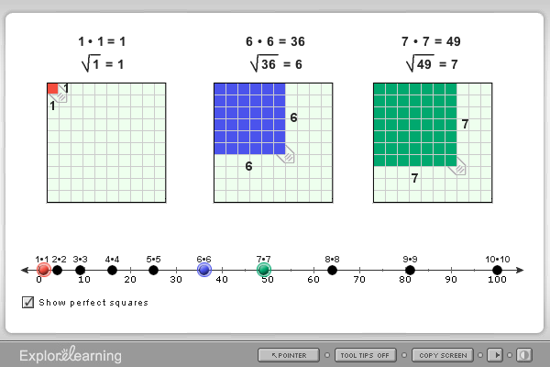

**7 ft**

**Prior Knowledge Questions** (Do these BEFORE using the Gizmo.)

1. Lyle’s kitchen floor is 7 feet by 7 feet. How many square-foot tiles does he need to tile his kitchen floor?
2. If he uses 16 square-foot tiles for his square bathroom, what are its dimensions?

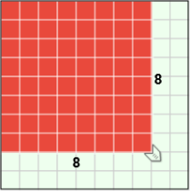**Gizmo Warm-up**

Area is the number of square units that fit in a two-dimensional figure. The area of a square equals the side length multiplied by itself, also called the **square** of the side length. For example, a 4-by-4 square has an area of 4 • 4 (“4 squared”) or 16 square units (42 = 16). The **square root** is the reverse, so the square root of 16 is 4 ( = 4).

In the *Ordering and Approximating Square Roots* Gizmo, you can model squares to help find the squares and square roots of numbers.

1. You can change the size of each shaded square in the Gizmo by dragging the tab attached to the lower right corner. Change the sides of the first (red) square to 8, as shown above.
2. Use the side length to find the area of the square.
3. What number is 8 the square root of?  = 8
4. How can you use the area of the square to find the side length?

1. The result of squaring an integer is a **perfect square**. For example, 42 = 16, so 16 is a perfect square. You can drag the tab in any square in the Gizmo to find perfect squares.

Use the Gizmo to find all perfect squares from 1 to 100. List them below.

|  |  |  |
| --- | --- | --- |
| **Activity:**  **Finding square roots** | Get the Gizmo ready:   * Create a 3-by-3 square on the first grid, a 4-by-4 square on the second grid, and a 5-by-5 square on the last grid. | 230SE2 |

1. The three grids in the Gizmo model the perfect squares 9, 16, and 25.
   1. What is the square root of these numbers?  =  =  =
   2. The number 16 is between 9 and 25. How does the square root of 16 compare to the square roots of 9 and 25?
   3. The points on the number line below the models represent the areas of the squares. Drag the tab on the middle square and watch how the points on the number line change. Also observe how the side length of the middle square changes.

If a given square has an area between two other areas, what must be true about the side length of the given square?

* 1. If a given number is between two other numbers, what must be true about the square root of the given number?

1. Create a 4-by-4 square on the first grid, and a 5-by-5 square on the last grid.
2. Drag the tab on the middle square until the side length is 4.5. Fill in the table below to show the square root equations modeled in the Gizmo.

|  |  |  |
| --- | --- | --- |
| **First model** | **Middle model** | **Last model** |
| = | = | = |

1. Select **Show perfect squares**. Notice that 16 and 25 are two consecutive perfect squares. How can you use 16 and 25 to approximate the square root of 20.25?

1. Experiment with other numbers in the Gizmo. How can you use perfect squares to approximate the square roots of numbers that are not perfect squares?

**(Activity continued on next page)**

**Activity (continued from previous page)**

1. Consider the number 33.64.
2. Which two perfect squares is 33.64 between?
3. Which two consecutive whole numbers is  between?

Check your answer in the Gizmo.

1. What does  equal?
2. State the pair of consecutive whole numbers each square root is between. Then use the Gizmo to check your answer and find the square root.
3.  is between and . The exact value of  is .
4.  is between and . The exact value of  is .
5.  is between and . The exact value of  is .
6.  is between and . The exact value of  is .
7. State the pair of consecutive whole numbers each square root is between. Then state which whole number you think the square root is closer to and explain why. If possible, use a calculator to check your answer.
8.  is between and . It is closer to because

1.  is between and . It is closer to because

1.  is between and . It is closer to because

1.  is between and . It is closer to because