Name: ______________________________________ Date: ________________________

Student Exploration: Osmosis

Vocabulary: cell membrane, concentration, diffusion, dynamic equilibrium, osmosis, semipermeable membrane, solute, solvent

Prior Knowledge Questions (Do these BEFORE using the Gizmo.)

- Suppose you were trapped on a desert island with no sources of fresh water. Should you drink water from the ocean? Explain why or why not.

_________________________________________________________________________

_________________________________________________________________________

- What do you think would happen if you watered your houseplants with salt water?

_________________________________________________________________________

_________________________________________________________________________

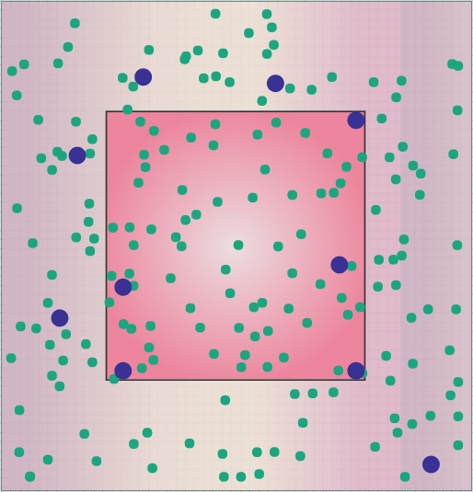
Gizmo Warm-up
A cell membrane is a thin “skin” that surrounds a cell. It is a semipermeable membrane, which means that some particles pass through the membrane easily while others cannot.

The Osmosis Gizmo portrays a cell (red square) in a solution of purple solute particles dissolved in green solvent particles. Press Play ( ) and observe.

- Which particles can pass through the cell membrane?

___________________________________________

- Which particles cannot pass through the cell membrane? ___________________________

- Click Reset (), and then click Play again. What do you notice about the size of the cell?

_________________________________________________________________________

Activity A:  Observing osmosis | Get the Gizmo ready:  - Click Reset. Set the Initial cell volume to 40%.  - You will need a calculator for this activity. | 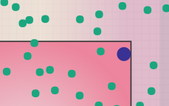

Question: How do solute concentrations affect the volume of a cell?

- Observe: Use the Solute outside slider to change the concentration of solute particles outside the cell. Click Play. In each case, focus on whether the cell gets bigger or smaller.

    - In what situation does the cell get larger? __________________________________

___________________________________________________________________

    - In what situation does the cell get smaller? _________________________________

___________________________________________________________________

- Calculate: The concentration of a solute is the amount of solute particles in a given amount of solvent. To calculate percentage concentration, divide the number of solute particles by the total number of particles (solute + solvent), and then multiply by 100:
% concentration = (solute ÷ total particles) × 100

Select the DESCRIPTION tab. Click Reset. Set the Solute outside to 10 and check that the Initial cell volume is 40%. (Note: The cell volume is expressed as a percentage of the container size.)

    - How many solute particles are found inside the cell? ________ Outside? ________

    - How many solvent particles are found inside the cell? _______ Outside? ________

    - What is the total number of particles inside the cell? ________ Outside? ________

    - What is the % concentration of solute inside the cell? __________________

    - What is the % concentration of solute outside the cell? _________________

- Observe: Click Play, and observe the numbers shown on the DESCRIPTION pane. How does each number change over time? Write “increases,” “decreases,” or “stays the same” (or “same”) in each space.

- Solute particles inside? ___________

- Solvent particles inside? ___________

- Solute concentration inside? _________

- Solute particles outside? ___________

- Solvent particles outside? ___________

- Solute concentration outside? _________

(Activity A continued on next page)
Activity A (continued from previous page)

- Observe: Wait until the numbers are not changing very much. What do you notice about the solute concentrations inside and outside of the cell? _______________________________
This situation is called dynamic equilibrium.

- Experiment: Click Reset. Check that the Solute outside is 10 and the Initial cell volume is 40%. To calculate the solvent concentration, divide the number of solvent particles by the total number of particles, and then multiply by 100. (Note: The Gizmo only displays the solute concentrations.)

    - What is the solvent concentration inside the cell? ____________________________

    - What is the solvent concentration outside the cell? ___________________________

    - Where is there a higher solvent concentration? _____________________________

    - Click Play. Do most of the solvent particles move into or out of the cell? (Hint: Does the cell expand or shrink?) ______________________________________________

- Experiment: Click Reset, and set the Solute outside to 1.

    - What is the solvent concentration inside the cell? ____________________________

    - What is the solvent concentration outside the cell? ___________________________

    - Where is there a higher solvent concentration? _____________________________

    - Do you think the cell will get larger or smaller? ______________________________

    - Click Play to confirm your predictions. Were you correct? _____________________

- Summarize: You have observed examples of osmosis—the diffusion of a solvent (such as water) across a semipermeable membrane. Summarize what you have observed by filling in the blanks in the following paragraph:

During osmosis, solvent particles move from an area of ____________ concentration to an area of ____________ concentration. When there is a higher concentration of solvent particles inside the cell, most solvent particles will move ____________ the cell and the cell will ____________. When there is a higher concentration of solvent particles outside the cell, most solvent particles will move ____________ the cell and the cell will ____________.
Activity B:  Effect of cell volume | Get the Gizmo ready:  - Click Reset.  - Set the Solute outside to 5.  - Set the Initial cell volume to 40%. | 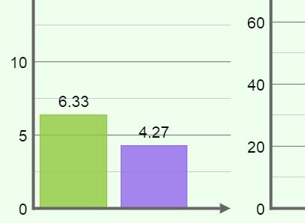

Question: How does changing the cell volume affect solute concentrations?

- Experiment: Select the BAR CHART tab, and turn on Show numerical values.

  - Based on solute concentrations, do you expect the cell to swell or shrink? ________

  - Click Play, and observe. Was your prediction correct? ________

- Observe: Click Reset. Move the Initial cell volume slider back and forth. How does the initial cell volume affect the solute concentrations inside and outside the cell?

_________________________________________________________________________

_________________________________________________________________________

_________________________________________________________________________

- Experiment: With the Solute outside set to 5, predict whether the cell will swell, shrink, or stay the same with each of the following Initial cell volume settings. Then use the Gizmo to check each prediction.

Predictions: 20% __________ 50% __________ 60% __________

Actual results: 20% __________ 50% __________ 60% __________

- Analyze: Why do solvent particles flow into the cell when the initial volume is below 50%?

_________________________________________________________________________

_________________________________________________________________________

- Extend your thinking: In the Osmosis Gizmo, the cell is placed in a very small chamber. Suppose a cell is placed in a large container of water with a very low solute concentration. What do you think would happen? Explain your answer.

_________________________________________________________________________

_________________________________________________________________________

_________________________________________________________________________

