Name: ______________________________________ Date: ________________________

Student Exploration: Paramecium Homeostasis

Vocabulary: adaptation, cell mouth, cilia, concentration, contractile vacuole, food vacuole, homeostasis, hypertonic, hypotonic, macronucleus, micronucleus, oral groove, osmosis, paramecium, solute, solution, solvent

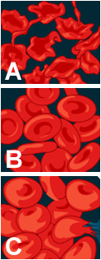
Prior Knowledge Questions (Do these BEFORE using the Gizmo.)

- The images show red blood cells (RBCs) in three different solutions.

- Which image shows RBCs in normal blood plasma? __________

- Which image shows RBCs in pure water? __________

- Which image shows RBCs in a very salty solution? __________

- What do you think is happening in images A and C? ________________

__________________________________________________________

__________________________________________________________

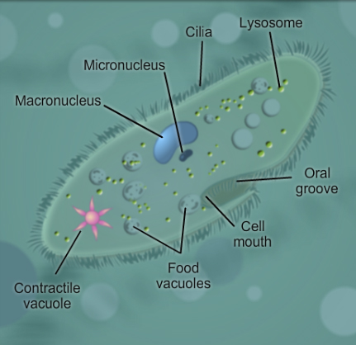
Gizmo Warm-up
A paramecium is a one-celled organism that lives in ponds and other bodies of water. One of the challenges for a paramecium is to maintain a stable size and shape.

On the Paramecium Homeostasis Gizmo, turn on the Show labels checkbox. Try to determine the function of each of the labeled structures.

- Through which two structures do you think food enters the paramecium? _____________________________

- Which two structures contain DNA? ____________________________________________

- Which tiny structures help the paramecium to move around? _________________________

- Which structure pumps out excess water and wastes? ______________________________

Activity A:  Maintaining a water balance | Get the Gizmo ready:  - Select the User controlled setting.  - Check that the Water solute concentration is 1.00%. | 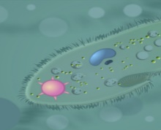

Introduction: Every organism needs to maintain stable internal conditions—a process known as homeostasis—in order to survive. A paramecium maintains homeostasis by responding to variations in the concentration of salt in the water in which it lives. (The concentration of a solution is equal to the amount of solute that is dissolved in a given amount of solvent.)

Question: How do changing solute concentrations affect a paramecium?

- Predict: In the Paramecium Homeostasis Gizmo, the solute is salt and the solvent is water.

    - Look at the top left of the Gizmo. What is the water solute concentration? _________

A solute concentration of 1.00% means that for every 1 gram of water there is 0.01 grams of solute (salt).

    - What is the concentration of solutes inside the paramecium? _________

The water solution outside the paramecium is said to be hypotonic because it has a lower solute concentration than the solution inside the paramecium.

    - Based on the internal and external solute concentrations, do you think the paramecium will swell up or shrink in this solution? Explain your reasoning.

___________________________________________________________________

___________________________________________________________________

___________________________________________________________________

- Observe: Click Play (), and observe the size of the paramecium.

    - What do you notice? __________________________________________________

    - What happens after about 16 seconds? ___________________________________

- Observe: Click Reset (). Set the Water solute concentration to 2.00%. (This is a hypertonic solution because it has a higher solute concentration than the solution inside the paramecium.) Click Play. What happens to the volume of the paramecium now?

_________________________________________________________________________

(Activity A continued on next page)
Activity A (continued from previous page)

- Infer: Water moves into and out of the paramecium by a process called osmosis. Osmosis is the movement of water across a membrane from a region of lower solute concentration to a region of higher solute concentration.

    - If the solute concentration in the water is low (hypotonic solution), does water move into or out of the paramecium? __________________________________________
    - If the solute concentration in the water is high (hypertonic solution), does water move into or out of the paramecium? __________________________________________
    - In which situation is the paramecium in danger of swelling up and bursting?

___________________________________________________________________

- Experiment: The contractile vacuole is a star-shaped structure that helps the paramecium to pump out excess water. This adaptation allows the paramecium to survive in hypotonic (low solute concentration) solutions.

Click Reset, and set the Water solute concentration to 1.00%. Click Play. When the contractile vacuole fills up, click Contract. Do this for a while, and then click Pause ().

    - How does contracting the vacuole affect the volume of the paramecium? _________ ___________________________________________________________________

    - Click Play, and then click Contract many times rapidly. What happens? __________

___________________________________________________________________

- Experiment: Click Reset. This time, try to maintain a steady volume for the paramecium. Pause the simulation after about one minute and select the TABLE tab.

How many contractions per minute were required for the paramecium to maintain a relatively stable internal solute concentration and stay the same size?

_________________________________________________________________________

- Summarize: How does the contractile vacuole help the paramecium survive in a freshwater environment?

_________________________________________________________________________

_________________________________________________________________________

Activity B:  Contractions and concentrations | 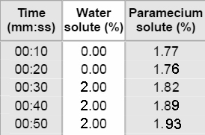  Get the Gizmo ready:  - Click Reset.  - Select the Paramecium controlled setting on the DESCRIPTION tab.

Question: How does a paramecium respond to changing solute concentrations?

- Form a hypothesis: How do you think the number of contractile vacuole contractions will change when the water solute concentration is reduced? Explain why you think so.

_________________________________________________________________________

_________________________________________________________________________

- Gather data: Set the Water solute concentration to 2.00%. Click Play. Pause after 30 seconds. On the TABLE tab, add the total number of contractions. Record the results in the table below. Click Reset, and repeat this procedure for all of the listed concentrations.

Water solute concentration | Contractions in 30 seconds
2.00%
1.50%
1.00%
0.50%
0.00%

- Analyze: What pattern do you see in your data? How does this compare to your hypothesis?

_________________________________________________________________________

_________________________________________________________________________

- Predict: How many contractions would you expect in 30 seconds if the water solute concentration was 0.75%? Test your prediction with the Gizmo.

Predicted contractions: __________ Actual contractions: __________

- Think and discuss: Paramecia that live in fresh water have contractile vacuoles, while those that live in salt water do not. Why do you think this is the case?

_________________________________________________________________________

_________________________________________________________________________

