Name: Date:

Student Exploration: Percent of Change

Vocabulary: percent, percent of change

Prior Knowledge Questions (Do these BEFORE using the Gizmo.)
Recall that a percent is a ratio of a number to 100. For example 39% means 39 out of 100.

- Last year, there were 20 students on the track team. Eight of them competed in the long jump. What percent of the team members competed in the long jump?

- This year, the team has 25 members. If the percent that compete in the long jump stays the same, how many team members will compete in the long jump?
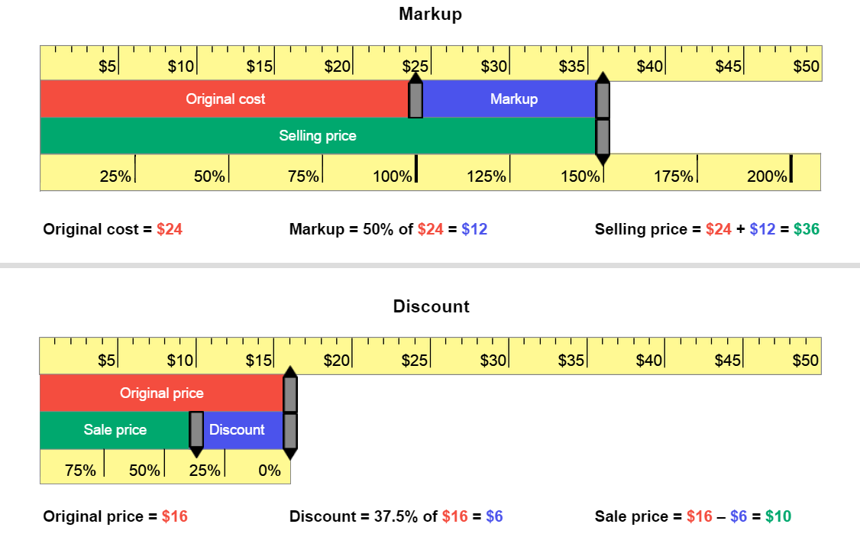
Gizmo Warm-up
Stores charge more for merchandise than they pay for it. In the Percent of Change Gizmo, you can use rulers to explore how stores price the items they sell.

A markup is the amount a store raises the cost of an item to get a selling price. A discount is the amount a store lowers the original price of an item to get a sale price.

- Use the Markup Ruler. Drag the handle to the right of Original cost to $24. Drag the handle to the right of Selling price to $36.

- What is the amount of markup for this item?

- Based on the Gizmo, what is the percent of markup for this item?

- Use the Discount Ruler to model this scenario: Original price = $16, Sale price = $10.

- What is the amount of discount for this item?

- Based on the Gizmo, what is the percent of discount for this item?

Percent of markup and percent of discount are two different types of percent of change.

Activity A:  Calculating markups | Get the Gizmo ready:  - Be sure to use the Markup Ruler. | 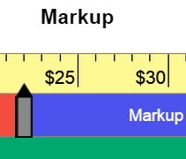

- An electronics store buys video games at an original cost of $25 each and sells them for $50 each. Model this situation with the Gizmo.

- What is the amount of markup on a video game?

- What is the percent of markup?

- What is true about the percent of markup if the original cost and the amount of markup are equal?

- A store buys sweatshirts at an original cost of $16 each and sells them for $24 each.

- Without using the Gizmo, find the amount of markup.

- What is the percent of markup?

- This proportion can help solve markup problems: =
Fill in the boxes to the right with the values for this sweatshirt example. Use x to represent the unknown value, the percent of markup.

- Solve for x. Model this in the Gizmo to check your answers.

- A sporting goods store sells footballs at a markup of 175%. The original cost of the footballs is $8. Model this in the Gizmo.

- What is the amount of markup? What is the selling price?

- How can you calculate the selling price if you know the original price and the amount of markup?

- Explain what it means when the percent of markup is greater than 100%.

(Activity A continued on next page)
Activity A (continued from previous page)

- A clothing store buys jeans at an original cost of $20 each and marks them up 50%.

- Find the amount of markup. What is the jeans’ selling price?

Check your answers in the Gizmo.

- After a month, the store marks up the selling price of the jeans by another 50%. Use the Gizmo to find the new selling price.
- Are two 50% markups the same as one markup of 100%? Explain.

- On the Markup ruler, use the gray handles to vary the original cost and the markup amount. As you vary those amounts, watch the percent ruler just below the handles.

- How does changing the original cost affect the percent ruler? (Pay special attention to the “100%” on the percent ruler.)

- How does changing the markup affect the percent ruler?

- Explain why the percent ruler works this way.

- Solve these problems by using a proportion. Show your work in the space below. Then check your answers using the Gizmo. (Note: The last one cannot be modeled in the Gizmo.)

- Original cost = $15
Selling price = $45

Percent of markup =
- Original cost = $64
Selling price = $96

Percent of markup =

Activity B:  Calculating discounts | Get the Gizmo ready:  - Be sure to use the Discount Ruler. | 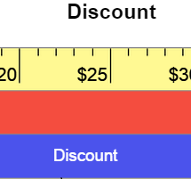

- Sweaters that have an original price of $28 are on sale for $21. Model this with the Gizmo.

- What is the discount amount? What is the percent of discount?

- One way to find the percent of discount is by solving the proportion = . Explain why this proportion correctly models the problem.

- A store has shoes with an original price of $50 on sale at a discount of 30%.

- Find the amount of discount.

- What is the sale price of the shoes? Check your answers in the Gizmo.

- Can you have a percent of discount greater than 100%? Explain.

- Solve these problems by using a proportion. Show your work in the space below. Then check your answers using the Gizmo. (Note: The last one cannot be modeled in the Gizmo.)

- Original price = $30
Sale price = $27

Percent of discount =
- Original price = $70
Sale price = $42

Percent of discount =

