Name: Date:

**Student Exploration:** **Percents and Proportions**

**Vocabulary:** percent, proportion

**Prior Knowledge Questions** (Do these BEFORE using the Gizmo.)

1. Jake has 10 t-shirts and 5 collared shirts. What is his ratio of   
   t-shirts to collared shirts? (Write this ratio in unsimplified form.)



=

1. If Jake buys 3 new shirts, how many of them would you expect to be to be t-shirts, and how many would you expect to be collared? t-shirts collared shirts

Explain.

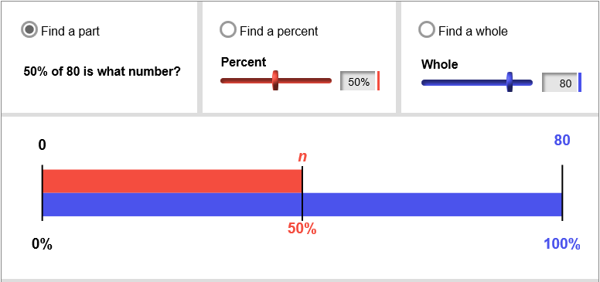

**Gizmo Warm-up**

A **proportion** is an equation that shows two equal ratios. In the *Percents and Proportions* Gizmo, you can solve proportions involving **percents** (ratios of a number to 100). A red-and-blue percent “ruler” can help you visualize the numbers involved.

1. With **Find a part** selected, set the **Percent** to 20%, and the **Whole** to 50.
2. What is 20% of 50? Click on **Show solution** to check your answer.
3. Vary the value of the **Whole** with the slider. Why do you think the blue bar is always the same length? (Remember, the red and blue bars represent percents.)

1. At the top, select **Find a percent**. Use the sliders to vary the values of the **Part** and **Whole**.
2. What is true of the percent when the part is greater than the whole?
3. How does making the whole larger affect the red (part) percent bar?

___________________________________________________________________

|  |  |  |
| --- | --- | --- |
| **Activity A:**  **Writing and solving a proportion** | Get the Gizmo ready:   * Click on **Find a part**. * Turn off **Show solution**. |  |

1. The Gizmo can be used to model the problem: 75% of 84 is what number?
   1. Which of the given numbers is the part, the whole, and the percent? (Write “unknown” for the one value that is unknown.)

Part: Whole: Percent:

Model this scenario in the Gizmo.

* 1. Use the equation to write the proportion. Use a variable to represent the unknown.

 =  =

* 1. Solve the proportion below. Then click on **Show solution** to check your answer.

1. Uncheck **Show solution**. Click on **Find a percent** and model this: 7 is what percent of 33?
2. Look at the blue-and-red percent ruler in the Gizmo. What would you estimate the percent to be? Explain your estimate.

1. Write and solve the proportion below. (Round your answer to 2 decimal places.) When you are done, click on **Show solution** in the Gizmo to check your answer.

**(Activity A continued on next page)Activity A (continued from previous page)**

1. Max says there were 6 students wearing shorts in his math class. He is not sure how many people were in the class, total, but he thinks about one third of them were wearing shorts.
2. Select **Find a whole**. Model this in the Gizmo. What percent is closest to ?

Explain.

1. Write and solve a proportion below, to estimate the number of students in the class.

About how many students were there? Select **Show solution** to check.

1. You decide the percent of students was probably between 30% and 35%. Drag the **Percent** slider between these values. What is a range for the estimated number of students in the class?

1. In Amy’s English class, 30% of the students play an instrument. She does not know how many in the whole school play an instrument, but there are 500 students in the school.
2. Solve the proportion  =  to estimate the total number of students in the school who play an instrument.
3. The Gizmo does not allow for the whole to be greater than 100. How can you use the Gizmo to help come up with this answer anyway?

|  |  |  |
| --- | --- | --- |
| **Activity B:**  **Using proportions to find percents** | Get the Gizmo ready:   * Click on **Find a percent**. * Turn off **Show solution**. | 266SE3 |

1. A restaurant surveys 60 of its customers about their new menu. 48 of the customers that take the survey prefer the new menu.
   1. Which value is unknown in this problem: the part, percent, or whole? Set up the Gizmo to model this scenario.
   2. Write and solve your proportion to find the percent of the customers that prefer the new menu. Click on **Show solution** in the Gizmo to check your answer.
   3. What percent of the customers do *not* like the new menu better?
2. Mia took a test with 60 multiple-choice questions. Her teacher told her she got 88% correct.
3. Write and solve a proportion to figure out how many questions she got correct.
4. What did you find for her number of correct answers?
5. Use the Gizmo to solve this problem. Does the solution represent the exact number of questions Mia answered correctly? Explain.
6. Mia’s teacher rounds all exam scores to the nearest percent. How many questions did Mia actually answer correctly?

**(Activity B continued on next page) Activity B (continued from previous page)**

1. Josh has a huge marble collection. He counts 280 marbles that are red, and he estimates that this is about 10% of his collection.
2. Write and solve a proportion to estimate the total number of marbles Josh has.
3. The Gizmo can only accept values from 1 to 100. Explain how you could use the Gizmo to check your answer.

1. Solve these problems by using a proportion. Then check your answers using the Gizmo. (Note: Some problems may not be able to be modeled directly with the Gizmo.)
2. What is 20% of 80?
3. 30 is what percent of 40?
4. What is 125% of 60?
5. 150% of what number is 30?