Vocabulary: Perimeter and Area of Rectangles

Vocabulary

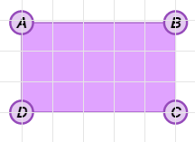
- Area – the number of square units inside a plane figure.
5
3
- For example, the area of the figure to the right is 15 square units.

- Perimeter – the distance around a plane figure.
- For example, the perimeter of ABCD shown above is 16 units.

- Rectangle – a quadrilateral with four right angles.
- Quadrilateral ABCD shown to the right has four right angles, so it is a rectangle.
- A rectangle is also a parallelogram.

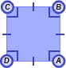
- Square – a quadrilateral with four right angles and four congruent sides.
- Quadrilateral ABCD shown to the right has four right angles and four congruent sides, so it is a square.
- A square is also a parallelogram and a rectangle.

