Vocabulary: Perimeters and Areas of Similar Figures

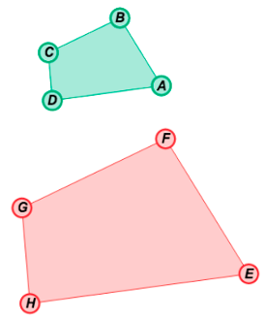
Vocabulary

- Scale factor – the ratio of the lengths of the corresponding sides of two similar figures.
  - For example, the side lengths of quadrilateral EFGH are twice as long as the side lengths of quadrilateral ABCD, so the ratio of the lengths of each pair of corresponding sides is 2.
  - A scale factor can also be called a similarity ratio.

- Similar – having the same shape, but not necessarily the same size.
  - The symbol ~ means “is similar to.”
  - For example, quadrilaterals ABCD and EFGH above are the same shape, but not the same size, so ABCD ∼ EFGH.

