**Vocabulary:** **Period of a Pendulum**

dictionary2

**Vocabulary**

* Controlled experiment – an experiment in which only one variableis changed at a time.
  + Generally, in a controlled experiment, all conditions are kept the same except for the variable being tested.
  + In some cases, it is impossible to perform a perfectly controlled experiment. For example, a scientist cannot perform a controlled experiment on animal behavior in the wild because there are too many uncontrollable variables, such as weather and the presence of other animals.
* Mean – the sum of a set of numbers divided by the number of items in the set.
  + The mean of a set of numbers is also known as the set’s *average*.
  + The symbol for the mean is *μ*.
  + For example, the mean of 4, 4, 5, 7, and 10 is: .

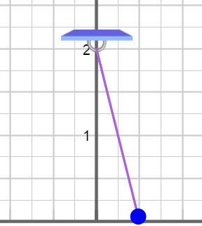

**Pendulum**

* Pendulum – a weight that can swing freely.
* Period – the amount of time required to complete a full cycle.
  + For a pendulum, the period is the time required for one full back-and-forth swing.