Name: Date:

Student Exploration: Periodic Trends

Vocabulary: atomic radius, electron affinity, electron cloud, energy level, group, ion, ionization energy, metal, nonmetal, nucleus, period, periodic trends, picometer, valence electron

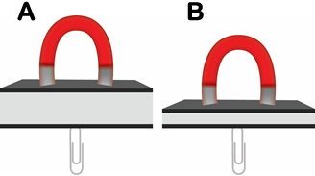
Prior Knowledge Questions (Do these BEFORE using the Gizmo.)

- On the image at right, the two magnets are the same. Which paper clip would be harder to remove?

- Which magnet would be most likely to attract additional paper clips?

- What is the relationship between the thickness of the book and the ability of the magnet to hold on to and attract paper clips?

Gizmo Warm-up
Just as the thickness of a book changes how strongly a magnet attracts a paper clip, the size of an atom determines how strongly the nucleus attracts electrons. In the Periodic Trends Gizmo, you will explore this relationship and how it affects the properties of different elements.

The atomic radius is a measure of the size of the electron cloud, or the region where electrons can be found. To begin, check that H (hydrogen) is selected in Group 1 on the left. Turn on Show ruler. To measure the radius, drag one end of the ruler to the proton in the nucleus and the other end to the electron. Click Save radius to record the value.

- What is the radius of hydrogen?

Notice that the radius is measured in picometers (pm). A picometer is one trillionth of a meter.

- On the right side of the Gizmo, select Li. Connect the right side of the ruler to the outermost electron, or valence electron. What is the radius of lithium?
Activity A:  Atomic radius | Get the Gizmo ready:  - Check that Atomic radius is selected from the drop-down menu. | 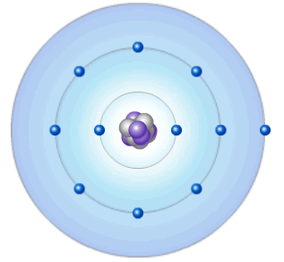

Question: What factors affect the radius of an atom?

- Predict: How do you think the radius of an atom will change as you move down a group (vertical column) in the periodic table?

- Collect data: Use the ruler to measure the atomic radii of the group 1 elements. As you do so, count the energy levels (shown as rings of electrons) in each atom. Record in the table.

Element | H | Li | Na | K | Rb | Cs
Number of energy levels
Atomic radius (pm)

- Observe: What happens to the radius as you move down group 1?

- Explore: Turn off Show ruler. Select Li, and then select Be. Observe the radii of the elements in group 2. Then look at other groups. What pattern do you see?

- Draw a conclusion: In general, what is the effect of the number of energy levels on the radius of an atom?

- Predict: How do you think the radius of an atom will change as you move across a period (horizontal row) in the periodic table?

- Collect data: Beginning with Na, record the number of energy levels, number of protons, and atomic radius for each element in period 3.

Element | Na | Mg | Al | Si | P | S | Cl | Ar
Number of energy levels
Number of protons
Atomic radius (pm)

(Activity A continued on next page)
Activity A (continued from previous page)

- Observe: What happens to the radius as you move across a period?

- Explore: Investigate other periods in the periodic table. Does the same trend occur?

Hypothesize why this trend occurs.

- Analyze: Consider how the number of protons might affect the size of the electron cloud.

- As you move across a period, are new energy levels added?

- What happens to the number of protons in the nucleus as you move from one element to the next across a period?
- If the proton number increases while the number of energy levels remains constant, what happens to the attractive force between the nucleus and the electrons?

- How does your answer to the previous question explain the trend in radii across a period?

- Extend your thinking: The Gizmo enables you to examine ions, or atoms that have gained or lost electrons. Select Na and turn on Show ion. Compare the radius of the neutral atom to that of the ion. Repeat with Cl. Then look at other ions. See if you can find a pattern.

- Why do you think the Na⁺ ion is smaller than a neutral Na atom?

- Why do you think the Cl⁻ ion is larger than a neutral Cl atom?

Unlike neutral atoms, ions have a different number of electrons than protons. The electrons are attracted to the protons and repelled by other electrons. If another electron is added, the repulsion between electrons increases while the attractive force of the nucleus stays the same. As a result, the electron cloud expands. If an electron is lost, the cloud is pulled in more tightly. Electron repulsions decrease while the number of protons remains constant.
Activity B:  Removing and adding electrons | Get the Gizmo ready:  - Choose Ionization energy from the drop-down menu. | 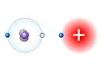

Question: How does the radius of an atom affect the ability of the protons in the nucleus to hold on to and attract electrons?

- Predict: Ionization energy (IE) is the energy required to remove an electron from an atom. As atomic radius increases, the valence electrons get farther from the nucleus. How do you think an atom’s size will affect its ability to hold on to its valence electrons? Why?

- Investigate: Select H. In the Gizmo, the hydrogen atom is shown next to a positive charge. As you move the atom to the right, the force of attraction between the positive charge and the valence electron will increase until the electron is removed.

Slowly drag the atom towards the charge. After the electron is removed, use the ruler to measure the distance between the original and the final position of the electron. Record the distance and ionization energy in the table, then repeat for the other group 1 elements.

Element | H | Li | Na | K | Rb | Cs | Fr
Distance (no units)
Ionization energy (kJ/mol)

- Analyze: What trend do you notice?

- Investigate: Gather data for ionization energy across a period. Record in the table below.

Element | Na | Mg | Al | Si | P | S | Cl | Ar
Distance (no units)
Ionization energy (kJ/mol)

- Analyze: What trend do you notice?

- Explore: Examine other groups and periods in the periodic table to see if the same trends exist. What trends do you see in ionization energy down a group and across a period?

(Activity B continued on next page)
Activity B (continued from previous page)

- Think and discuss: As you move down a group, you will recall that the radius increases. Why do you think an increase in atomic radius would result in a lower ionization energy?

- Think and discuss: As you move across a period, you will recall that the radius decreases. Why do you think a decrease in atomic radius would result in a greater ionization energy?

- Predict: Electron affinity (EA) refers to the energy released when an electron is added to an atom. This release of energy is always expressed as a negative value. The greater the magnitude of the negative value, the greater the attraction for electrons. (An EA of –100 kJ/mol would indicate a stronger attraction for electrons than an EA of –50 kJ/mol.)

How do you think the size of an atom will affect its ability to attract additional electrons?

- Investigate: Choose Electron affinity and select fluorine (F). In the Gizmo, the fluorine atom is shown next to an electron. To measure the electron affinity, slowly drag the fluorine atom toward the electron. When the electron hops over, use the ruler to measure the distance.

What is the ruler distance? What is the electron affinity?

- Explore: Find the electron affinity for each of the other Group 17 elements and each of the other Period 2 elements. Record these below. (Note: If an atom has a positive EA it will have no attraction for an electron.) All values in the tables below will be in kJ/mol.

Grp. 17 EA | F: | Cl: | Br: | I: | At: | Ts:

Per. 2 EA | Li: | Be: | B: | C: | N: | O: | F: | Ne:

What is the trend in EA down a group?

What is the trend in EA across a period?

- Think and discuss: What is the relationship between electron affinity and atomic radius? Why do you think this relationship occurs?

Activity C:  Periodic trends | Get the Gizmo ready:  - Select the TRENDS tab. Check that Groups is selected from the drop-down menu. | 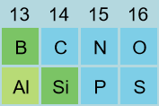

Introduction: The periodic table is so named because similar patterns repeat, or appear periodically, throughout the table. These patterns are referred to as periodic trends.

Question: How do atomic radius, ionization energy, and electron affinity change throughout the periodic table?

- Predict: Based on your investigations in activities A and B, predict where in the periodic table you will typically find the following: Largest atoms, smallest atoms, highest ionization energy, lowest ionization energy, highest electron affinity, lowest electron affinity.

Upper left region | Upper right region
Far left column | Far right column
Lower left region | Lower right region

- Observe: Choose Atomic radius from the drop-down menu to see the relative sizes of the elements. In which parts of the table do you find the largest and smallest atoms?

- Observe: Choose Ionization energy. Ionization energy is shown by color. In which parts of the table do you find atoms with the highest, and the lowest, ionization energies?

- Observe: Choose Electron affinity. Electron affinity is shown by color, with darker blue corresponding to the highest (most negative) electron affinity. In which parts of the table do you find the greatest and lowest attraction for electrons?

- Infer: Which group has high ionization energies but very weak electron affinities?

Why do you think this is so?

(Activity C continued on next page)
Activity C (continued from previous page)

- Investigate: Select Groups. The periodic table is divided into metals and nonmetals. Metals are to the left of the metalloids and nonmetals to the right. To the left of the table you will see a list of group names. Click on each group name to reveal its properties.

- Metals tend to have low ionization energies. What properties of elements in the metal groups do you think are the result of this tendency?

- Except for the noble gases, nonmetals tend to have high electron affinities. What properties of nonmetals do you think are the result of this tendency?

- Analyze: The metallic character of an element is determined by how readily it loses electrons. Elements that lose electrons most easily have the greatest metallic character.

- Which group has the greatest metallic character?

- Which group has the lowest metallic character?

- What is the relationship between metallic character and ionization energy?

- Summarize: On the back of your paper (or on a separate paper), draw a rough sketch of a blank periodic table, with the accompanying arrows, as shown to the right.

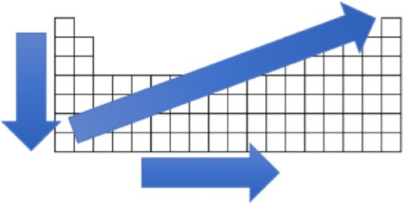
- Label the metals and the nonmetals.

- For the vertical arrow, indicate the trend for atomic radius (AR), ionization energy (IE) and electron affinity (EA) by writing next to the arrow whether each property increases or decreases.

- Repeat the instructions in B for the horizontal arrow.

- For the diagonal arrow, indicate whether metallic character increases or decreases.

- What conclusion can you draw about the ability of metals to hold on to and attract electrons, as compared to nonmetals?

