Name: ______________________________________ Date: ________________________

Student Exploration: Phase Changes

Vocabulary: altitude, boil, boiling point, freeze, freezing point, gas, liquid, melt, melting point, phase, solid

Prior Knowledge Question (Do this BEFORE using the Gizmo.)
Marla wants a hard-boiled egg for breakfast. The recipe says boil water, then lower the heat so the water is simmering. But Marla is in a rush, so she keeps the heat on high as the egg cooks.

Do you think the egg will be done faster if the heat is kept on high as the water boils?

Explain your answer.

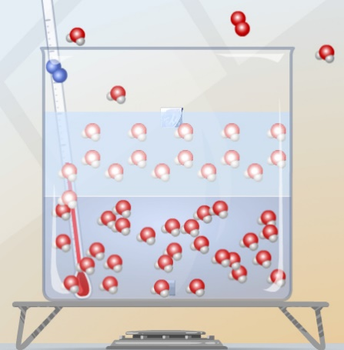
Gizmo Warm-up
In the Phase Changes Gizmo, select Micro view. Notice the nitrogen (), oxygen (), and water () molecules.

To start, create ice. Set Add/remove heat energy to -200 J/s, click Play (), and then click Pause () when the container is about half ice, half water. Set Add/remove heat energy back to 0 J/s, and then click Play.

- Observe water molecules in the solid (ice), liquid (water), and gas (air) phases.

  - In which phase(s) do molecules move freely?

  - In which phase(s) are molecules held together?

  - What do you notice about the positions of the ice molecules?

When frozen, water molecules form a hexagon (six-sided shape) pattern.

- Click Reset (), and select Macro view. Set the Ice volume to 25 cm³.

  - In which phase(s) is water held in a defined shape?

  - In which phase(s) does the water take the shape of the container?

Activity A:  Phase changes | Get the Gizmo ready:  - Click Reset. Check that Macro view is selected.  - Set the Water temperature to 10 °C.  - Set the Ice volume to 0 cm³. | 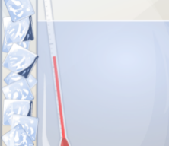

Question: How is temperature related to phase changes?

- Predict: Based on your prior knowledge, predict the following:

    - At what temperature will water change from a liquid to a solid (freeze)?

    - At what temperature will water change from a solid to a liquid (melt)?

    - At what temperature will water change from a liquid to a gas (boil)?

- Investigate: Use the Gizmo to explore phase changes. Use the Add/remove heat energy slider to control the water temperature. Record your observations in your notes, then answer the questions below:

    - At what temperature does water freeze? This is the freezing point.

    - At what temperature does ice melt? This is the melting point.

    - At what temperature does water boil? This is the boiling point.

- Observe: Set up the Gizmo to observe freezing. What do you notice about the temperature while the water is in the process of freezing?

- Explore: Use the Gizmo to investigate melting and boiling. Does the temperature change while either of these phase changes is occurring?

- Interpret: Select the GRAPH tab to see a graph of temperature vs. time. Click the “–” button until the whole graph is visible. What does the graph look like during a phase change?

- Extend your thinking: Why do you think the temperature does not change much during a phase change? If possible, discuss your answer with your classmates and teacher.

Activity B:  Temperature and molecular motion | Get the Gizmo ready:  - Click Reset, and select the Micro view.  - Set Ice volume to 0 cm³.  - Set Add/remove heat energy to 0 J/s.

Question: Why do phase changes occur?

- Compare: Set the Water temperature to 0 °C and click Play. Observe the water molecules. Click Reset, set the Water temperature to 100 °C, and click Play again.

What do you notice?

- Observe: Click Reset. The average molecular speed of the water molecules is displayed below the container. Set the Water temperature to 0 °C and Add/remove heat energy to 500 J/s. Click Play.

    - How does the average speed of the water molecules change as they are heated?

    - Does the average molecular speed change as much as the temperature as the water heats up? Explain.

- Explain: How is temperature related to the motions of molecules?

- Observe: Click Reset. Set the Water temperature to -10 °C and Add/remove heat energy to 100 J/s. Click Play. As the ice melts, how do the molecules in the liquid interact with the molecules in the solid?

(Activity B continued on next page)
Activity B (continued from previous page)

- Observe: Click Reset. Set the Water temperature to 100 °C and Add/remove heat energy to 500 J/s. Click Play. How does this situation compare to the previous one?

- Propose a theory: Based on what you have observed, explain why you think phase changes occur. If possible, discuss your theory with your classmates and teacher.

- Apply: Use your theory to explain what happens at the molecular level in each of the following situations. Also, list the temperature at which each transition occurs.

    - Ice is warmed to the melting point.

Temperature:

    - Water is warmed to the boiling point.

Temperature:

    - Water is cooled to the freezing point.

Temperature:

- Extend your thinking: Click Reset. Set the Water temperature to 0 °C and Add/remove heat energy to -500 J/s. Click Play and wait until all of the water freezes.

    - What volume of ice is created from 100 cm³ of water?

    - Why might it be a bad idea to put a glass container full of liquid in the freezer?

Activity C:  Altitude and phase changes | Get the Gizmo ready:  - Click Reset. Check the Ice volume is 0 cm³.  - Set the Altitude to 5,000 meters (16,404 feet). | 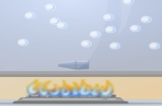

Introduction: Boxes of pasta have special instructions for people who live in the mountains. They are told to cook the pasta in boiling water a few minutes longer than normal.

Question: The altitude of a location is its vertical distance above sea level. How does altitude affect phase changes?

- Form a hypothesis: As altitude increases, the air pressure decreases. How do you think the lower pressure will affect the following? (Circle your answers.)
    - Freezing point: Increase Stay the same Decrease
    - Melting point: Increase Stay the same Decrease
    - Boiling point: Increase Stay the same Decrease

- Experiment: Use the Gizmo to find the freezing, melting, and boiling points of water at 5,000 meters (16,404 feet). Write these values below.

Freezing point: Melting point: Boiling point:

- Analyze: How did increasing altitude affect the freezing, melting, and boiling points of water?

- Challenge: Try to explain these results based on the fact that air pressure decreases with altitude. If possible, discuss your ideas with your classmates and teacher.

- Apply: Why does pasta take longer to cook in the mountains?

- Apply: A pressure cooker heats liquids at high pressure. Why do you think this is useful?

