Name: ______________________________________ Date: ________________________

Student Exploration: Phases of the Moon

Vocabulary: axis, crescent, First Quarter, Full Moon, gibbous, illuminate, Moon phase, New Moon, orbit, revolve, rotate, Third Quarter, waning, waxing

Prior Knowledge Questions (Do these BEFORE using the Gizmo.)

- A Moon phase is what the Moon looks like from Earth at a particular time. In the space below, draw a few pictures of different Moon phases, based on what you have seen before.

- About how often does a Full Moon happen? ______________________________________

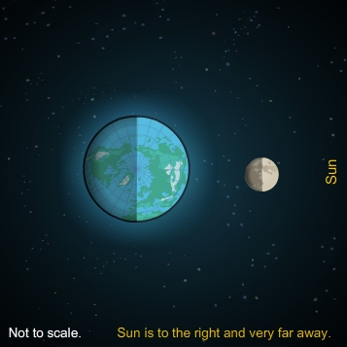
Gizmo Warm-up

- In the Phases of the Moon Gizmo, click Play (). What do you notice about the motion of the Moon?

________________________________________

The path that the Moon takes is called its orbit. The Moon is revolving around Earth.

- What do you notice about the motion of Earth?

________________________________________

This motion is called rotation. Earth rotates on its axis, a straight line connecting the North Pole to the South Pole.

- Where would you have to be to see the view shown above? Explain. __________________
_________________________________________________________________________

Activity A:  Moon phases | Get the Gizmo ready:  - Click Reset (). | 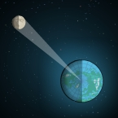

Question: Why do we see phases of the Moon?

- Brainstorm: Why do you think we see phases of the Moon? __________________________

_________________________________________________________________________

_________________________________________________________________________

- Run Gizmo:

  - Click Play. As the Moon goes around Earth, notice what the Moon looks like on the right side of the Gizmo. (This shows what an observer on the North Pole would see.)

  - Turn on Show view area to see which part of the Moon is visible from Earth.

- Observe: How does the Moon’s appearance change as the Moon revolves around Earth?

_________________________________________________________________________

_________________________________________________________________________

- Analyze:

    - Look at the overhead view of the Moon and Earth. How much of the Moon is always lit up, or illuminated, by the Sun? ________________________________________
    - Can we always see the same amount of the illuminated side of the Moon from Earth? Explain. ____________________________________________________________

- Think and discuss: Based on your observations, why do we see Moon phases?

_________________________________________________________________________

_________________________________________________________________________

_________________________________________________________________________

Activity B:  Name that phase! | Get the Gizmo ready:  - Click Reset. | 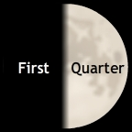

Goals: Learn the names of Moon phases and when they occur.

- Run Gizmo: Click Play. When you are ready to fill in part of the diagram, click Pause (). Sketch what the Moon looks like and write the phase name and day next to your sketch. (The first two are done for you.) Click Play to continue.

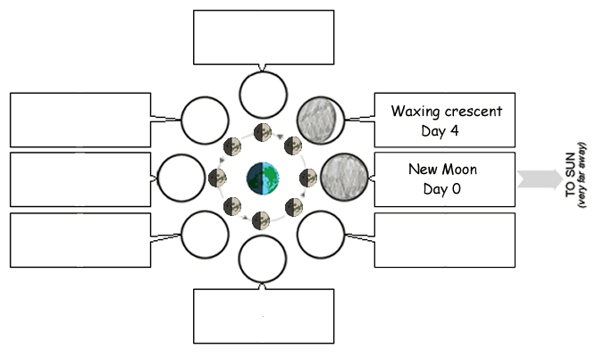

- Predict: Suppose you saw a waxing gibbous Moon. What phase would you expect one week later? ______________________________________ Test your prediction using the Gizmo.

- Think and discuss: Waxing means “growing” and waning means “shrinking.”

  - Seen from the North Pole, which side of a waxing Moon is illuminated? ___________

  - Which side is illuminated when the Moon is waning? _________________________

  - Suppose you see a crescent Moon. How do you know if it is waxing or waning?

___________________________________________________________________
Extension:  The Man in the Moon | Get the Gizmo ready:  - Click Reset.  - Turn on Show flag. | 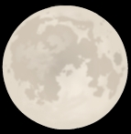

Question: If you look closely at the Full Moon, you may notice dark areas that look a bit like a face. This is known as “The Man in the Moon.” Does this side of the Moon always face Earth?

  - Form hypothesis: Do you think we always see the same side of the Moon? _____________

  - Run Gizmo: Click Play. The flag helps you notice how quickly the Moon is rotating. Click Pause when the flag has rotated in a full circle, showing that the Moon has rotated once.

  - Observe: Where does the flag point as the Moon revolves around Earth? _______________

  - Draw conclusions: Do we always see the same side of the Moon? How do you know?

_________________________________________________________________________

  - Observe:

    - How long did it take for the Moon to go around Earth?

___________________________________________________________________

    - How long did it take for the flag to rotate once in a full circle?

___________________________________________________________________

  - Analyze: What do you notice about these two time intervals? ________________________

_________________________________________________________________________

  - Think and discuss: Suppose the Moon rotated on its axis just as quickly as Earth. Would we still always see the same side of the Moon from Earth? Explain.

_________________________________________________________________________

_________________________________________________________________________

