Name: ______________________________________ Date: ________________________

Student Exploration: Pith Ball Lab

Vocabulary: Coulomb’s law, electrostatic force, gravitational force, induced charge, pith ball, Pythagorean Theorem, tension, vector

Prior Knowledge Questions (Do these BEFORE using the Gizmo.)

- A girl rubs a balloon on her head and then holds it a short distance away. Why does her hair stick to the balloon?

___________________________________________________

___________________________________________________

- Why do you think the individual strands of hair are spread apart?

___________________________________________________

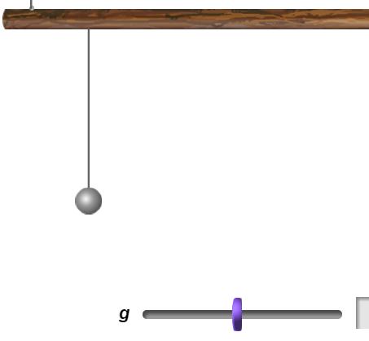
Gizmo Warm-up
The girl’s hair was attracted to the balloon by the electrostatic force, a force between all charged objects. Most objects acquire a charge (q) by gaining or losing electrons. Objects that gain electrons become negatively charged, while objects that lose electrons become positively charged.

The Pith Ball Lab Gizmo shows two pith balls hanging by strings. Pith balls are made from lightweight material that can easily acquire a charge. To begin, check that the charge on each pith ball (q₁ and q₂) is 0.0 × 10⁻⁶ coulombs (C).

Use the sliders to test each combination of charges listed below. State whether the electrostatic force is attractive (balls move together), repulsive (balls move apart), or zero (balls don’t move).

Charge on left ball (q₁) | Charge on right ball (q₂) | Electrostatic force
Positive | Zero
Zero | Negative
Positive | Positive
Negative | Negative
Positive | Negative

Activity A:  Coulomb’s law | Get the Gizmo ready:  - Set q₁ and q₂ to 0.0 × 10⁻⁶ C.  - Set the mass of the pith balls to 5 grams.  - Check that g is 9.8 m/s² and L is 0.50 m. | 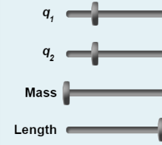

Question: What factors affect the force between charged objects?

- Summarize: Summarize what you have learned so far by filling in the blanks:

If the two charges are the same, the force is ___________________________.
If the two charges are opposite, the force is ___________________________.
If one of the charges is zero, the force is ___________________________.*
*Note: For simplicity, the Pith Ball Lab Gizmo does not show induced charge. An induced charge occurs when a charged object is brought near a neutral object, causing the electrons in the neutral object to move away from or towards the charged object. This results in an attractive force between the charged object and the neutral object.

- Predict: How do you think the strength of electrostatic force is related to the charges on the balls and the distance between them? __________________________________________
_________________________________________________________________________

_________________________________________________________________________

- Observe: Set q₁ to -5.0 × 10⁻⁶ C. Gradually decrease q₂ below 0.0 × 10⁻⁶ C.

- What do you observe? _________________________________________________

___________________________________________________________________

- What does this tell you about the force between the pith balls? _________________

___________________________________________________________________

- Observe: Now slowly increase q₂ above 0.0 × 10⁻⁶ C. What do you observe, and what does this tell you about the electrostatic force?

_________________________________________________________________________

_________________________________________________________________________

(Activity A continued on next page)
Activity A (continued from previous page)

- Gather data: Turn on Show angle. For each combination of charges in the table below, record the product of the two charges and the resulting angle. (Note: If you like, you can type the charge values directly into the text boxes to the right of each slider and hit “Enter.”)

q₁ | q₂ | q₁ × q₂ | Angle
6.0 × 10⁻⁶ C | 4.0 × 10⁻⁶ C
8.0 × 10⁻⁶ C | 3.0 × 10⁻⁶ C
16.0 × 10⁻⁶ C | 1.0 × 10⁻⁶ C
-4.0 × 10⁻⁶ C | -4.0 × 10⁻⁶ C

- Analyze: How does the electrostatic force relate to the product of the charges? Explain.

_________________________________________________________________________

_________________________________________________________________________

- Calculate: Coulomb’s law states that the electrostatic force (Fq) between charged objects is equal to a constant k multiplied by the product of the charges divided by the square of the distance between them:
Turn on Show geometric dimensions and Show force vectors and magnitudes. Set q₁ and q₂ to -5.0 × 10⁻⁶ C and the mass to 50 grams.

- What is the distance between the pith balls (R)? ____________________

- What is the value of the electrostatic force (Fq)? ____________________

- Based on the known values, use Coulomb’s law to solve for the proportionality constant, k. Show your work. (Note: The units of k are N·m²/C².)

k = ___________________

- Apply: Turn off Show force vectors and magnitudes. Choose your own values for q₁ and q₂ that are between -5.0 × 10⁻⁶ C and 20 × 10⁻⁶ C. Based on these values and R, calculate the force between the pith balls and write it below. Use the Gizmo to check your answer.

q₁ ___________ q₂ ___________ R ___________ Fq = ___________

Activity B:  Pith ball geometry | Get the Gizmo ready:  - Set q₁ and q₂ to 0.0 × 10⁻⁶ C.  - Set the mass of the pith balls to 50 grams.  - Turn off Show geometric dimensions and Show angle.  - Turn on Show force vectors and magnitudes. | 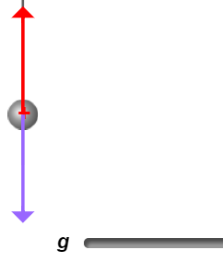

Introduction: At any time, there are up to three forces acting on the pith balls. The gravitational force (Fg) pulls the pith balls downward. The tension of the string (T) opposes gravity and pulls the pith balls up. You have already learned about the electrostatic force (Fq). Each force is represented by an arrow, or vector. The longer the arrow is, the greater the force.

Question: How does tension relate to the electrostatic force and the force of gravity?

- Observe: Look at the arrows on each pith ball.

- What two forces are affecting the pith balls right now? ________________________

- What is the value of each force? _________________________________________

- What would happen if these forces were not equal in magnitude? _______________

___________________________________________________________________

- Gather data: The fact that the balls are stationary indicates that the forces are balanced, or equal in magnitude. Set q₁ and q₂ to 10.0 × 10⁻⁶ C.

- What are the values of T, Fg, and Fq?

T = _____________ Fg = _____________ Fq = _____________

- How does the direction of the tension vector relate to the directions of the Fg and Fq vectors? ____________________________________________________________

- Calculate: Because Fg and Fq are perpendicular, you can use the Pythagorean Theorem to calculate the combined force of gravity and the electrostatics.

- What is the combined force of gravity and electrostatics (F_{Total})? ________________

- How does this force compare to the string tension? __________________________

___________________________________________________________________

(Activity B continued on next page)
Activity B (continued from previous page)

- Challenge: If you know Fg and Fq, you can calculate the angle of the string (θ). When you have finished your calculation, turn on Show angle to check your answer.

Hint: You can calculate the angles of a right triangle using the following trigonometry functions:

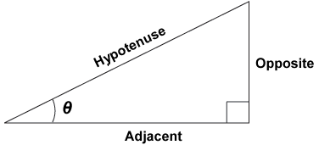

θ = __________

- Practice: Turn off Show angle and Show force vectors and magnitudes. Turn on Show geometric dimensions. Set q₁ and q₂ to 15.0 × 10⁻⁶ C. The force of gravity on each pith ball is equal to the mass of the ball (in kilograms) multiplied by gravitational acceleration (g).

In the space below, calculate Fg, Fq, T, and θ. Show your work. (Hint: To convert a mass in grams to kilograms, divide by 1,000.) When you have finished your calculation, turn on Show angle and Show force vectors and magnitudes to check your answer.

Fg = ____________ Fq = ____________ T = ____________ θ = ____________

Activity C:  Exploring variables | Get the Gizmo ready:  - Set q₁ and q₂ to 8.0 × 10⁻⁶ C.  - Set the mass of the pith balls to 50 grams.  - Check that g is 9.8 m/s² and L is 0.50 m. | 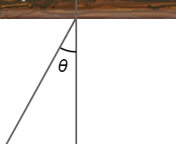

Question: What factors affect the angle of the pith balls?

- Observe: If necessary, turn on Show angle. What is the current value of θ? _____________

- Predict: Predict the effect of each change on the angle of the pith balls (θ). Fill in each blank with either “θ increases” or “θ decreases.” Explain each of your predictions.

- g increases: _______________ g decreases: _______________

Explain: ____________________________________________________________

- Mass increases: _______________ Mass decreases: _______________

Explain: ____________________________________________________________

- Length (L) increases: _______________ L decreases: _______________

Explain: ____________________________________________________________

- Test: Use the Gizmo to test each of your predictions. Write your results below.

- g increases: _______________ g decreases: _______________

- Mass increases: _______________ Mass decreases: _______________

- L increases: _______________ L decreases: _______________

- Interpret: How is increasing the mass of the pith balls similar to increasing the value of g?

_________________________________________________________________________

_________________________________________________________________________

- Think and discuss: Why does increasing the length of the string cause the angle of the pith balls to decrease? (Hint: Why wouldn’t you expect the angle to stay the same?)

_________________________________________________________________________

_________________________________________________________________________

_________________________________________________________________________

