Name: Date:

Student Exploration: Point-Slope Form of a Line

Vocabulary: point-slope equation, slope, slope-intercept equation, y-intercept

Prior Knowledge Questions (Do these BEFORE using the Gizmo.)

- After five days in her new job, Karen has $800 in her bank account. If she is adding exactly $50 to her account each day, when will her balance reach $1000? Explain.

- How much was in Karen’s account five days ago, just before she started the job? Explain.

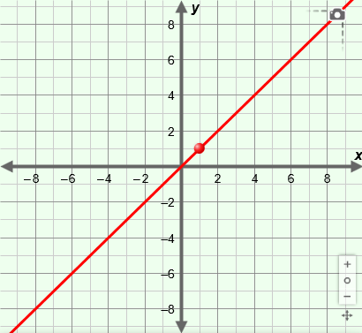
Gizmo Warm-up
There are many ways to define a line. One way is to state the coordinates of a point on the line – such as (5 days, $800) – and the rate of change of the line – such as $50/day – which is also called the slope. You can explore how lines are graphed in this way with the Point-Slope Form of a Line Gizmo.

To begin, check that m, x₁, and y₁ are set to 1.0. (To quickly set a slider to a specific value, type the value into the text box to the right of the slider and press Enter or Return on your keyboard.)

- The slope of the line is given by the variable m. Slowly drag the m slider to the right. How does this change the line?

- Set m to 2.0. Turn on the Show triangle checkbox. The triangle shows how much the
y-coordinate of the line changes (the rise) for a given change in the x-coordinate (the run). The ratio “rise over run” is the slope of the line.

What is the rise? What is the run? What is the slope?

- Turn off Show triangle. Drag the red point on the line to different locations on the grid.

- How do the point’s coordinates relate to x₁ and y₁?

- Does the slope change when the position of the point is changed?

Activity A:  The point-slope equation | Get the Gizmo ready:  - Be sure Show slope-intercept form and Show triangle are turned off.  - Set m to 3.0, x₁ to 0.0, and y₁ to 0.0. | 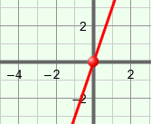

- The point-slope form of a linear equation is y – y₁ = m(x – x₁). This form is most helpful when you know the slope of a line (m) and a point on the line with coordinates (x₁, y₁). First, you will work with a situation in which the point is at the origin, so (x₁, y₁) is (0, 0).

  - What is the point-slope equation for this line?

  - Select the TABLE tab. For each value of x, how do you calculate the value of y?

- On the CONTROLS tab, set y₁ to 2.0. Notice how the position of the line changed.

  - What are the coordinates of (x₁, y₁), the point shown on the line now?

  - What is the point-slope equation for this line?

  - The point where the line crosses the y-axis is called the y-intercept. Turn on Show slope-intercept form. In the slope-intercept form, the line is described by the slope m and the y-intercept b: y = mx + b.

How does the slope-intercept form compare to the point-slope form?

  - When x₁ = 0, how does the value of y₁ compare to b?

- Select the TABLE tab. Check that the STEP is 1.00.

  - How much does the value of y change each time x increases by 1?

  - For each value of x, what is the value of y – 2?

  - Recall that the slope of the line is equal to “rise over run,” or the change in the
y-value divided by the change in the x-value:
m = =
How does the value “y – 2” relate to the equation for slope?

(Activity A continued on next page)
Activity A (continued from previous page)

- On the CONTROLS tab, set m to –2.0, x₁ to 1.0, and y₁ to 6.0.

- What are the coordinates of the designated point on the line?

- What is the point-slope equation of this line?

- In the space to the right, solve this equation for y. Then state the equation of the line in slope-intercept form, and its y-intercept.

slope-intercept form: y-intercept:

- Select the TABLE tab. How does y change if x increases by 1?

- How does “x – 1” relate to the equation for slope: m = ?

- How does “y – 7” relate to the slope?

- Algebra connection: Consider the general point-slope form of a line: y – y₁ = m(x – x₁).

- What part of the formula represents the change in y?

- What part of the formula represents the change in x?

- Describe the point-slope form by filling in the blanks: The change in is equal to the multiplied by the change in .
- Rearrange the equation to solve for the slope, m. m =

Is this equivalent to the equation for slope given in question 4F above?

Explain.

- Rearrange the equation to solve for y. y =

- Challenge: Compare your equation to the slope-intercept form of a line. What is the value of the y-intercept (b) in terms of m, x₁, and y₁? b =

- Describe what you know about the line described by the equation y – 3 = –2(x + 4).

Activity B:  Horizontal and vertical lines | Get the Gizmo ready:  - Turn on Show slope-intercept form.  - Turn off Show triangle. | 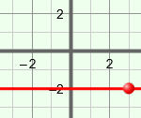

- Set m to 0.0 to create a horizontal line. Then set x₁ to 3.0 and y₁ to –2.0.

  - Write the slope, point, and point-slope equation of the line below.

slope: __________ point: __________ equation: _________________

  - Select the TABLE tab. What do all the points on this line have in common?

  - Drag the point around to graph more horizontal lines. What is the general equation of a horizontal line?
  - What is the equation of the horizontal line that contains the point (–8, 7)?

Explain.

- Select the CONTROLS tab. Set x₁ to 3.0 and y₁ to –2.0. Carefully drag the line until it is perfectly vertical. (When the line is perfectly vertical, the slope is undefined.)

  - Write the slope, point, and equation of your line below.

slope: __________ point: __________ equation: _________________

  - What do all the points on this line have in common?

  - Drag the point around to graph more vertical lines. What is the general equation of a vertical line?
  - What is the equation of the vertical line that contains the point (–4, –5)?

Explain.

Activity C:  Using  y – y₁ = m(x + x₁) | Get the Gizmo ready:  - Turn off Show slope-intercept form and Show triangle. | 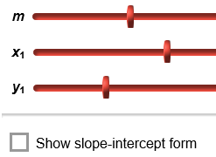

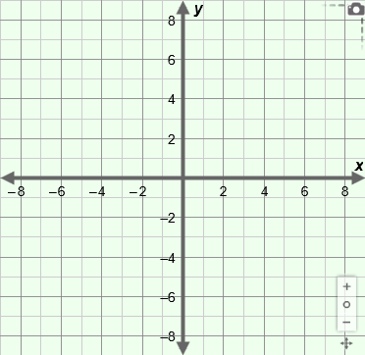
- Graph the line y + 5 = –0.5(x – 2) on the grid to the right.

  - What is the slope of this line?

  - What point lies on this line?

  - What is the y-intercept?

  - Write the equation of the line in slope-intercept form. Check your answer using the Gizmo.

- Turn off Show slope-intercept form. A line has a slope of –2.5 and contains the point (–5, 7).

- Write the equation of the line in point-slope form.

- What is the y-intercept of the line?

- Write the equation in slope-intercept form. Check your answer using the Gizmo.

- Graph the line in the grid to the right.

- A line contains the points (1, 2) and (5, –4).

- Find the slope of the line. Show your work.

m =

- Write two point-slope equations of the line.

- Graph the line and check it with the Gizmo.

