Name: Date:

Student Exploration: Polling: City

Vocabulary: margin of error, normal distribution, poll, population, sample

Prior Knowledge Questions (Do these BEFORE using the Gizmo.)
In the weeks leading up to the 1948 presidential election, polls showed that Thomas Dewey held a large lead on Harry Truman. Before voting booths had even closed, the Chicago Tribune printed the infamous headline: “Dewey Defeats Truman.” Truman’s victory is considered the greatest presidential election upset in history.

- What do you think are the characteristics of the most accurate polls?

- Why do you think some polls are inaccurate?

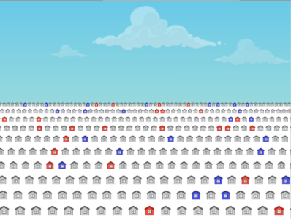
Gizmo Warm-up
Polls aim to predict the result of a vote when surveying the whole population is not possible. But polls can be inaccurate. In the Polling: City Gizmo, you can explore what affects poll accuracy by taking lots of polls from a large population.

To begin, check that Show population values is turned off. On the TABLE tab, click the Play 1 ( ) button to take a single poll of 100 phone calls.

- Out of the sample of 100 calls, what was the percentage of “Yes” votes?

- Click the Play 1 nine more times, for a total of ten 100-call polls.

- How many times did the polls predict “Yes” would win?

- What was the mean percentage of “Yes” votes?

- What do you think is the true percentage of “Yes” votes in the city?

- Turn on Show population values. What was the true “Yes” percentage?

Activity A:  Polling accuracy | Get the Gizmo ready:  - Check that Show population values is selected.  - Set the slider so the Yes percentage is 55%.  - On the TABLE tab, set the Simulation speed to its highest setting. | 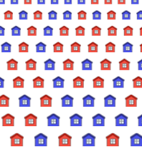

Introduction: Statisticians often study the accuracy of polls. One way to do this is to run many simulated polls on a known population. By testing the accuracy of simulated polls, we can learn how to interpret real-world polls (when the true “Yes” percentage is unknown).

- Set the Phone calls per poll to 1. (To quickly set the slider to a value, type the value into the text box to the right of the slider, and hit Enter.) Click the Play ( ) button. Wait until at least 5,000 of these one-call polls have been taken, and then click Pause ( ).

- What percentage of polls correctly predict that “Yes” will win?

- What was the mean “Yes” percentage?

- Suppose you could only take one 1-person poll. Based on this experiment, what is the probability that the poll will correctly predict that “Yes” will win?

- Click Reset ( ). With the population “Yes” percentage still at 55%, repeat the experiment with 50, 100, 200, and 500 calls per poll. For the 500-person poll, type “500” in the text box next to the slider. Fill in the results in the table below, including the result for the 1-call poll.

Phone calls per poll | Percentage of polls that predict “Yes” wins | Mean “Yes” %
1
50
100
200
500

- Based on your results, how likely was each poll to correctly predict that “Yes” will be the winner?

1-call: 50-call: 100-call: 200-call: 500-call:

- How did the size of the poll relate to the percentage of polls that were correct?

(Activity A continued on next page)
Activity A (continued from previous page)

- Click Reset. Set the Phone calls per poll to 100 and the set the “Yes” percentage to 70%. Use the Gizmo to simulate at least 5,000 polls with actual “Yes” percentages of 70%, 60%, 55%, 52%, and 51%. Record results in the table below.

“Yes” percentage in population | Percentage of polls that predict “Yes” wins | Mean “Yes” %
70%
60%
55%
52%
51%

- Suppose you could take a single 100-person poll. Based on your simulated-poll results, how likely is it that your poll will correctly predict that “Yes” is going to win the election, with the following actual “Yes” percentages?

70%: 60%: 55%: 52%: 51%:

- How did the percentage of “Yes” votes affect the likelihood of a correct poll?

- Suppose you work for a newspaper, covering an upcoming election between Mr. N and Ms. Y. Your editor wants you to conduct a poll with a 95% chance of correctly picking the winner. Use the Gizmo to determine the minimum number of phone calls you can make per poll in each of the following scenarios. (Hint: The Phone calls per poll can be increased up to 500 by typing the number directly in the text box to the right of the slider, and hitting Enter.)

- Mr. N = 36%, Ms. Y = 64%

- Mr. N = 59%, Ms. Y = 41%

- Mr. N = 46%, Ms. Y = 54%

- Based on what you have observed, what are two factors that can affect how likely it is for a poll to correctly predict the winner of an election?

Activity B:  The normal distribution | Get the Gizmo ready:  - If necessary, turn on Show population values.  - Set the “Yes” percentage to 55%, set the Phone calls per poll to 100, and set the Simulation speed to its lowest setting. | 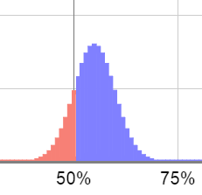

- On the TABLE tab, click Play 1.

- What is the percentage of “Yes” votes in the 100-person poll?

- Did the poll correctly predict that “Yes” will win?

- Select the HISTOGRAM tab. To the right of the graph, click twice to zoom in. How is a single poll plotted on the histogram?
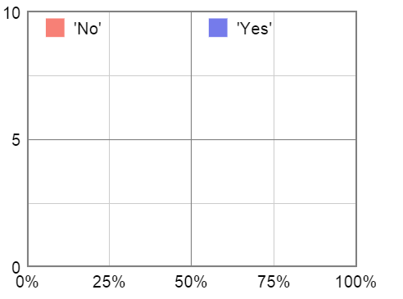
- Click Play until about 50 polls have been taken. Notice the “Yes” percentage in each poll is plotted. The blue polls are polls in which “Yes” is predicted to win, and the red polls are polls in which “No” is predicted to win.

- What percentage of polls correctly predicted that “Yes” will win?
- Sketch the histogram in the graph to the right.

- Select the PROBABILITY tab. Set the True Yes % to 55% and Houses polled to 100, matching the experiment you just conducted. The histogram shows the theoretical probability of each result. This bell-shaped curve is known as a normal distribution.

- How does the shape of the normal distribution compare to the histogram you drew?

- What is the theoretical percentage of polls predicting a “Yes” win?

- How does the theoretical percentage of “Yes” winners compare to the experimental percentage?
- Why do you think the normal distribution has the shape that it has?

(Activity B continued on next page)
Activity B (continued from previous page)
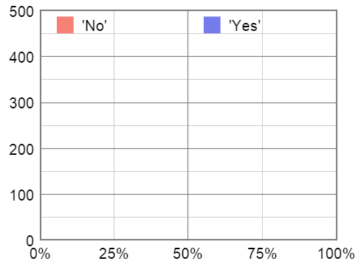
- Set the population “Yes” percentage to 55%. On the HISTOGRAM tab, set the Phone calls per poll to 50 and the Simulation speed to its highest setting. Next to the graph, click the “zoom out” ( ) button until the greatest number on the y-axis is 500.

Click Play, and then click Pause when the highest-frequency bar on the histogram is about 400. (This will probably occur after about 3,000 or 4,000 polls.) Sketch this histogram in the blank grid to the right.
What percentage of polls correctly predict that “Yes” will win?

- Set the Phone calls per poll to 200. Click Play, and then click Pause when the highest-frequency bar on the histogram is about 400. (This will probably occur after about 6,000 or 7,000 polls.) Sketch this histogram in the blank grid to the right.

What percentage of polls correctly predict that “Yes” will win?

- Compare the two histograms.
- How does the shape of the histogram change as the size of the poll increases?

- How does the shape of the histogram relate to the accuracy of a poll?

- On the PROBABILITY tab, set the True Yes % to 55% and Houses polled to 50.

- What is the theoretical percentage of polls that predict “Yes” will win?
- Move the Houses polled slider to 200. What is the theoretical percentage of polls that predict “Yes” will win now?
- Move the Houses polled slider back and forth. How does the shape of the normal distribution change as the number of calls increases?

Activity C:  Margin of error | Get the Gizmo ready:  - On the PROBABIILITY tab, set the True Yes % to 60%. | 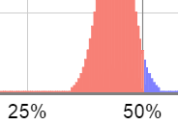

Introduction: If you see real-life poll results, it might say something like “52% favor ‘Yes,’ ±3%.” The “±3%” part is called the margin of error (MOE). If a poll has a 3% margin of error, it is very likely (usually 95% probable) that the poll result is within 3% of the real value. So, in this case, there is a 95% probability that the actual population “Yes” value is between 49% and 55%.

      - Suppose you wish to conduct a poll with a 95%-confidence MOE of ±10%. If the true population “Yes” % is 60%, that means there is a 2.5% chance that the poll will show a “Yes” % of 70% or greater and a 2.5% chance of a “Yes” % of 50% or less (“No” wins).

On the PROBABILITY tab, adjust the Houses polled slider until the “No wins” value is as close to 2.5% as possible.

About what number of Houses polled gives a margin of error of 10%?

      - Select Show population values and set the population “Yes” percentage to 60%. On the TABLE tab, set the Phone calls per poll to the value you found above. Click Play.

- After about 5,000 polls, how many incorrectly predicted a “No” win?

- What was the total number of polls conducted?

- What percentage of polls predicted a “No” win?

- Is this percentage close to 2.5%, as expected?

      - On the PROBABILITY tab, set the True Yes % to 57%. Use the tab to find the poll size that results in a margin of error of ±6%, at a 95% level of confidence. (Hint: The correct sample size is reached when “No” wins 2.5% of the polls.)

- About what number of Houses polled gives a margin of error of 7%?

- Next, try it out! (At the bottom left, set the population “Yes” % to 57%. On the TABLE tab, set Phone calls per poll to the value you found above. Then click Play.)

After 5,000 polls, what percent incorrectly predicted a “No” win?

      - For a large population, the margin of error can be estimated from the size of the poll. If the poll size is n, the 95% margin of error ≈ . Use this formula to estimate the size of the poll needed for the following 95% margins of error: ±5% (0.05), ±3% (0.03), and ±1% (0.01).

5% MOE: 3% MOE: 1% MOE:

